**LARGS REGATTA FESTIVAL**

**CUMBRAES WEEKEND**

Saturday 30th and Sunday 31st August 2025

Largs, Ayrshire, Scotland, KA30 8EZ

**NOTICE OF RACE**

The Organising Authority (OA) is Largs Sailing Club (LSC) for the Dinghy and Catamaran Fleet  
 and Fairlie Yacht Club (FYC) for the Keelboat and MOCRA Multihull Fleet.

The notation ‘[NP]’ in a rule means that a boat may not protest another boat for breaking   
that rule. This changes RRS 60.1(a).

Incorporating the 707 and International Etchell Scottish Championships

# **RULES**

## The Event will be governed by the Rules as defined in the Racing Rules of Sailing (RRS).

## The prescriptions of the RYA available at [www.rya.org.uk](http://www.rya.org.uk) will apply. The World Sailing Offshore Special Regulations (OSR) available at [www.sailing.org](http://www.sailing.org) will apply, see NoR 10.2. The IRC rules available at [www.ircrating.org](http://www.ircrating.org) will apply (except for Part D that will NOT apply). The CYCA Handicap System available at [www.cyca-online.org.uk](http://www.cyca-online.org.uk) will apply. The Multihull Offshore Cruising & Racing Association (MOCRA) Rating Rules available at <https://mocra-sailing.org.uk/racing/> will apply.

# **2 SAILING INSTRUCTIONS**

## 2.1 The Sailing Instructions (SIs) will be available after 1600, Friday 1st August 2025 on the event website [www.LargsRegattaFestival.com](https://largsregattafestival.com/) The sailing instructions may change some RRS.

2.2 The Sailing Instructions will indicate two race areas on separate courses: IRC/ CYCA and one design.

# **COMMUNICATION**

## The online official noticeboard is located at the Event website [www.LargsRegattaFestival.com](https://largsregattafestival.com/) There will be no physical notice board.

## [NP] [DP] All keelboats and MOCRA Multihulls shall carry a VHF radio capable of communicating on channels, M1(37A), M2(P4), 72, 77.

## [NP] The race committee may make courtesy broadcasts to keelboat and MOCRA Multihull competitors on VHF radio. The channel and details of regular scheduled communication (if any) will be stated in the SIs.

## [DP] From the first warning signal until the end of the last race of the day, except in an emergency, a boat shall not make voice or data transmissions and shall not receive voice or data communication that is not available to all boats.

# **ELIGIBILITY AND ENTRY**

## The Event is open to dinghies and catamarans with a recognised Portsmouth Number (PN) of 1369 or lower or the equivalent SCHRS Rating.

## The SCHRS rating system may be used to calculate results for catamarans, and it may be used to generate an equivalent PN for catamaran classes if they are racing with dinghies.

## The Event is open to keelboats with valid IRC rating certificates with ratings of 0.840 and higher, keelboats with valid CYCA rating certificates, and multihulls with valid MOCRA rating certificates.

## The Event is open to keelboats with valid CYCA handicaps, in the restricted sail configuration (see SI 4.9) with unlimited crew numbers.

## The Event is open to keelboats, with valid CYCA handicaps, in both unrestricted and restricted sail configurations (see SI 4.9) sailed by 2 persons.

## The Event is also open to any yachts that do not wish to race but intend to cruise in company during the weekend and attend the social function on Saturday. Separate details of the cruise will be available on the event website [www.LargsRegattaFestival.com](http://www.LargsRegattaFestival.com) To be eligible for the discounted social function entry fee cruising yachts shall participate in the cruise in company on the water and register online.

## Proposed Dinghy and Catamaran Classes.

|  |  |
| --- | --- |
| ***Class*** | ***Handicap*** |
| Handicap Dinghy (Up to 2 Classes) | Portsmouth Yardstick |
| Catamarans | SCHRS |

## Proposed Keelboat & MOCRA Multihull Classes

|  |  |
| --- | --- |
| ***Class*** | ***Anticipated Handicap Band*** |
| International Etchells |  |
| 707s |  |
| Class 1 (IRC) | >=1.000 |
| Class 2 (IRC) | <1.000 |
| Class 3 (CYCA) | 0 to 13.0 |
| Class 4 (CYCA) | >13.0 |
| Class 5 (CYCA) Restricted Sail | All valid CYCA handicaps |
| Class 6 (MOCRA) Multihulls | All valid MOCRA ratings |
| Class 7 (CYCA) 2 Handed | All valid CYCA handicaps |
| Class 8 (CYCA) 2 Handed Restricted Sail | All valid CYCA handicaps |

## In the Restricted Sail classes spinnakers shall not be used, and only one headsail may be used at any one time except for cutter rigged (or similar) yachts that have 2 (or more) headsails recorded on their CYCA rating certificate.

## The OA may amalgamate, combine, cancel, divide, subdivide or rearrange classes at its sole discretion, and shall publish the class divisions on the event website no later than 2000 on Friday 29 AUG 2025.

## Boats may enter the event by registering online and paying the appropriate fees via the Event website [www.LargsRegattaFestival.com](http://www.LargsRegattaFestival.com)

## To be considered an entry in the Event, all boats in all classes shall complete all registration requirements and pay all fees.

# **FEES**

## Entry fees are as follows:

|  |  |
| --- | --- |
| ***Dinghy & Catamaran*** | |
| Double Handed - Both days | £57.00 |
| Single Handed - Both days | £47.00 |
| Double Handed Under 18 - Both days | £32.00 |
| Single Handed Under 18 - Both days | £27.00 |
| Double Handed - One Day only  (please identify which day on the entry form) | £42.00 |
| Single Handed - One Day only  (please identify which day on the entry form) | £37.00 |
| Double Handed Under 18 One Day only  (please identify which day on the entry form) | £20.00 |
| Single Handed Under 18 One Day only  (please identify which day on the entry form) | £17.00 |

|  |  |
| --- | --- |
| ***Keelboat & MOCRA Multihulls*** | |
| Yachts >= 9m LOA, Both Days | £80.00 |
| Yachts >= 9m LOA, 1 Day Only  (please identify which day on the entry form) | £42.00 |
| Yachts < 9m LOA, Both Days | £65.00 |
| Yachts <9m LOA, 1 Day Only  (please identify which day on the entry form) | £37.00 |
| 707s & International Etchells | £65.00 |
| Cruise in Company Yachts Marquee Entry (donation to Ellan MacArthur Trust) | £25.00 |

## Entries received after 22nd AUG 2025 shall be subject to an additional late entry fee of £10.00. To allow for sufficient planning to take place, entries received after 1700 on Wednesday 27th AUG 2025 shall not be accepted.

# **CREW LIMITATIONS**

## Keelboat and MOCRA Multihull crew number and crew weight limitations described in the IRC and MOCRA ratings rules shall not apply.

## The crew number for each entry in Classes 7 and 8 shall be 2 persons.

# **ADVERTISING**

## [DP] Boats may be required to display advertising chosen and supplied by the organising authority.

# **QUALIFYING SERIES AND FINAL SERIES – Not applicable at this event.**

# **SCHEDULE**

## Dates of Racing.

|  |  |
| --- | --- |
| ***Class*** | ***Dates*** |
| Handicap Dinghy | Saturday 30th August 2025  Sunday 31st August 2025 |
| Catamaran |
| International Etchells |
| 707s |
| Class 1 (IRC) |
| Class 2 (IRC) |
| Class 3 (CYCA) |
| Class 4 (CYCA) |
| Class 5 (CYCA) Restricted Sail |
| Class 6 (MOCRA) Multihulls |
| Class 7 (CYCA) 2 Handed |
| Class 8 (CYCA) 2 Handed Restricted Sail |

## Number of Races

|  |  |  |  |
| --- | --- | --- | --- |
| ***Class*** | ***Total Number  of Races*** | *No Of Races Scheduled  Saturday* | *No Of Races Scheduled  Sunday* |
| Handicap Dinghy | **5** | 4 | 1 |
| Catamaran | **5** | 4 | 1 |
| International Etchells | **7** | 4 | 3 |
| 707s | **7** | 4 | 3 |
| Class 1 (IRC) | **5** | 4 | 1 |
| Class 2 (IRC) | **5** | 4 | 1 |
| Class 3 (CYCA) | **5** | 4 | 1 |
| Class 4 (CYCA) | **5** | 4 | 1 |
| Class 5 (CYCA) Restricted Sail | **3** | 2 | 1 |
| Class 6 (MOCRA) Multihulls | **3** | 2 | 1 |
| Class 7 (CYCA) 2 Handed | **3** | 2 | 1 |
| Class 8 (CYCA) 2 Handed Restricted Sail | **3** | 2 | 1 |

## The scheduled time of the first warning signal each day is as follows:

|  |  |  |
| --- | --- | --- |
| ***Fleet*** | *Saturday* | *Sunday* |
| Dinghy & Catamarans | 1155 | 1055 |
| Keelboat & MOCRA Multihulls | 1005 | 1000 |

## On the last scheduled day of racing no warning signal will be made after 1500.

# **EQUIPMENT INSPECTION**

## [NP] [DP] Keelboats and MOCRA Multihulls shall produce or verify the existence of a valid rating certificate no later than Friday 22nd August 2025. Copies of certificates shall be emailed to [dave@largsyachthaven.com](mailto:dave@largsyachthaven.com)

## [DP] Keelboats and MOCRA Multihulls shall comply with OSR Appendix B.

## Boats may be inspected at any time during the event. The fact that race officials may conduct inspections of a boat does not reduce the responsibilities of each competitor set out in this notice of race.

# **CLOTHING AND EQUIPMENT - Not applicable at this event.**

# **VENUES**

## Racing for Dinghies and Catamarans will take place in the Largs Channel and the waters surrounding Great Cumbrae Island.

## Racing for Keelboats and MOCRA Multihulls will take place to the North of Great Cumbrae and the waters surrounding Little Cumbrae and Great Cumbrae Islands.

## **COURSES**

## Courses may be windward leeward, triangular, trapezoidal, around fixed marks and/or around islands.

12.2 Separate courses will be set for 707s and Etchells.

# **PENALTY SYSTEM**

## The Two-Turns penalty shall be replaced by the One-Turn penalty. This changes RRS 44.1.

## The Post-Race Penalty and RYA Arbitration of the RYA Rules Disputes Procedures shall apply (for full information on the procedures, go to [www.rya.org.uk/go/rules](http://www.rya.org.uk/go/rules) ). The outcome of an RYA Arbitration can be referred to a protest committee, but an arbitration cannot be reopened or appealed.

## Protest hearings and RYA arbitration may take place virtually and competitors shall need to be able to access a device suitable for running popular commercially available video conferencing software. Further details may be published on the on-line noticeboard on the event website.

# **SCORING**

## One race is required to be completed to constitute a series.

## (a) When fewer than 4 races have been completed, a boat’s series score will be the total of her race scores.

## (b) When 4 or more races have been completed, a boat’s series score will be the total of her race scores excluding her worst score.

# **SUPPORT PERSON VESSELS – Not applicable at this event.**

# **CHARTERED OR LOANED BOATS – Not applicable at this event.**

# **BERTHING –** Contact Largs Yacht Haven for special event rates for berthing and lifts.

# **HAUL OUT RESTRICTIONS**

## [DP] Keelboats or MOCRA Multihulls shall not be hauled out during the event except with and according to the terms of prior written permission of the race committee.

# **DIVING EQUIPMENT AND PLASTIC POOLS – Not applicable at this event.**

# **DATA PROTECTION**

## The personal information you provide to the organising authority will be used to facilitate your participation in the event. If you have agreed to be bound by the Racing Rules of Sailing and the other rules that govern the event (the rules), the legal basis for processing that personal information is contract. If you are not bound by the rules, the legal basis for processing that personal information is legitimate interest. Your personal information will be stored and used in accordance with the organising authority’s privacy policy. When required by the rules, personal information may be shared with the RYA, your national authority and/or World Sailing. The results of the event and the outcome of any hearing or appeal may be published.

# **RISK STATEMENT**

## Rule 3 of the Racing Rules of Sailing states: "The responsibility for a boat’s decision to participate in a race or to continue racing is hers alone."

## Sailing is by its nature an unpredictable sport and therefore inherently involves an element of risk. By taking part in the event, each competitor agrees and acknowledges that:

## (a) They are aware of the inherent element of risk involved in the sport and accept responsibility for the exposure of themselves, their crew and their boat to such inherent risk whilst taking part in the event;

## (b) They are responsible for the safety of themselves, their crew, their boat and their other property whether afloat or ashore;

## (c) They accept responsibility for any injury, damage or loss to the extent caused by their own actions or omissions;

## (d) Their boat is in good order, equipped to sail in the event and they are fit to participate;

## (e) The provision of a race management team, patrol boats, inspection and other officials and volunteers by the event organiser does not relieve them of their own responsibilities;

## (f) The provision of patrol boat cover is limited to such assistance, particularly in extreme weather conditions, as can be practically provided in the circumstances.

## (g) It is their responsibility to familiarise themselves with any risks specific to this venue or this event drawn to their attention in any rules and information produced for the venue or event and to attend any safety briefing held for the event.

# **INSURANCE**

## Each participating boat shall be insured with valid third-party liability insurance with a minimum cover of £3,000,000 per event or the equivalent.

# **PRIZES**

## Prizes will be awarded to the first three boats in each class for the series. The number of prizes awarded may vary, at the discretion of the organising authority, depending on the number of entries within each class.

## The ENTERPRISE AYRSHIRE ROSEBOWL will be awarded to the boat that, in the opinion of the Largs Regatta Festival Committee, has produced the best overall performance of all boats during Largs Regatta Festival’s Cumbraes Weekend.

## The HUNTERSTON WHEEL TROPHY for the yacht of the Event will be awarded to the keelboat or MOCRA multihull that, in the opinion of the Largs Regatta Festival Committee, has produced the best performance during Largs Regatta Festival’s Cumbraes Weekend.

## The LARGS ‘LIFEBOAT CREW’ TROPHY for the dinghy or catamaran of the Event will be awarded to the dinghy or catamaran which, in the opinion of the Largs Regatta Festival Committee has produced the best performance during Largs Regatta Festival’s Cumbraes Weekend.

## Prizes will be awarded for the 707s and International Etchells Scottish Championships.

## The OA may award other prizes at its discretion.

# **FURTHER INFORMATION**

## Further information is available from the Event website [www.LargsRegattaFestival.com](http://www.LargsRegattaFestival.com) and by telephoning or e-mailing the following: Largs Yacht Haven Tel: 01475 675333, or email to [dave@largsyachthaven.com](mailto:dave@largsyachthaven.com)

## **Largs Regatta Festival also offers midweek evening racing for Keelboats (2nd & 3rd September) and Dinghies (2nd, 3rd & 4th September). Further to that the Festival also organises the Scottish Two-Handed race – a distance race around Arran or the Holy Island for 2 handed keelboats on 6th & 7th September.**

## **Preferential berthing rates are available mid-week if entered in the mid-week series following the Regatta weekend and before the 2 handed. Please visit the Event website** [**www.LargsRegattaFestival.com**](http://www.LargsRegattaFestival.com) **for more details of the additional events.**



Dinghy and Catamaran Race Area

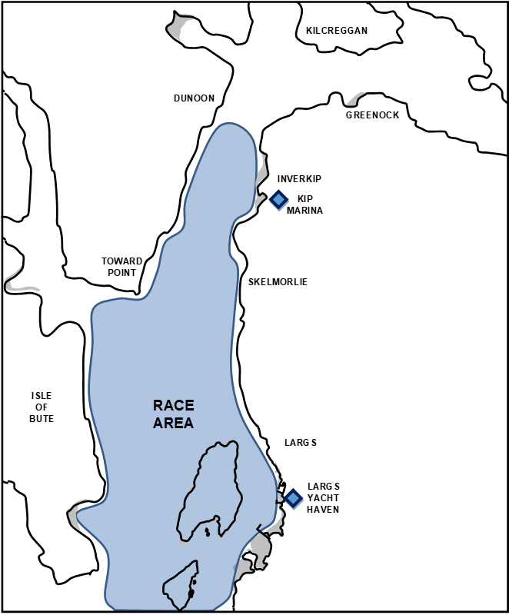

Keelboat & MOCRA Multihull Race Area

