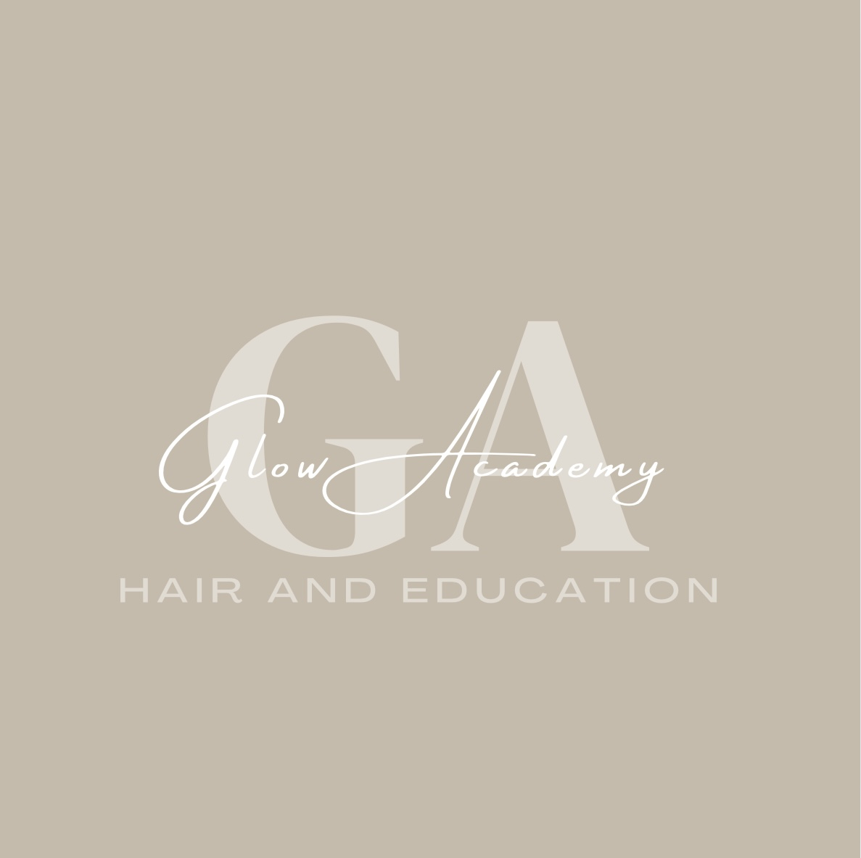

Glow Academy Hair & Education – Health & Safety Policy

1. Policy Statement
Glow Academy Hair & Education is committed to ensuring the health, safety, and welfare of all learners, staff, visitors, and contractors. We aim to provide a safe and healthy environment for teaching, learning, and salon activities in line with the Health and Safety at Work etc. Act 1974 and other relevant legislation.

2. Aims
- Prevent accidents and work-related ill health.
- Provide safe facilities and equipment.
- Ensure safe storage and handling of products and materials.
- Provide clear health and safety information, instruction, and training.

3. Responsibilities
The Director is responsible for implementing and monitoring this policy.
Staff are responsible for following health and safety procedures and reporting hazards.
Learners must follow safety rules and instructions from staff.

4. Risk Assessment
We will carry out regular risk assessments of the salon, classrooms, and activities to identify and manage hazards. Risk assessments will be reviewed annually or when there are significant changes.

5. Salon-Specific Safety
- All electrical equipment will be PAT tested annually.
- COSHH regulations will be followed for storing and handling hair and beauty products.
- Staff will ensure learners use PPE where required (e.g., gloves, aprons).
- Heat-resistant mats will be used with styling tools.
- First aid kits will be available in all working areas.

6. Emergency Procedures
- Fire evacuation procedures will be displayed and practised.
- Staff will be trained in emergency first aid.
- Accidents will be recorded in the accident book and reported as required.

7. Training
Staff and learners will receive induction training on health and safety rules, including salon safety, fire safety, and manual handling.

8. Monitoring and Review
This policy will be reviewed annually or sooner if legislation or guidance changes.

