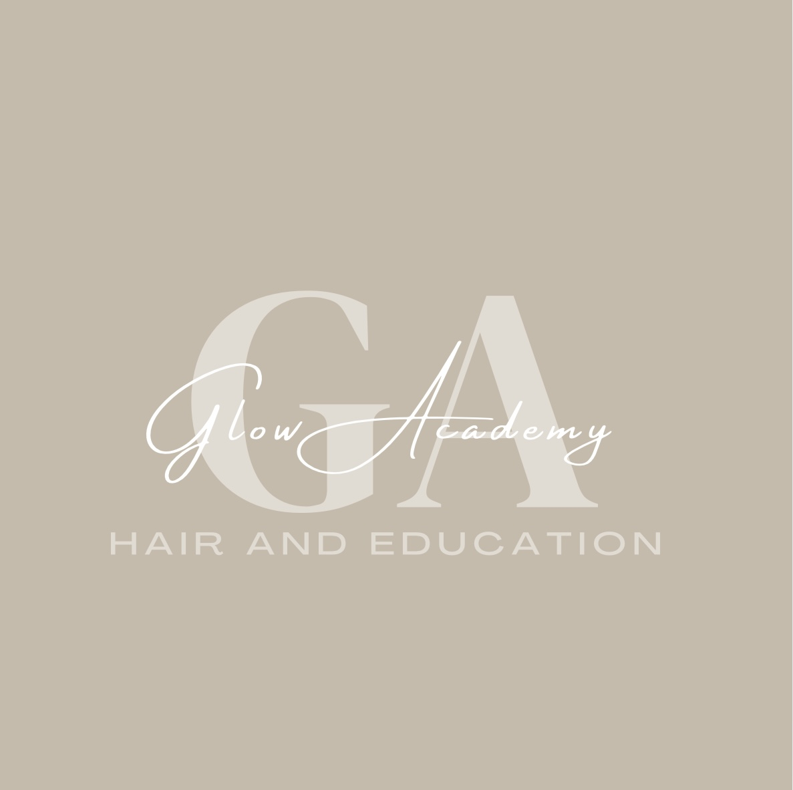

Glow Academy Hair & Education – Appeals Policy

1. Policy Statement
Glow Academy Hair & Education is committed to ensuring that assessment decisions are fair, consistent, and in line with awarding body standards. Learners have the right to appeal if they believe that an assessment decision is incorrect or unfair. This policy outlines the process for making and handling appeals.

2. Scope
This policy applies to all learners undertaking programmes delivered by Glow Academy, including those leading to qualifications awarded by VTCT or other awarding bodies. It covers:
- Assessment decisions.
- Internal verification decisions.
- Decisions relating to reasonable adjustments or special considerations.

3. Grounds for Appeal
Learners may appeal on the following grounds:
- They believe the assessor did not apply the assessment criteria correctly.
- They believe the assessment was not conducted in line with awarding body requirements.
- They believe they were not given a fair opportunity to demonstrate their competence.

4. Appeals Procedure
Stage 1 – Informal Resolution:
The learner should first discuss the decision with the assessor within 5 working days of receiving the result. Many issues can be resolved at this stage.
Stage 2 – Formal Appeal:
If unresolved, the learner must submit a written appeal to the Internal Quality Assurer (IQA) within 10 working days. The appeal should include details of the decision being challenged and the grounds for appeal.
Stage 3 – Appeal Review Panel:
An impartial panel, including a senior manager and a different assessor, will review the evidence and make a final decision.
Stage 4 – External Appeal:
If the learner is still dissatisfied, they may appeal directly to the awarding body in line with its procedures.

5. Timescales
We aim to resolve all appeals within 20 working days of receipt. If additional time is needed, the learner will be informed.

6. Record Keeping
All appeals will be recorded, including outcomes and actions taken. Records will be retained for a minimum of three years.

7. No Detriment
Learners will not be disadvantaged for making an appeal in good faith.

8. Monitoring and Review
This policy will be reviewed annually to ensure compliance with awarding body and regulatory requirements.

