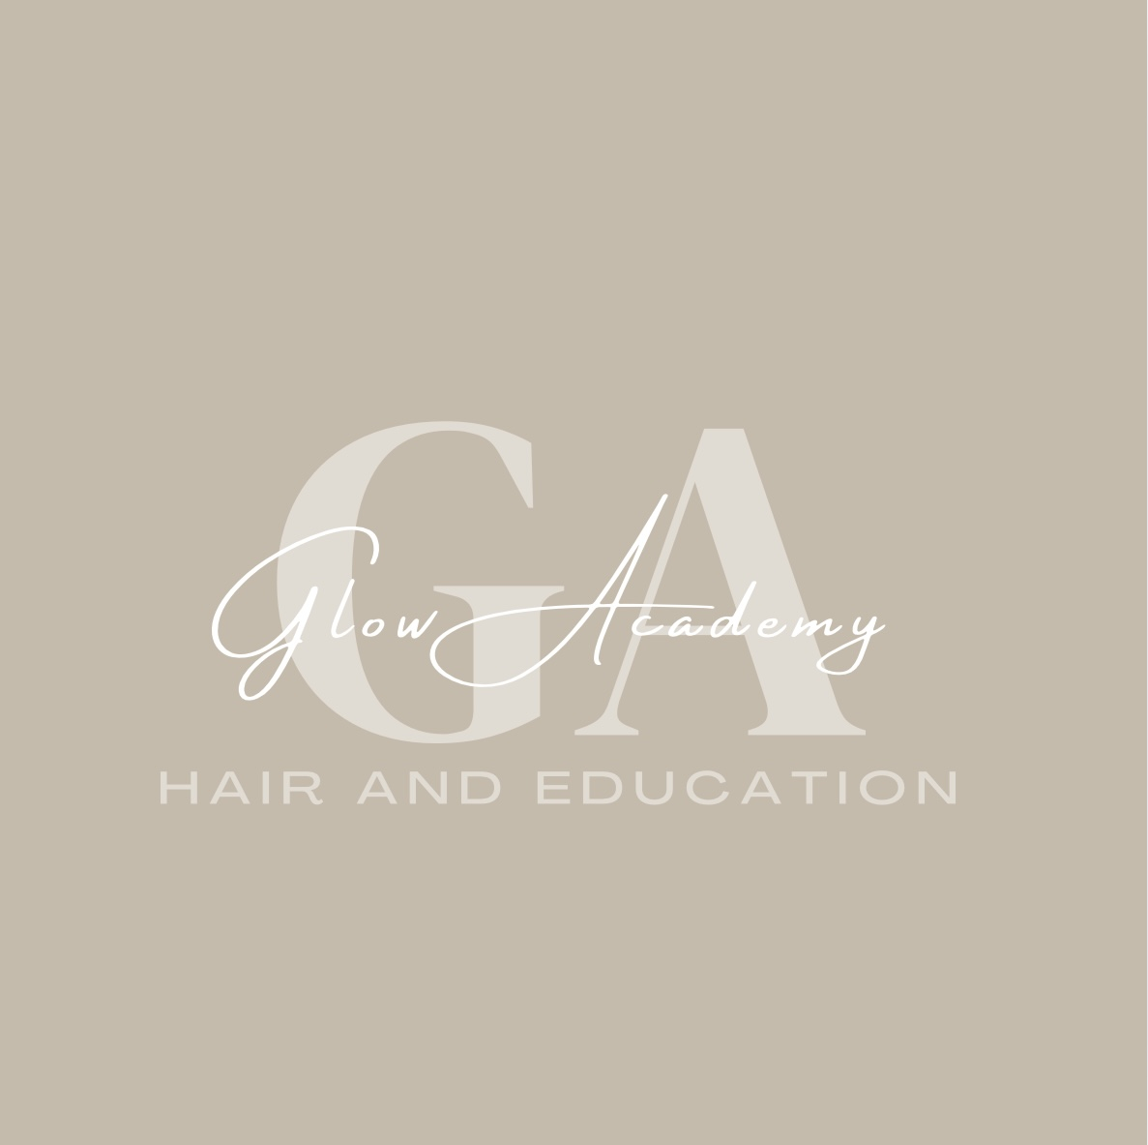

Glow Academy Hair & Education – Curriculum Policy

1. Policy Statement
Glow Academy Hair & Education provides a high-quality, inclusive curriculum that meets the needs, interests, and aspirations of all learners. Our curriculum is designed to equip learners with the knowledge, skills, and behaviours required for success in the hair and beauty industry, as well as supporting their personal development, wellbeing, and future employability.

2. Aims
- Provide an engaging, challenging, and inclusive curriculum.
- Meet the requirements of awarding bodies and regulatory frameworks.
- Equip learners with vocational skills, industry knowledge, and employability skills.
- Promote personal growth, resilience, and positive attitudes to learning.

3. Curriculum Principles
- Learner-centred and responsive to individual needs.
- Aligned with current industry standards and practices.
- Balanced between practical skills, theoretical knowledge, and personal development.
- Promotes equality, diversity, and inclusion.

4. Curriculum Structure
Our curriculum includes:
- Accredited qualifications (e.g., VTCT Level 1 and Level 2 in Hair and Beauty).
- Functional skills in English and Maths where required.
- Employability skills, including communication, teamwork, and problem-solving.
- Personal, Social, Health and Economic (PSHE) education.
- Enrichment activities to broaden learner experience.

5. SEND and Additional Support
We make reasonable adjustments to ensure learners with Special Educational Needs and Disabilities (SEND) can access and succeed in the curriculum, in line with our SEND Policy.

6. Teaching and Learning Approaches
- Practical, hands-on learning in a realistic salon environment.
- Differentiated instruction to meet diverse learning needs.
- Use of technology to enhance learning.
- Regular formative and summative assessment to track progress.

7. Work Experience and Industry Links
Learners will have opportunities for work experience and engagement with industry professionals to prepare them for future employment.

8. Review and Evaluation
The curriculum will be reviewed annually in consultation with staff, learners, employers, and awarding bodies to ensure it remains current, relevant, and effective.

