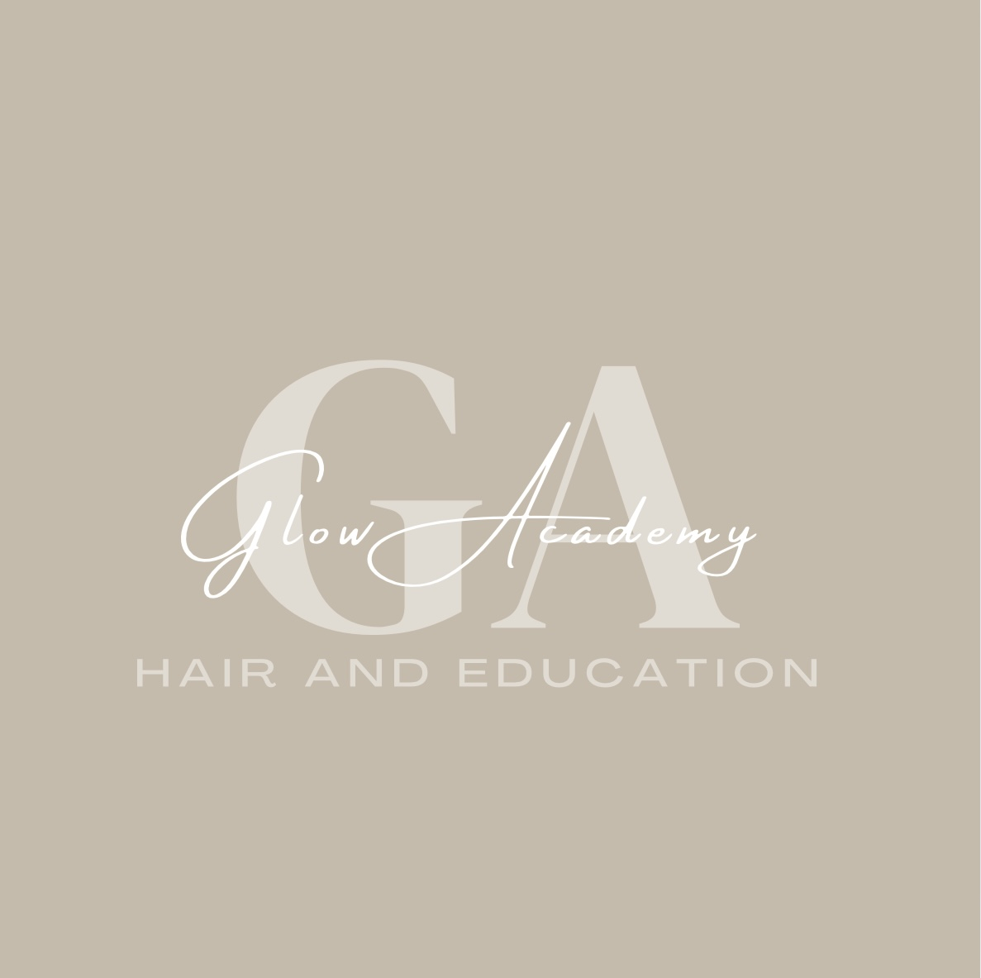

Glow Academy Hair & Education – COSHH Policy

1. Policy Statement
Glow Academy Hair & Education is committed to complying with the Control of Substances Hazardous to Health (COSHH) Regulations 2002 to protect learners, staff, and visitors from risks associated with hazardous substances used in hair and beauty treatments.

2. Aims
- Identify hazardous substances used in the salon.
- Assess and control risks associated with their use.
- Provide training and information to staff and learners.
- Ensure safe storage, handling, and disposal of substances.

3. Responsibilities
The Director is responsible for implementing the COSHH Policy and ensuring compliance.
Staff are responsible for following procedures and reporting hazards.
Learners must follow all safety instructions when using salon products.

4. Hazardous Substances
Hazardous substances in the salon may include hair dyes, bleach, disinfectants, aerosols, and cleaning products. Material Safety Data Sheets (MSDS) will be kept for all products.

5. COSHH Risk Assessments
A COSHH risk assessment will be carried out for all hazardous substances, considering:
- How the substance is used.
- Who may be exposed.
- Possible health effects.
- Control measures to reduce risk.

6. Control Measures
- Use of Personal Protective Equipment (PPE) such as gloves and aprons.
- Adequate ventilation when using volatile substances.
- Safe storage in clearly labelled containers.
- Training for staff and learners on safe use.

7. Training and Information
Staff and learners will receive COSHH awareness training, including reading product labels, understanding hazard symbols, and following safety instructions.

8. Disposal of Substances
Hazardous waste will be disposed of in accordance with manufacturer guidelines and local authority regulations.

9. Monitoring and Review
This policy will be reviewed annually or when new substances are introduced.

