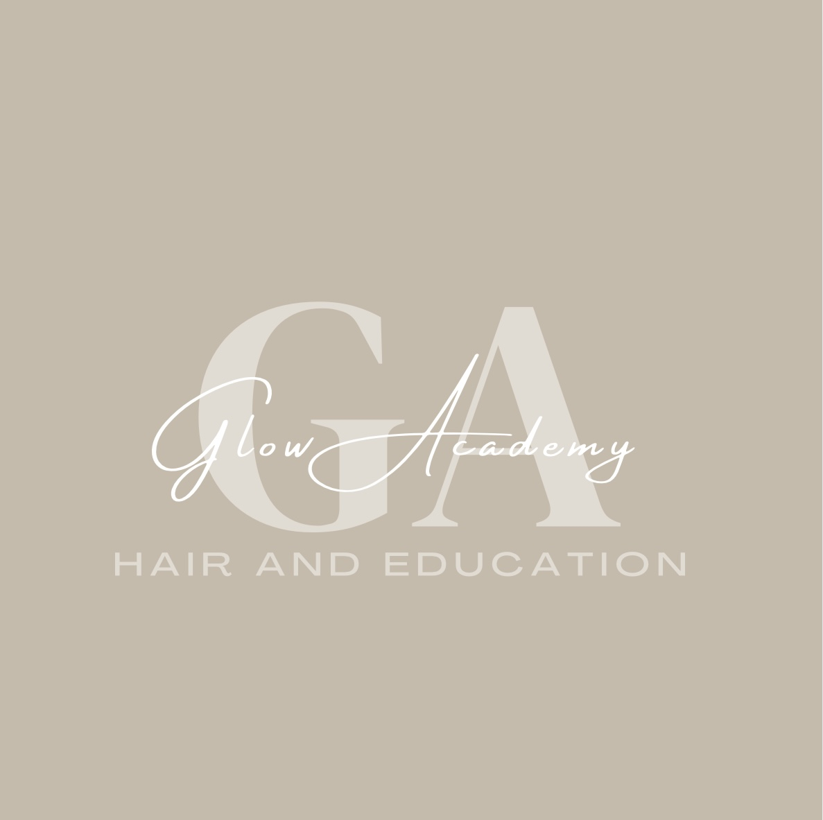

Glow Academy Hair & Education – Behaviour & Positive Relationships Policy

1. Policy Statement
Glow Academy Hair & Education is committed to creating a safe, respectful, and positive learning environment where all learners can thrive. We believe in promoting positive behaviour through mutual respect, clear expectations, and restorative approaches, rather than relying solely on sanctions.

2. Aims
- Promote positive relationships between staff, learners, and peers.
- Encourage learners to take responsibility for their actions.
- Support learners in developing self-regulation and resilience.
- Ensure a consistent approach to behaviour management across the academy.

3. Scope
This policy applies to all learners, staff, volunteers, and visitors within Glow Academy and during off-site activities.

4. Expectations
We expect all members of the Glow Academy community to:
- Treat others with respect and kindness.
- Follow instructions from staff.
- Engage positively in lessons and activities.
- Respect the salon environment and equipment.
- Maintain professional standards appropriate to a working salon.

5. Promoting Positive Behaviour
- Recognising and celebrating achievements.
- Using praise and encouragement.
- Providing clear routines and boundaries.
- Offering restorative conversations to repair relationships.
- Modelling respectful and professional conduct.

6. Managing Unacceptable Behaviour
When behaviour does not meet expectations, staff will:
1. Use de-escalation techniques where possible.
2. Remind learners of expectations and offer choices.
3. Use restorative approaches to address issues.
4. Apply proportionate sanctions if necessary (e.g., temporary removal from activity).

7. SEND Considerations
We recognise that some behaviours may be linked to a learner’s Special Educational Needs or Disabilities (SEND). Staff will adapt their approach, use personalised strategies, and seek advice from the SEND Lead where appropriate.

8. Bullying and Harassment
Glow Academy has a zero-tolerance approach to bullying, harassment, or discrimination. Incidents will be addressed promptly in line with our Anti-Bullying Policy.

9. Partnerships with Parents/Carers
We work closely with parents/carers to support learners in developing positive behaviour and meeting expectations.

10. Monitoring and Review
This policy will be reviewed annually and updated in line with best practice and legislation.

