Prompting Overview
For GPT Thinking Models, there are two schools of thought:
- Steer the AI to build its own context by asking it a pointed question using industry jargon within the field you want the AI to be an expert, such as in the example of mathematics, where the classroom video demonstrated asking about explained partial deferential equations (PDEs), or in the Hands-on exercise for analysis, asking about calculating negative exponentials.

- Use the Meta Prompt, which was found to be effective in the earlier non-thinking versions of LLMs, such as GPT-4.

Steer the AI to Build its own Context:
Example: For Hands-on exercise 7, where you use ChatGPT for analysis, you might start with:
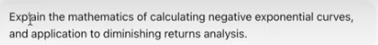

Then, after AI responds, and has built up its context, you feed it the prompt and data:
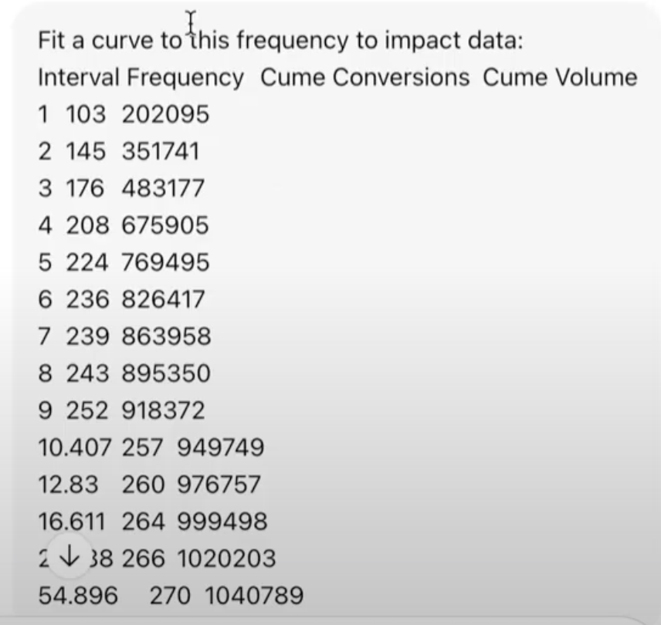

This should produce high quality output without having to create a meta prompt, which can take much longer to craft, and may not perform any better. (In our testing, build up prompts often edge out meta prompts).

Meta Prompt:
- CONTEXT: Condition AI with <context>context</context> increase expertise
- ROLE: Name the expertise the model should simulate
- OBJECTIVE: Make the vague ask specific and testable
- APPROACH: Force a methodology that includes failure-mode thinking
- OUTPUT: Specify format and success criteria the code must pass
- INQUIRY: If uncertain, ask clarifying questions. Do not ask questions just for the sake of asking questions.
- GUARDS: Require validation logic like parse checks and type checks
- EVIDENCE: Ask for a short "why this design" note so you can review choices

Example:
CONTEXT:
Consider this context [insert expert level published academic paper, or section from wikipedia on the technical topic, e.g. “multivariate analysis”, “economics of diminishing returns”, etc].
ROLE:
You are an expert [insert domain, e.g. “senior software architect”, “marketing measurement scientist”, “prompt engineer”].
OBJECTIVE:
Clearly and specifically state the task you want the model to perform (e.g., “Analyze the following campaign performance data and identify the top three drivers of ROI, with supporting rationale and assumptions”).
APPROACH:
Describe the methodology the model should follow, including how it will handle failures or edge cases (e.g., “First identify any missing or inconsistent data; if more than 10% of entries are incomplete, flag anomaly and stop. Then segment by channel, apply frequency to impact response functions, compare to current frequency, and highlight if the campaign is past the point of diminishing returns.”).
OUTPUT:
Specify both the format (table, JSON, bullet list, report) and the success criteria the output must satisfy (e.g., “Provide a table with channels, attribution percentage, confidence score. Success means each channel sums to 100%, confidence ≥ 0.8 for at least two channels”).
INQUIRY:
Consider task, and ask clarifying questions only if needed (e.g. “In this analysis, if you are uncertain about which data features to use, ask questions, but only if you can not make an informed decision on your own.).
GUARDS:
Include validation logic, parse checks and type checks (e.g., “Ensure that attribution percentages are numeric and sum to 100% ± 1%. If any non-numeric value appears, insert error message. Check date fields are valid ISO format. If validation fails, return a structured error object instead of analysis.”).
EVIDENCE:
Provide a short note explaining why this design (approach, output format, validations) was chosen — the reasoning behind your structure (e.g., “This design ensures reproducibility, automates edge-case handling, and produces machine-friendly output for downstream ingestion”).
Example of Bad vs. Good Prompt
Bad | ROLE:  Help me with coding.  OBJECTIVE:  Fix this function.  APPROACH:  Just look at it and fix anything wrong.  OUTPUT:  Give me the corrected version.  GUARDS:  Make sure it works.  EVIDENCE:  Explain briefly.
Why this is bad | - The role is vague; no expertise is defined.  - The objective is not specific or testable.  - The approach has no method, no checkpoints, no failure-mode thinking.  - The output has no structure or success criteria.  - Guards are meaningless without explicit validation requirements.  - Evidence is underspecified and does not reveal design reasoning.

Good | ROLE:  Act as a senior TypeScript engineer who specializes in static analysis, refactoring, and designing robust validation systems.  OBJECTIVE:  Rewrite the provided function so that it correctly parses a user profile object, validates required fields, rejects malformed input, and returns a fully typed result structure. The goal is a version that is testable, deterministic, and free of silent failures.  APPROACH:  Follow this methodology:  - Inspect the input specification and identify potential failure modes such as missing fields, wrong types, unexpected nulls, or structural inconsistencies.  - Define exact validation checks for each field.  - Redesign the function using a stepwise parse-validate-return pattern.  - If any validation fails, return a structured error object with error codes rather than throwing.  - Only then generate the final typed result.  If any part of the problem statement is ambiguous, state the assumption explicitly.  OUTPUT:  Return two objects:  - refactoredCode containing the rewritten TypeScript function.  - testSuite containing at least five test cases in Jest format that check correct behavior, failure modes, and edge cases.  Success criteria:  - Code compiles without warnings.  - All tests pass.  - All validation checks appear explicitly in code.  GUARDS:  Before producing final output, run the following internal checks:  - Ensure all returned fields have explicit TypeScript types.  - Verify validation logic covers: type checking, required fields, null handling, and structural checks.  - Confirm percentages, dates, IDs, or other primitives use correct formats.  - If a guard fails, return a diagnostic object instead of the refactoring.  EVIDENCE:  Provide a short explanation titled “Why this design”, describing design tradeoffs, how failure modes were mitigated, why the chosen structure ensures testability, and how the guards prevent silent failures.

