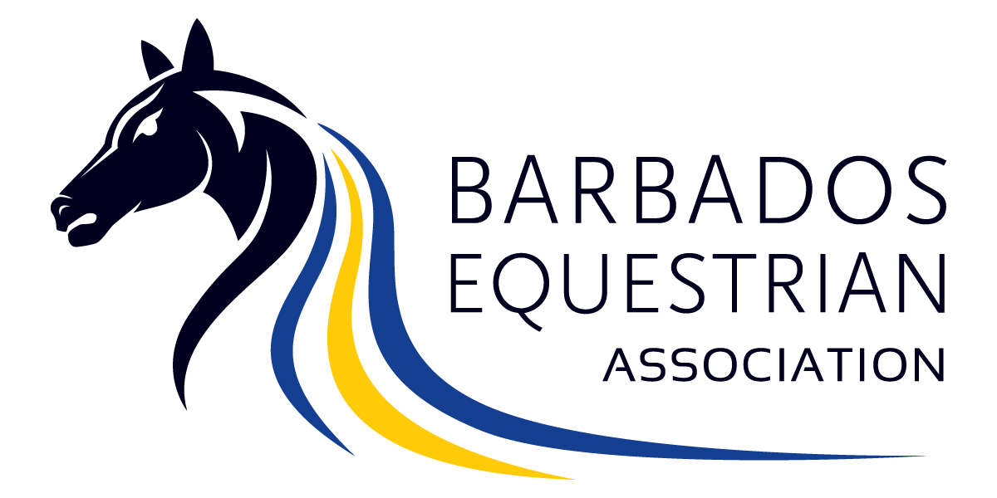

**C/o The Secretary, BEA**

**Barbados Olympic Association Headquarters,**

**Wildey, St Michael,**

**Barbados.**

**barbadosequestrian@gmail.com**

**Annual Waiver form to be completed and signed before competing in your first event for the year 2019.**

NAME OF PARTICIPANT:...............................................................................................................

HOME ADDRESS...............................................................................................................Country............................

TEL: .............................. CELL: ............................. Email: .....................................................................

• Do you or did you have any medical or physical condition/injury or other condition that should be taken into

consideration in case of an emergency. Yes_____ No______

**If YES, please outline briefly:**.............................................................................................................................................................

...........................................................................................................................................................................................

• All riders must wear safety helmets or hard hats while mounted at all times. (The only exception to this rule will be for Dressage riders competing at PSG and above where the FEI allows for the use of Top Hats. It is further acknowledged that these riders do so at their own risk.)

• All riders and participants agree to comply with the FEI’s Code of Conduct & Welfare of the Horse as well as all

instructions given by any Officer, representing the Association, while attending any event held under the auspices of the Barbados Equestrian Association. Breaches of the foregoing will result in disciplinary measures as stated in and Bye law 1 and Article 14, of the constitution.

• The Barbados Equestrian Association reserves the right to refuse or allow participation of any individual and/or horse,

should their behaviour be inconsistent with the FEI’s Code of Conduct & Welfare of the Horse or should any mental or

physical condition deem it unsuitable for them to participate. The Barbados Equestrian Association reserves the right to make such a judgement on behalf of the participant, or alternatively, request a doctor/veterinarian examination, at the expense of the participant, based on which the BEA may make a final decision before allowing participation.

• All persons ride and participate at their own risk. The Barbados Equestrian Association or the property owners of any

venue utilized by the BEA, are not liable for any accident, loss, theft, damage, injury, illness or death, which is suffered by any rider, horse, owner, groom, spectator or participant, cars, their contents and accessories or any other person or property whatsoever, whether caused by their negligence, breach of contract or in any other way whatsoever. Should you be unclear on any matter addressed in this document you are required to clarify such matters before signing this form. Should you require information as to how you may acquire a copy of any document referred to

within this form, it is your responsibility to access such information from the Secretary of the Barbados Equestrian

Association.

I HAVE READ, UNDERSTOOD AND AGREE TO THE FOREGOING.

Signed by: ………………………………………………………………………………… Date: ………………………………………………………

Please print name if signing on behalf of a Minor……………………………………………………………………………………………

Witnessed by an Officer of the BEA: Print Name ……………………………………………………………………………………………

Signature…………………………………………………………………… On behalf of the Barbados Equestrian Association

**Our mission: The Barbados Equestrian Association exists to** *Build, Encourage* **and** *Advance* **the**

**continuing development and progress of Equestrian Sports in Barbados.**