BEA Horse Registration Form
For Horses Based Internationally
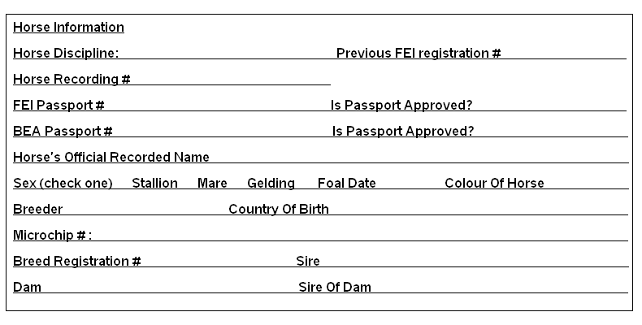
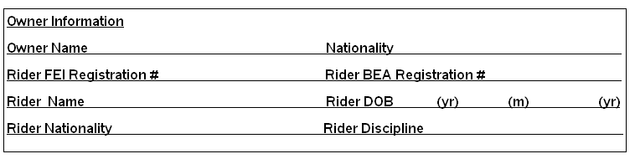
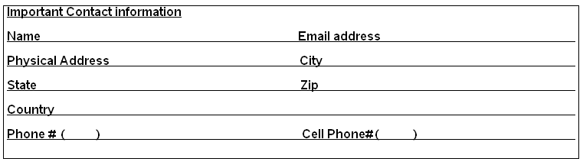
I……………………………………………………………….(OWNER OF HORSE’S SIGNATURE) hereby state that the above information is true and accurate to date.
……………………………….………… ……………………………………………………. ………(d)…………(m)………….(yr)
Rider’s Full Name Riders Signature Date

