About Our Breeds and Herds
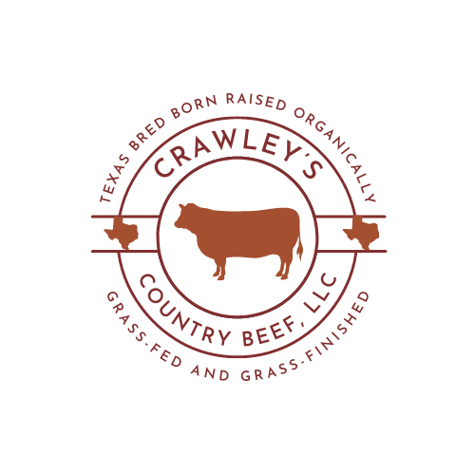
Our herd of cattle originated from registered Red Angus heifers and the son of a registered Red Angus bull that ranked at the top of the red Angus breed for marbling, tenderness and eating quality of meat. This was in 1985 and we have bred our animals to maintain this consistency through the years. In 2015 we decided to add some Red Devon influence into our herd by purchasing a quality bull to breed our cows. Red Devon cattle are known to grow and finish well on grass while producing quality meat. We have not been disappointed. Our calves from this out cross have done well and our customers have agreed. We have since kept an outstanding young bull from our calves to continue the outstanding traits of the Red Angus and Red Devon breeds. We will continue to build a closed herd of cattle, raising all our own heifers and bulls for breeding. While at the same time raising calves to sell for meat to our customers that are raised and finished on grass. Happily grazing the pastures, they were born on.

In 2016 we purchased a few young Dorper sheep to graze our pastures with the cows to eat the weeds the cows do not. The Dorper breed are sheep known for good eating quality. They are easy keepers, which are qualities we ranchers always like. We will continue to grow and maintain a herd of these sheep that like the cattle are raised and finished on grass and weeds only and sell the meat from the male lambs to our customers.

In 2017 we decided to add Kiko goats to our product mix to help keep the brush along the fence lines and other areas of the ranch under control They normally only eat what the cows and sheep don't. We picked the Kiko breed because they too are known to be easy keepers and are more tolerant to worms than other breeds. Plus, there is a growing demand for goat meat, so we decided to jump in and add them to our product mix. We started with a few registered nannies and one registered buck to build the herd. Like the cows and sheep, the only food they get is from the pastures and fence lines on the ranch.

However, there are times in the winter months we supplement cattle, sheep, and goats with quality hay. Sheep and goats will also be fed additional pellet feed during inclement weather when needed.

We strive for and maintain a natural holistic approach to our grazing methods and stick to the natural organic way of life. Our health, land, animals, and business are all held to the same standard.

