General Information
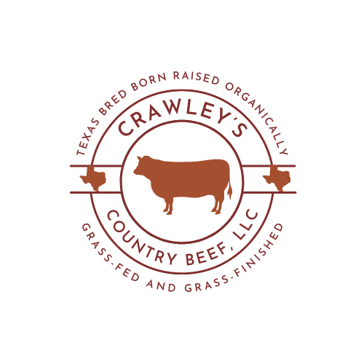

Hours of Operation:
Monday to Friday 8:00 am – 4:00 pm
Saturday: 8:00 am – 12:00 pm
(Shipping done on Tuesday’s)
Contact Information:
Mailing and shipping address:
195 HCR 3373 Hubbard, Tx. 76648
Phone- 254-330-0016
Please leave a message as your call is very important to us. We will return your call as soon as possible.
Email- info@texasbredorganicmeat.com
Denver Crawley Owner & Operator
Shea Norcross office manager

Local Processors:
Huse's Country Meats Southern Custom Meat
3697 State Highway 171 967Wildcat Circle (Gholson)
Malone, TX 76660 Waco, Tx. 76705

Beef: Whole, Side, Family Beef Bundle(1/4), 1/8, Budget Bundle, Value Boxes, and by the CUT
Goat: Whole animal or call for more information
Lamb: Whole animal or call for more information
Payment Options:
Cash, Visa, Master Card through Square

Return & Refund Policy:
We stand behind our products. We want the customer to be completely satisfied. If you are not satisfied with our product, please give us a call.

