Proper Karate Uniform and Belt Wear

The karate uniform is called a gi (pronounced “gee”). It should be a clean, white karate-cut gi and worn correctly at all times to reflect the pride and professionalism of the person wearing it.
Gi pants must be sewn, not cuffed, to a length equal at least ¾ shin length. You may opt for longer; however, pants must never touch the floor or go under the foot.
- Pants have extra material (gusset) sewn into the crotch making the pants affording greater flexibility but adding 3” or more to bottom line. You may roll pants up 1 – 2 times at the waist to lift pants off the floor and adjust for the gusset’s bottom – which can hinder flexibility.
Gi jacket sleeves must be sewn, not cuffed, to a length equal to or between the wrist and ¾ length of forearms. The left front panel (manufacturer’s label on bottom corner) should overlap the right front panel.
- The dojo patch should be displayed on the left breast side over the heart. The word “Warriors” should be parallel to the ground when positioned correctly. Patch exceptions:
  - Athletes who participated in NKF Nationals are permitted to wear the NKF patch
  - No TKC member may teach or workout displaying an IKGA patch due to USA restrictions on use of this logo/patch. Display for ceremony only when permitted
- Female students are required to wear a plain, crew neck (or V-neck if not too low), white tee shirt under their gi jacket at all times; and, male students do not wear shirts
- Illustration below shows how jacket panel crossing should be displayed
The karate belt is called an obi (pronounced “oh-bee”). When one looks at the obi, there is a manufacturer’s label on one side – this is the displayed side (away from the body). The obi encircles the waist once and then directly overlaps itself - creating a look of a single belt width all around with the exception of the knot. Both ends of the obi are display to the front. It is a very old karate tradition to NOT wash the obi. A worn/tattered Black Belt is a symbol of dedication, diligence and tenacity. These illustrations provide good directions on tying your obi:
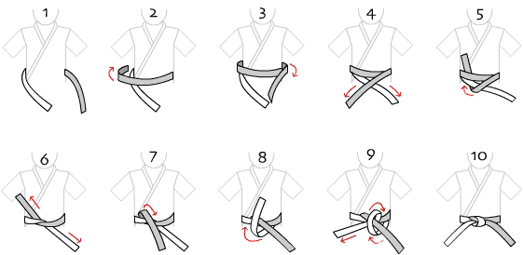
Like learning to tie your shoelaces, it takes practice before you learn how to tie it correctly. TKC instructors will gladly clarify any questions regarding your gi and obi.

