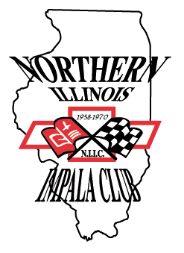
Name _______________________________ Home Phone ___-___-___
Northern Illinois Impala Club – N.I.I.C.
Local Chapter of the National Impala Association

Dedicated to the preservation & restoration of Full Size Chevrolet cars
1958 – 2020 Impala, Super Sport, Caprice, Biscayne, Bel-Air,
Delray, 59-60 El Camino, 58-62 Nomads

Membership Application
Address _____________________________ Work Phone ___-___-___
City _________________ State __________ Zip Code __________
Email address_________________________ Join Group Email? Y N
Current N.I.A. members please list your membership # _____________

Please tell us about your Full Size Chevrolet(s)

Year Model Type Color Engine Trans Rear End

Car 1 ____ _________ _________ _________ _________ _____ ________

Special features _______________________________________________________

Year Model Type Color Engine Trans Rear End

Car 2 ____ _________ _________ _________ _________ _____ ________

Special features _______________________________________________________

If you have more than two Full Size Chevrolets please give details on back of this form.

If you include some pictures of your car(s) with a few words about yourself and them we will include them in the monthly club newsletter “CHEVY CHRONICLES”

Signature_____________________________ Date____/____/____

Include membership fee of $10.00 for calendar year 3/1/22 – 2/28/23

Please mail this membership
For official club use only

Application Received – Date ___/___/___
Treasurer ___________________
Amount Received $________ Ck#__________
Date ___/___/___ Director _______________
Club Identity No. __________________
Reply sent ______ Decal Sent _____ By ______
application along with check
made payable to:

Northern Illinois Impala Club
c/o Randal Merzdorf -Treasurer
19W675 97th Street
Lemont, IL 60439

