Easier Access Project Updates – Christie, Museum & Rosedale Stations
University-Rosedale (Ward 11)

Issued: February 14, 2025

Christie Station Easier Access: Project Update

The elevators are expected to be in service at the end of 2025.
Construction at Christie Station continues as part of TTC’s Easier Access Program, which will make all subway stations accessible.
Work was staged to maintain access to the station and the 126 Christie bus stop within a constrained work site. Lane occupancy at Erlichman Lane is required for construction activities and storage of materials. TTC is renting a portion of the Green P parking lot from the Toronto Parking Authority, with designated spots reserved for adjacent business tenants, whose parking was displaced.
Enabling works in 2022 included moving and upgrading utilities, followed by dewatering in 2023 to safely manage groundwater conditions and facilitate construction. TTC has completed all structural work. The contractor has constructed elevator shafts connecting to the westbound and eastbound platforms. They will begin elevator installation within Q1, 2025. Two of the three upgraded station entry doors are complete, with one set of double swing doors to be installed.
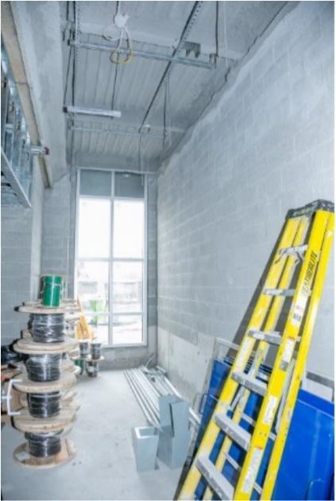
This year's work includes mechanical and electrical upgrades, installing new wall tiles, new ceiling, and terrazzo flooring in the station. Work outside includes restoring the parking lot, laneway, and landscaping around the station.
Once construction is complete, TTC will work with a local artist to install large-scale photographic artwork inside Christie Station.
A public art preview will be held with Councillor Saxe at Christie Station on March 24, from 8 a.m. to 10 a.m.
Caption: Photo shows the interior view of the future elevator lobby connecting street level to the concourse and westbound platform (E1).

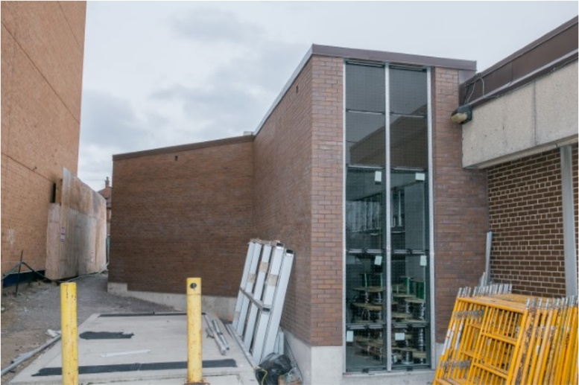
Caption: Exterior view of the westbound elevator lobby.

For more information:
Bethany Wong
Senior Community Liaison
647-459-6426
Bethany.wong@ttc.ca
www.ttc.ca/christieconstruction

Museum Easier Access: Project Update
The elevators are expected to be in service by Q2 2026
Constructing elevators in an active subway station has challenges including a limited work site. At Museum Station, three projects are bundled into a single contract.

The first project to build a new secondary station entrance and exit at the south end of Museum Station was completed in 2024 at Queens Park Circle. The secondary entrance/exit improves customer safety and convenience, and includes bicycle-accessible rails on the new stairwells.

The second part of the project at Museum Station includes rebuilding the concourse level to add two new elevators and other accessibility features. Expansion of the concourse level makes room for the construction of a new staircase and escalator.

To provide construction access to the platform from the Main Entrance and to make room for the elevator, the TTC had to remove the existing staircase and escalator. TTC must maintain the structural integrity of the original subway building while completing full-depth excavation directly adjacent to it. The existing north entrances to Museum Station remain closed to build the new concourse safely. Customers can use the new Queen’s Park Circle entrance as this work continues.

The third part of the project includes significant repairs and adding waterproofing to the subway station roof. Much of this work is directly accessed from street level on Queens Park.

The temporary lane closures on Queens Park have shifted. The southbound bike lanes re-opened late last year. The northbound bike lanes will re-open as soon as it is safe to do so.
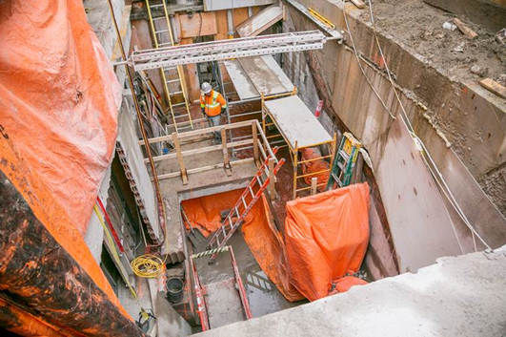
Caption: The picture shows the current construction activities to accommodate the future elevator from the concourse level to the subway platform.

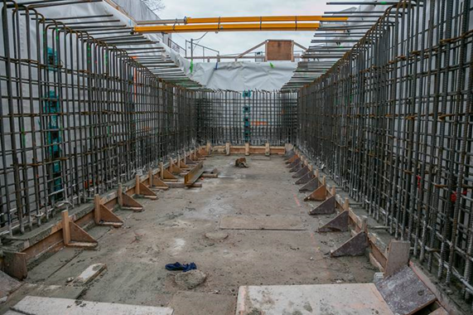
Caption: The picture shows the work on the extension of the concourse level to accommodate a new escalator and staircase.
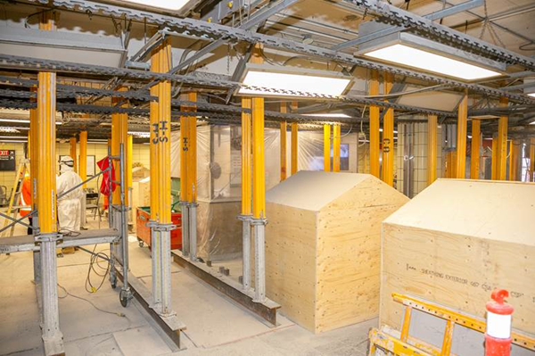
Caption: The picture shows the current work for the rehabilitation of the station’s concrete roof

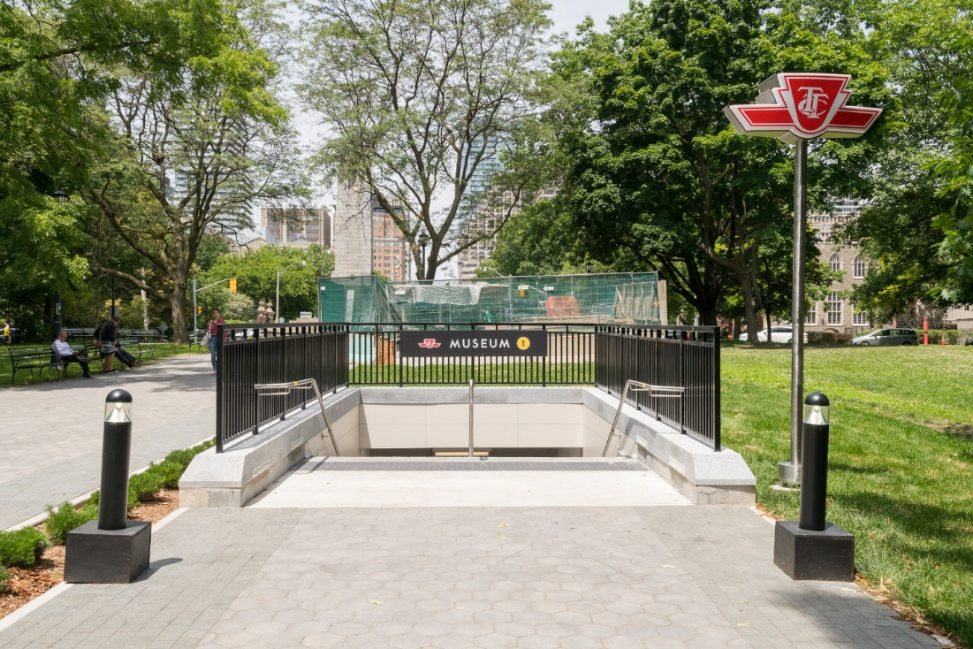
Caption: The picture shows the new secondary entrancy/exit in Queen’s Park
For more information:
Clive Scott
Senior Community Liaison
437-219-5174
clive.scott@ttc.ca
www.ttc.ca/projects

Rosedale Easier Access: Project Update
Elevators are expected to be completed by mid-2025

The work to have a barrier-free path to all levels of Rosedale Station continues. The new features at Rosedale Station will include two elevators, improved signage, and CCTV security cameras.
Many things were considered when determining the location of the elevators:
- maximizing customer convenience by figuring out the shortest path from street level to subway platform and bus terminal
- minimizing construction, community, and ravine impacts and
- ensuring customer safety during construction
The station remains operational during all phases of construction, with access to sidewalks and a path leading to the ravine. The bus service has operated without disruption even as the contractor removed a substantial section of the bus canopy and used the bus loop as a staging area.

In 2022, work on the northbound building presented unique challenges due to the tight space between bridge footings, the existing station, and century-old sewers. Engineers carefully transferred the new building’s loads 50 feet underground, bypassing the sewers and preventing any impact on the bridge’s foundation.
In 2023, much of the structural work was completed first for the southbound building, followed by the northbound building.
In 2024, the architectural façade enclosed the buildings, allowing for the installation of elevator equipment and key electrical and mechanical systems.
This year, the contractor is completing the final architectural finishes to the elevator lobbies. TTC is also in the final stages of testing and commissioning all installed equipment to ensure a safe and seamless experience for TTC customers.

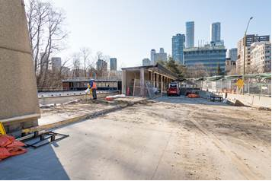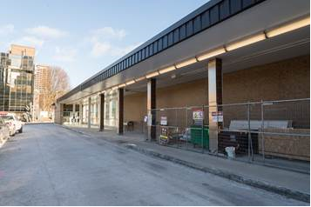
Caption: Pictures showing the old bus canopy demolition and upgrade, to facilitate construction of the southbound elevator shaft/building.
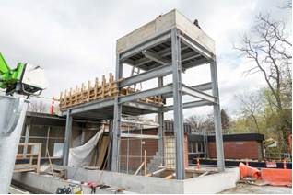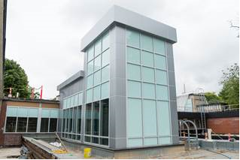
Caption: Exterior view of the elevator for the southbound platform at Rosedale Station.

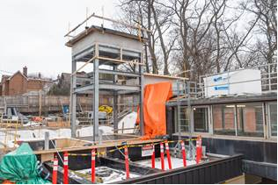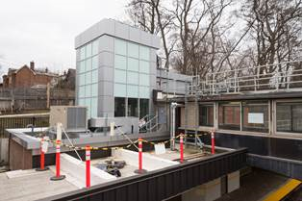
Caption: Exterior view of the elevator for the northbound platform at Rosedale Station.

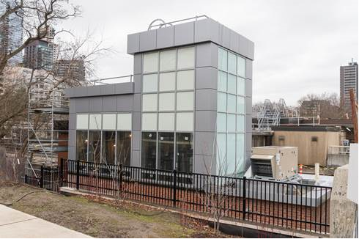
Caption: Exterior view of the elevator for the northbound platform from the Rosedale Ravine.
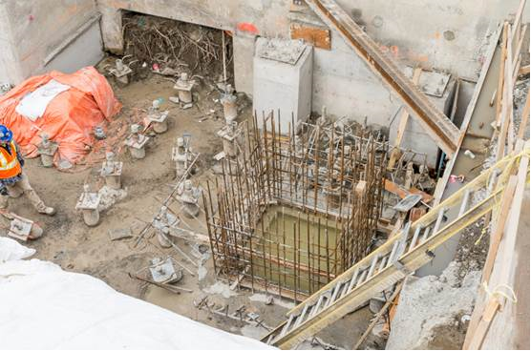
Caption: Elevator pit for the northbound platform.

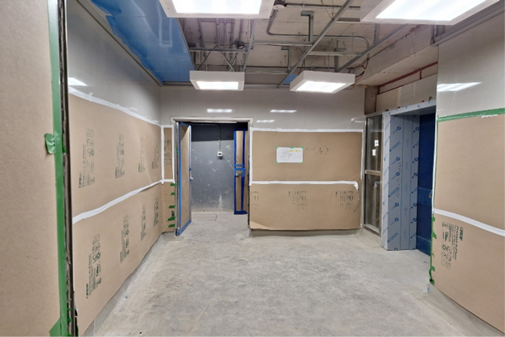
Caption: E1 elevator vestibule on the southbound subway platform. The entrance to the elevator is on the right. The door straight ahead provides access to the mechanical room and the elevator mechanical room beyond.

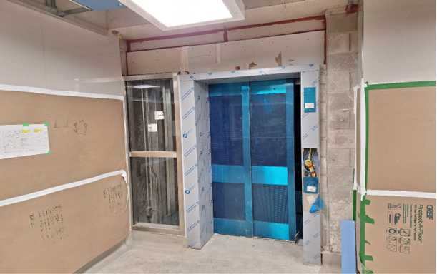
Caption: E1 elevator entrance on the Southbound Platform.

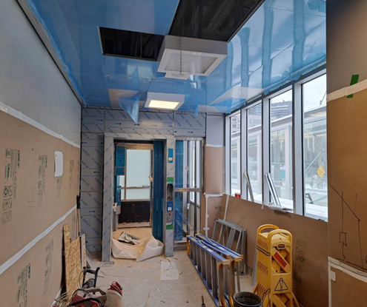
Caption: Street-level E1 elevator vestibule and the elevator entrance leading to the Southbound Platform.

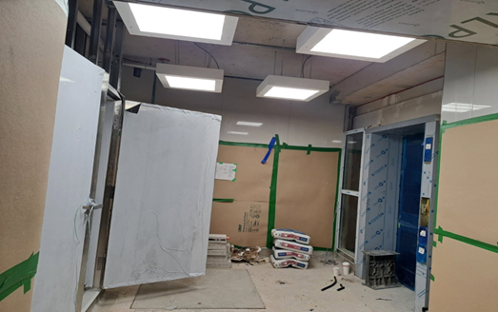
Caption: E2 elevator vestibule on the northbound platform, with the elevator entrance on the right

For more information:
Clive Scott
Senior Community Liaison
437-219-5174
clive.scott@ttc.ca
www.ttc.ca/projects

