Summerhill Easier Access: Project Update
Elevators are expected to be completed by the end of 2025.
Constructing elevators in an active subway station has challenges including a constrained work site. At Summerhill Station, there is limited space to install the elevators and other accessibility features. The lane occupancy on Shaftesbury Avenue is required to safely facilitate construction. The TTC must maintain the structural integrity of the original subway structure while completing full-depth excavation directly adjacent to it. Work must also integrate this new structure with the subway platform and above ground station structure.

The newly opened station entrance was part of the initial construction phase, followed by the north elevator, south elevator and mechanical support rooms. TTC’s contractor has to relocate multiple utilities and is enhancing electrical and mechanical services. There are multiple projects wrapped into one contract.

Structural work underground is now complete for additions on the west and east sides of the station, which include the elevator shafts and connections with the northbound and southbound subway platforms. The east addition (north elevator) is fully integrated with upgraded electrical and mechanical services.

Work continues to build elevator equipment rooms on the west side of Summerhill Station, which will enable elevator installation. The new entrance opened in January 2024 with automatic sliding doors and accessible fare gates.
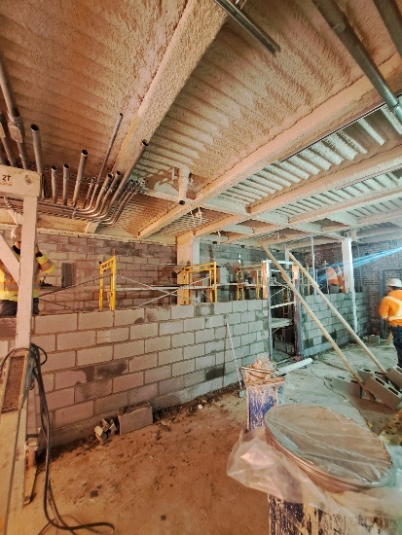

Southbound elevator construction (E2) and support rooms – Summerhill Station
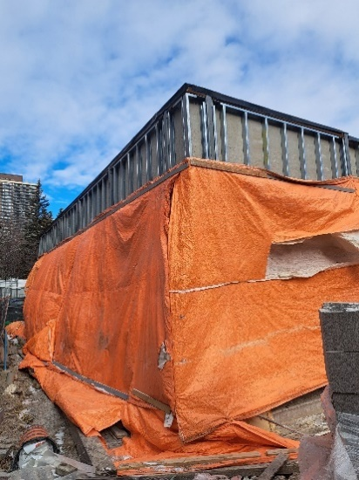

Exterior view of the south elevator (E2) and support rooms - Summerhill Station
For any questions or to receive project updates on Summerhill Easier Access, please contact:
Alexa Aiken
Senior Community Liaison
437-488-5084
alexa.aiken@ttc.ca
www.ttc.ca/projects see: Easier Access Program

Spadina Station Easier Access: Project Update
Elevators are expected to be completed in late 2026.
Prior to beginning accessibility-specific construction, TTC’s contractor had to relocate utilities and corresponding supports to make room to install the elevators and other accessibility features at Spadina Station.
The project has been staged to maintain at least one lane in each direction on Spadina Road. Closure of Lowther Avenue west of Spadina Road and lane occupancy on Spadina Road is required to safely build.
There are many existing buildings and underground structures neighbouring the station that TTC’s contractor must work around. At the street level, construction of the new southbound elevator includes building enclosure walls, these walls provide important fire safety features for elevator occupants. Exterior walls are being constructed for the new accessible pathway to the future elevator (and new stairwell).

Current work inside the station includes installing the new accessible pathway that will connect the concourse level with the southbound subway platform underneath.

Progress on the new northbound elevator includes adding a widened staircase that will connect the concourse level to the elevator. The elevator shaft is built up to the underside of the station roof. Electrical and plumbing infrastructure is being upgraded concurrently throughout the station.

Underground, the TTC has completed a sewer bypass and installed the majority of the new watermain pipes. Behind the construction hoarding, the mechanical and HVAC rooms at the concourse level are complete, as is a new corridor at the concourse level, separating Line 1 and Line 2.

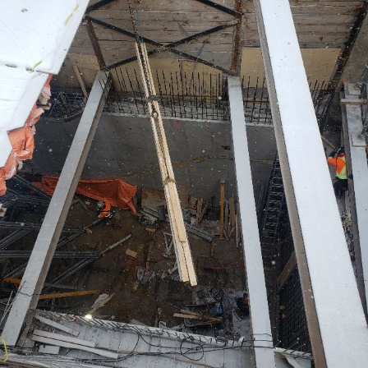

Excavation at Lowther Avenue west of Spadina Road for Elevator 2 (from street level)
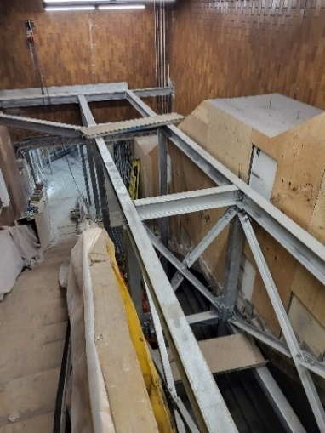

Construction area for Elevator 2 for the southbound platform (from concourse level inside Spadina Station Line 1)

For any questions or to receive project updates for Spadina Station Easier Access, please contact:
Reka Sivarajah, Senior Community Liaison
437-994-6317
Reka.sivarajah@ttc.ca

www.ttc.ca/projects see: Easier Access Program

