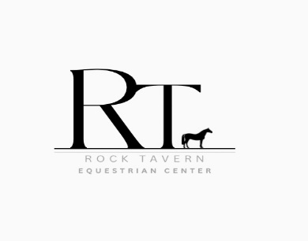Hudson Valley Dressage Show Series  
Hosted By

Rock Tavern Equestrian Center

ENTRY FORM

Show Name Rock Tavern Equestrian Center 2025 Date: Saturday August 9th 2025

Rider’s Name: *_______________________________________________________________________*

Address: *____________________________________________________________________________*

Email: *_____________________________________* Phone #: *____ - _________________________*

*(required) (required)*

Junior Rider DOB: *______________* Adult Amateur DOB:______*________* Open Rider: ____________

Horse’s Name: *____________________________* DOB:*________* Breed:_*_______________*

Horse Owner’s Name: *______________________­____________________________________________*

Horse Owner’s Address*:_________________________________________________________________*

Horse Owner’s Email: *________________________________ /* Phone #: *____ - ____________________*

Barn Name: ________________________ Trailer: 2-Horse ____ / 3-Horse ____ / 4-Horse ____ / 6-Horse ____

Judge: Regina Cristo  
**Cost Per Class: $35.00 / Cost Per Championship Class $55.00**

***Entries must be received by August 4th, 2025***

|  |  |  |
| --- | --- | --- |
| **Class # *(Limit: Two Tests Per Rider)*** | **Class Name** | **Total** |
|  |  | **$________** |
|  |  | **$________** |
|  | **Office /EMT Fee** | **$30.00** |
|  | **TOTAL** | **$________** |

**Entries Must Be AccompaniedBy a Negative Coggins / Proof of Vaccinations and Payment.**

**Enter Via:or**

* Mail: Rock Tavern Equestrian Center,1679 Little Britain Road, Rock Tavern, NY 12575

**Forms of Payment:**

* Cash / Check / Zelle (RockTavernEquestrian@Gmail.com)*i*(please add $7.00 electronic processing fee)

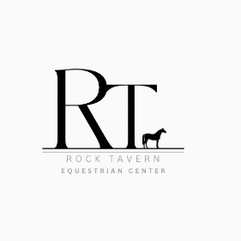

Rock Tavern Equestrian Center

Release Form  
(One Form Per Participating Rider)

I __________________________, as show exhibitor (or guardian of rider) am aware of the inherent risks associated with horseback riding and acknowledge that I am riding at my own risk. I hereby assume this risk and further do release and hold harmless and indemnify Rock Tavern Equestrian Center and its owners, organizers, judges, and officials, their officers, agents, employees, and volunteers, the host of this event or horse show, and the owners of any property on which the event or show is being held, from all liability for negligence or any responsibility for accidents, damage, injury or illness to myself, owners, lessee, trainers, handlers, riders, grooms, employees, attendants, spectators, or any other person or property whatsoever including the horse or horses which I will compete at this event or show.

By entering and signing all forms I agree to the above statement.

If I am a parent or guardian of a junior exhibitor, I consent to the minor’s participation and agree to the above statement.

Rider’s Signature ____________________________________ Date ___________________

Parent /Guardian Signature ___________________________ Date ___________________

(if exhibitor is a minor)

Owner’s Signature ___________________________________ Date ___________________