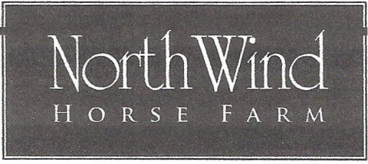
2496 Bruysnwick Road, Wallkill NY 12589
September 19, 2021
HudsonValleyDressageShows.com
North Wind Horse Farm DRESSAGE SHOW ENTRY FORM
Judge: Krystal Wilt L with Distinction
Rider’s Name: __________________________________ USDF #:____________________________

Address: _____________________________________________________________________________

Email: _____________________________________ Phone: ____ - ___________________________
(required)
Rider Date of Birth _______________________ Junior/ Senior

Horse’s Name: _______________________ DOB:________ Breed:_______________ USDF #:______

Owner’s Name: _________________________________ USDF #: ____________________________
Owner’s Address:______________________________________________Email___________________

Cost Per Class: $30.00
Office Fee: $10.00

Class # | Class Name |  | Total
 |  |  | $________
 |  |  | $________
 |  |  | $_________
 |  |  | $________
 |  | Office Fee | $10.00
 |  | Total
Entries Must Be Accompanied With Payment To: North Wind Horse Farm
2496Bruynswick Rd., Wallkill, NY 12589 or emailed to: nwhf@frontiernet.net
(payment must be received within five (5) days of receipt of email entry)
To avoid late fee Entries must be received by September 12, 2021 “USDF Regional Schooling Show Awards Program Participating Competition”

