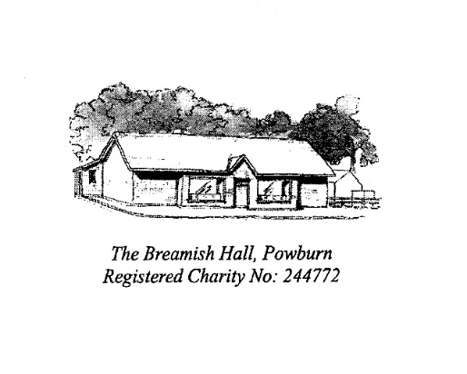
APPLICATION TO HIRE THE BREAMISH VILLAGE HALL, POWBURN

Name of Organisation/Organiser
Purpose of the hire (party, meeting, fund raiser, etc)
Name of contact person
Email Address
Phone Number | Day |  | Evening
Booking Info | One off/Regular (please delete as applicable). If regular please provide frequency:
Date of Booking
Time of Booking
Will the hall be used for commercial purposes? (ie for profit) | Yes/No (please delete as applicable)
Is the organisation insured for the proposed activity? | Yes/No (please delete as applicable)
If Yes – name of insurer & amount of public liability
Insurance Policy No (if applicable)
Does the organisation work with under 18s | Yes/No (please delete as applicable)
If Yes – do those people leading the activity have the appropriate checks in place, ie DBS checked. | Yes/No (please delete as applicable)
Do you require the use of the kitchen for catering? | Yes/No (please delete as applicable)  If yes, there will be an additional £10 charge
Will alcohol be consumed and by what arrangements? | Yes/No (please delete as applicable)  If yes please complete below:  Bring your own/pay bar (please delete as applicable)  If you are having pay bar, you must apply to Northumberland County Council for a Temporary Events Notice. We will require sight of the notice prior to the event going ahead.
Do you require use of stage? | Yes/No (please delete as applicable)  If yes, thre wil be additional £7 charge for the putting up the stage
Do you require wifi access?  Wifi code displayed in hall | Yes/No (please delete as applicable)

Please note, that while the Trustees of The Breamish Village Hall make every effort to ensure the safety of all who use its premises, your organisation will be solely responsible for premises, equipment, personnel and its activities during the period of your booking.

I have read and agree to abide by the Condition of Hire (please retain a copy)
Signed: | Date:

HIRE CHARGES
Individual/one-off booking/Organisations | £12.00 per hour
Regular users | £7.00 per hour
Party booking (ie use of both halls) | Please contact Julia Simpson
Use of kitchen for catering purposes  (ie use of oven, dishwasher, etc) | £10 one-off charge per event
Putting up/dismantling of stage | £7 one-off charge

Please return completed form to:
Email: breamishhall@gmail.com

Post: 1 South Hedgeley
Powburn
Alnwick
NE66 4HS

