Natural Pathways Massage Therapy, LLC
Client Intake Form

Today’s Date __________ Name____________________________________________ Date of Birth___________

Street Address___________________________________________City_________________State___ Zip_______

Email Address__________________________________________ OK to contact you via Email? Yes No

Cell# ____________________________Home#_________________________ Work#_______________________

Referred By ________________________ □ I Have a Current Doctor’s RX for Massage

Why Are You Seeking a Massage? ________________________________________________________________

What will help ensure your comfort level during the session? ____________________________________________

Are You Sensitive to Aromas, Scents, Lotions, Creams, Chemicals, or Other…(explain)____________Yes No
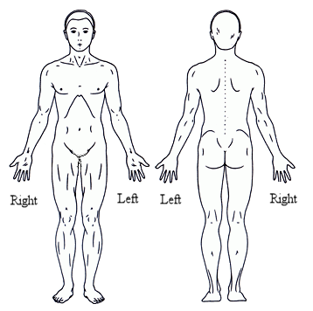
Please Circle Areas
Of Discomfort:
FRONT BACK

PLEASE LIST YOUR MEDICAL HISTORY INCLUDE DATES & TREATMENTS FOR:

Illnesses/Diseases, Surgeries, Injuries, Medications

Spinal Injuries/Surgeries/Diagnoses_________________________________________________________________________
Other Injuries or Surgeries?________________________________________________________________________________
Bone Breaks/Fractures/Falls_______________________________________________________________________________
Heart Conditions/Surgeries________________________________________________________________________________
Other Diagnoses or Issues________________________________________________________________________________
Other Unexplained Symptoms or Issues______________________________________________________________________
________________________________________________________________________________________________________________
Respiratory/Breathing Issues_______________________________________________________________________________
Blood Pressure High Low Fibro Myalgia Chronic Fatigue Anxiety Fatigue Sleep Issues_______________________
Numbness, Tingling, Weakness in any part(s) of your body?______________________________________________________
Cancer(s)____________________________________________________________________________________________________________________________________________________________________________________________________
Are you Currently Receiving (or Have Had) Chemotherapy? Radiation? If Yes to either, describe the course(s) (Dates)________________________________________________________________________________________________Last Treatment Date_____________________________________________________________________________________
Lymph Nodes Removed? ____________________Reconstructive Surgeries_________________________________________
Please List All Medications and Purposes____________________________________________________________________
______________________________________________________________________________________________________
______________________________________________________________________________________________________
Are you Pregnant? Y N What Trimester?____________ Due date______________

PLEASE READ AND SIGN BELOW: Massage and Bodywork therapy practices are designed to promote and maintain the health and well-being of the client. Massage and Bodywork therapies do not include the diagnosis of illness, disease, impairment or disability. If I experience any pain or discomfort during this session, I will immediately inform the therapist so that the pressure and or/manipulations may be adjusted to my level of comfort. Because massage and bodywork therapy may be contraindicated due to certain medical conditions, I affirm that I have informed the therapist of all my known medical conditions and will keep the therapist updated as to any changes in my medical condition.

Client Signature_____________________________________________________________________________Date__________________
Parental Consent: . I am a legal guardian/parent for this child. I am giving my consent to Beth Campbell to apply therapeutic massage techniques for the purposes and manner described above. I have provided my child’s complete medical history. I understand that it is customary for me to remain present during the session.
Child’s Name _____________________________Parental Signature_____________________________________ Date______________

