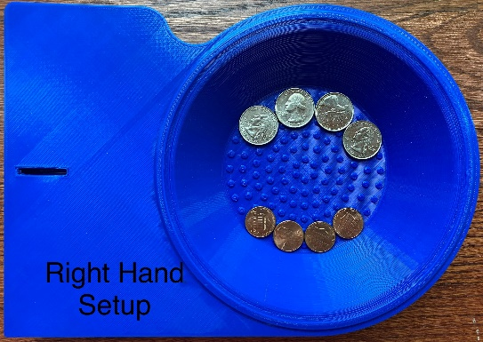
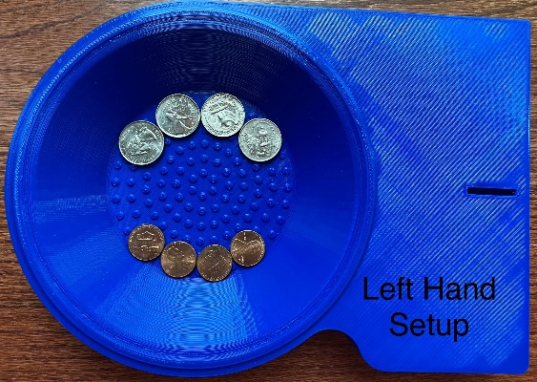

Instructions to the Test Administrator

- The test involves a C-QHFT board, four quarters, and four pennies (one additional penny and a quarter are provided if the coin lands on the floor and is difficult to retrieve during the test).
- Clients are comfortably seated in a chair, and the kit is placed in front of the clients on a table of appropriate height.
- Position the kit so that the bowl is closer to the testing hand and the slot is closer to the non-testing hand. The middle of the kit should be aligned with the midline of the clients. Each side of the kit has a yellow marker in the middle to help position the kit in the middle of the clients. The yellow marker should align with the client's midline.
- Place four quarters towards the top of the bowl, four pennies towards the bottom, and one extra quarter and penny on the table towards the bowl.
- The test starts with the dominant hand first.
- Each cue earns one penalty point (one cue = one second).
- Each coin drop from the palm or fingers earns one penalty point. (one coin drop = one second).
- If a corrective cue is given during the coin drop, it accounts for two penalty points: one for the coin drop and another for the corrective cue.
- The administrator provides the prompts needed to perform the test accurately. Cues count is based on the action, not the number of words or sentences used during the cueing. Normally, cues are required if the client a) picks up the wrong coin, b) does not move the picked-up coin to the palm, c) places the wrong coin in the slot, and uses another hand to maneuver the coin. The administrator keeps count of corrective cues/prompts provided to the client. Encouraging cues provided, such as you are doing good, that is right, etc., are not accounted for in the penalty point.
- The administrator keeps count of the # of times the coins fall out of the palm or fingers. If the coin drops in the bowl, it is still counted as a drop.
- Total Raw Score = Time it takes to complete the task + # of corrective cues required to complete the task + # of times the coin falls out of hand/fingers using the qualitative assessment, and the administrator notes down the deficits.
- Noted deficits are used for intervention or documentation purposes only. It does not account for the final score.
  - Grasp
  - Release
  - IHM
    - Finger-to-palm translation
    - Stabilization
    - Palm-to-finger translation
  - Dexterity
  - Coordination
  - Motor speed
  - Cognitive skills
    - Attention
    - Memory
    - Difficulty following directions
    - Any other cognitive challenges
- The administrator demonstrates the test to the client:
  - Pick up a quarter and roll it into your palm.
  - While holding the quarter in your palm, pick up a penny.
  - Roll the penny into your palm and shift the quarter to your fingertips.
  - Place the quarter into the slot.
  - Repeat steps 1-4, alternating placement of quarters and pennies in the slots.
  - C-QHFT Demonstration Video
- One practice trial with each hand to be tested is mandatory.
- If needed, the administrator clears up client doubts before the test begins.

Instructions provided by the Test Administrator to the Client
- The objective is to alternately pick up quarters and pennies with one hand, switch them in the palm, and place the coins into the slot until all eight coins are successfully placed as quickly as possible, as demonstrated by me.
- You earn penalty points when the administrator provides cues and prompts during the test if the test is not performed as instructed.
- You also earn penalty points when the coin drops from the palm or fingers.
- You pick up the dropped coin if it is within your reach with the same hand and continue with the test.
- If it falls outside your reach, I will pick up the coin for you, and you will continue with extra coins that are kept on the table for such events.
- Use the hand being tested to maneuver the coins.
- Hold the kit with a non-testing hand to stabilize the Board if needed.
- The timer starts when you touch the first quarter and ends when you place the last coin in the slot.
- I will demonstrate the test for you.
- Ask me if you have questions before you start the test.

