
Nationwide Mutual Insurance Company
1100 Locust St., Dept 2006 Des Moines, IA 50391-2006

Application for Fidelity Coverage
For an ERISA Pension or Welfare Plan
For Bonds $500,000 or Under

Agency Code 76569
Agency Name: A.A. Dority Company, Inc. (617) 523-2935 www.aadority.com
Agency Address: 226 Lowell Street, Suite B-4; Wilmington, MA 01887

- List Name of PLAN(s) exactly as reported to the Internal Revenue Service on the Annual Return, Form 5500

Mailing Address:

- Amount of Bond $:
($500,000 or under)
Per ERISA Guidelines, the applicant is required to obtain a bond for just 10% of the plan assets, not exceeding $500,000
Nationwide Surety & Fidelity will adhere to this guideline while also giving your plan room to grow

- Effective Date of Coverage:

- Term of Bond: Circle one: 1yr 2 yr 3 yr 4 yr 5yr

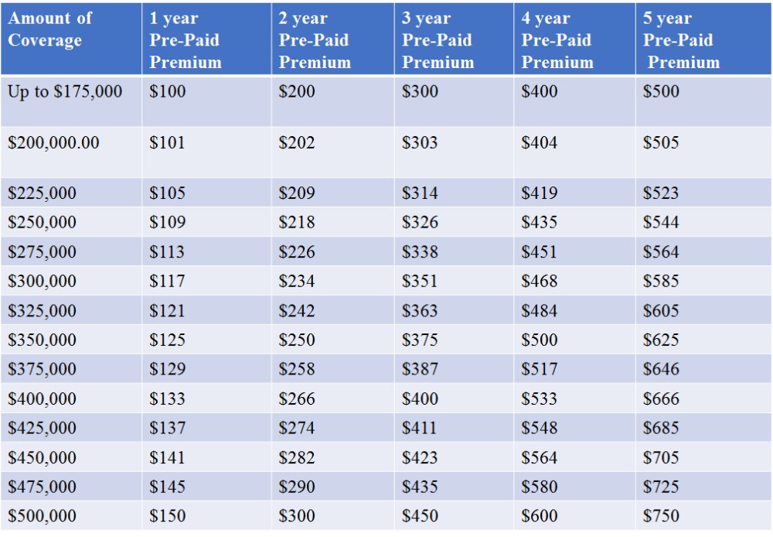

Application BDJ 93 required for bonds above $500,000
BDJ 94 (12/07) 18

