**2022-2023 Dress Code**

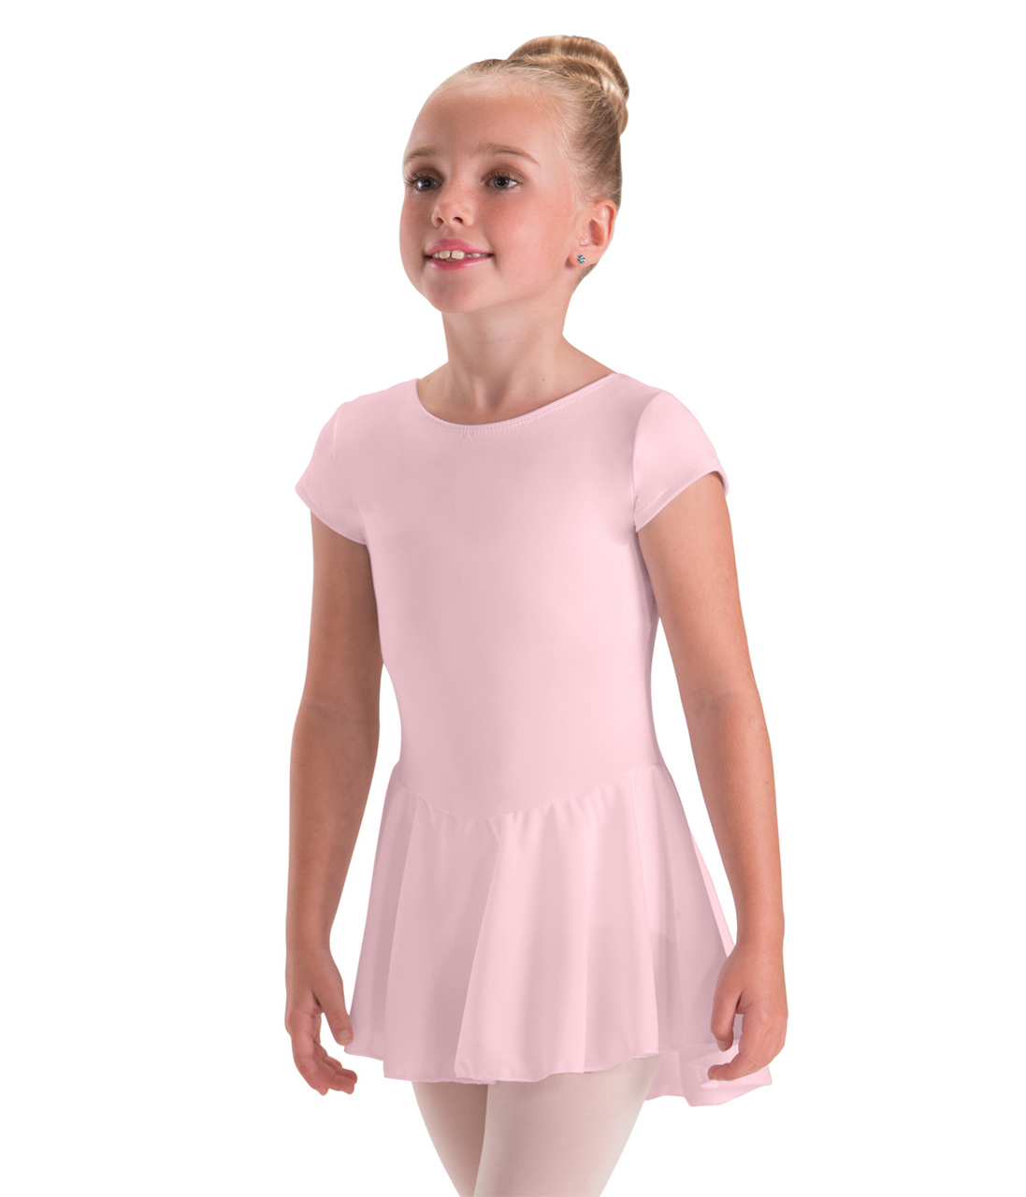

**Play Dance**

* Pink Short-Sleeve Leotard with sewn on skirt

*Suggested Brand:* Basic Moves:BM5492G

* Pink Ballet Shoes
* Pink Socks (not tights)
* Black Tap Shoes

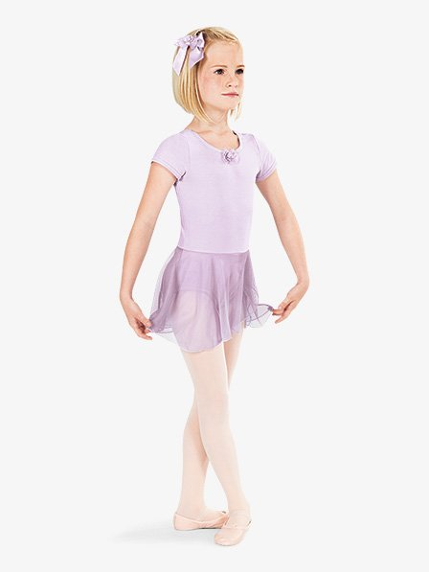

**Pre-Ballet**

* Lavender Short-Sleeve Leotard with sewn on skirt

*Suggested Brand:* Basic Moves:BM5492G

* Pink Ballet Shoes
* Pink Socks (not tights)
* Black Tap Shoes

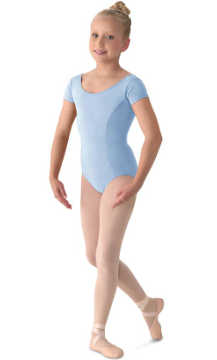

**Pre-Primary**

* **Light Blue** Cap Sleeve Leotard with Matching Skirt
* Pink ballet shoes
* 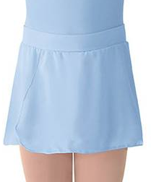Pink Socks (or tights)
* Black Tap Shoes

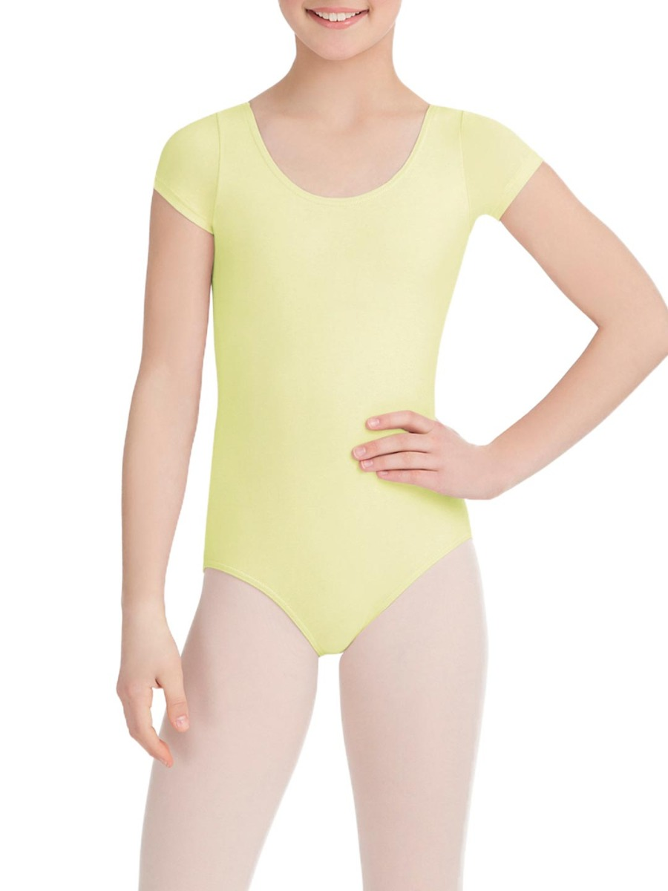**Primary**

* **Light Yellow** Cap Sleeve Leotard with Matching Skirt
* Pink ballet shoes
* Pink Socks (or tights)
* 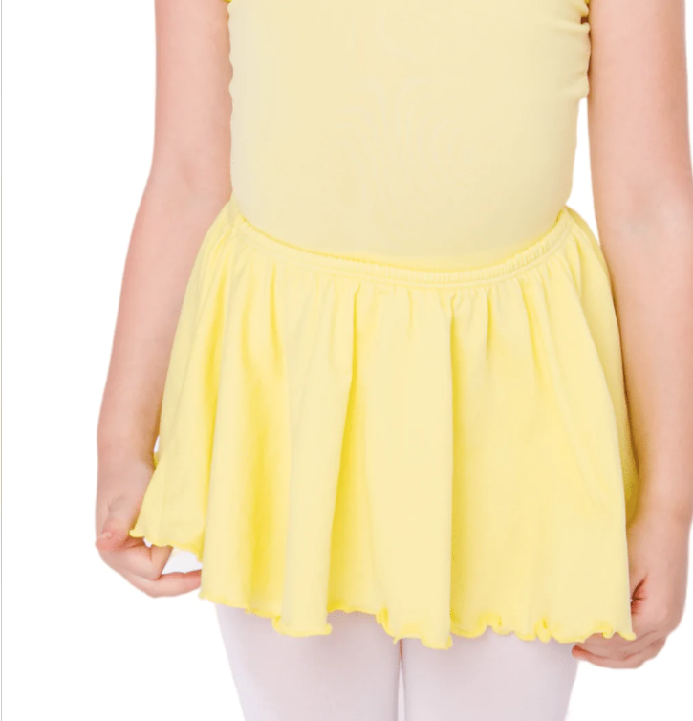Black Tap Shoes

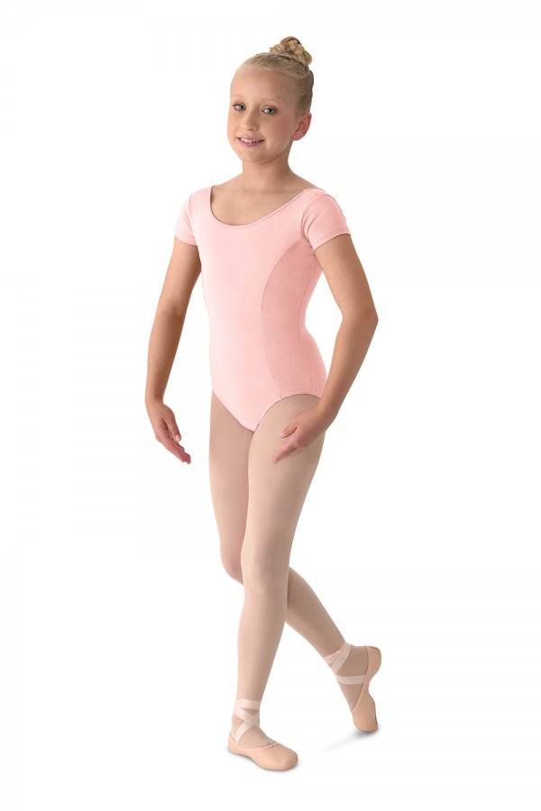

**Ballet 1**

* **Light Pink** Cap Sleeve Leotard

*Suggested Brand: Mirella M515C*

* Matching Belt and scrunchie
* Pink ballet shoes and pink tights
* Pink tights

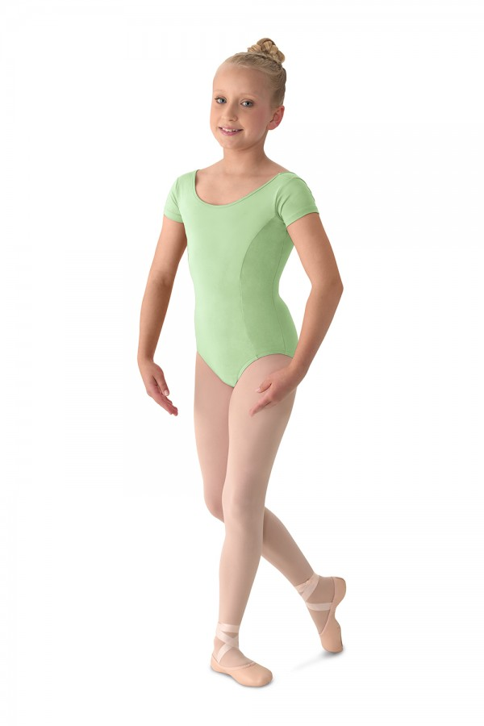

**Ballet 2**

* **Seafoam** Cap Sleeve Leotard

*Suggested Brand: Mirella M515C*

* Matching belt and scrunchie
* Pink ballet shoes and pink tights

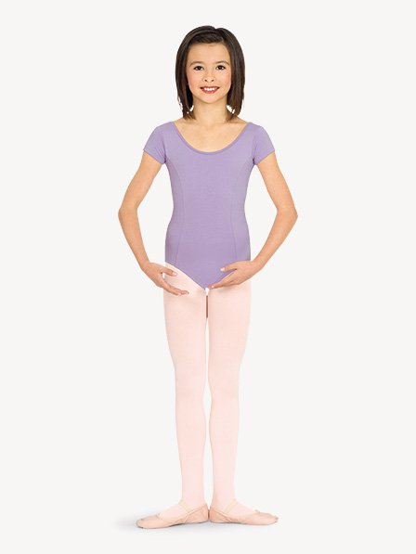**Ballet 3**

* **Lilac** Cap Sleeve Leotard

*Suggested Brand: Mirella M515C*

* Matching belt and scrunchie
* Pink ballet shoes and pink tights

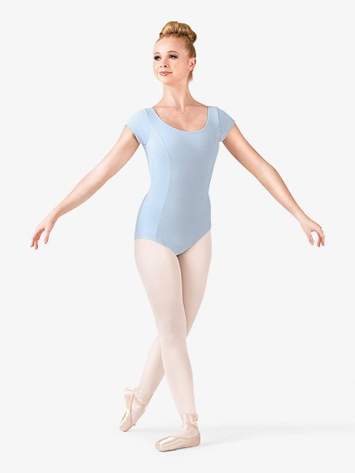

**Ballet 4**

* **Light Blue** Cap Sleeve Leotard

*Suggested Brand: Mirella M515C*

* Matching Belt and scrunchie
* Pink ballet shoes and tights

apezio_Princess_Tank_Leotard_Girls_Royal_CC202C


**Ballet 4**  **+**

* **Royal Blue** Cap Sleeve Leotard

*Suggested Brand: Capezio CC202*

* Matching Belt and scrunchie
* Pink ballet shoes and tights

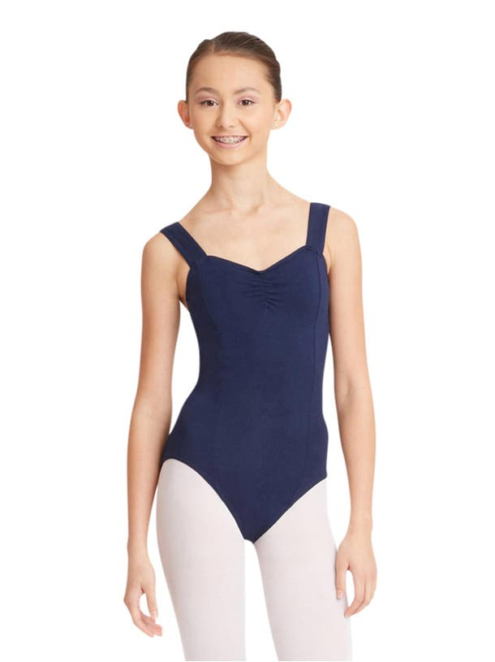

**Ballet 5**

* **Navy** Leotard with Matching Belt

*THEATRICALS N5501 / N5501C*

* Matching belt
* Pink ballet shoes and pink tights
* Pointe Shoes

**Jewel Tone Levels**

* Any style **Black** Leotard
* Pointe Shoes
* Pink ballet shoes and tights

**Boys Dress Code**

**Play Dance, Pre-Ballet, Pre-Primary and Primary**

* Black shorts
* White fitted Shirt
* White Shoes, white socks

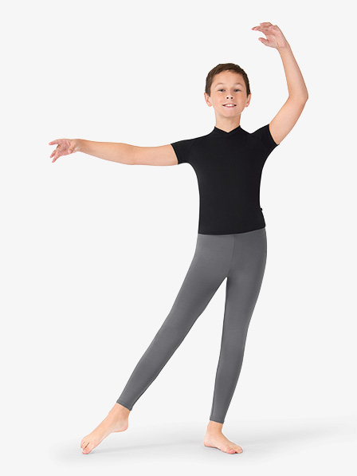

**Ballet 1, Ballet 2, Ballet 3, Ballet 4, Ballet 5**

* Grey Tights
* Black fitted Shirt
* Black Shoes, Black socks

*Grey/Charcoal dance legging*

**Contemporary**

Shoes: Lyrical shoes, split soles, half-soles

*Some examples:*

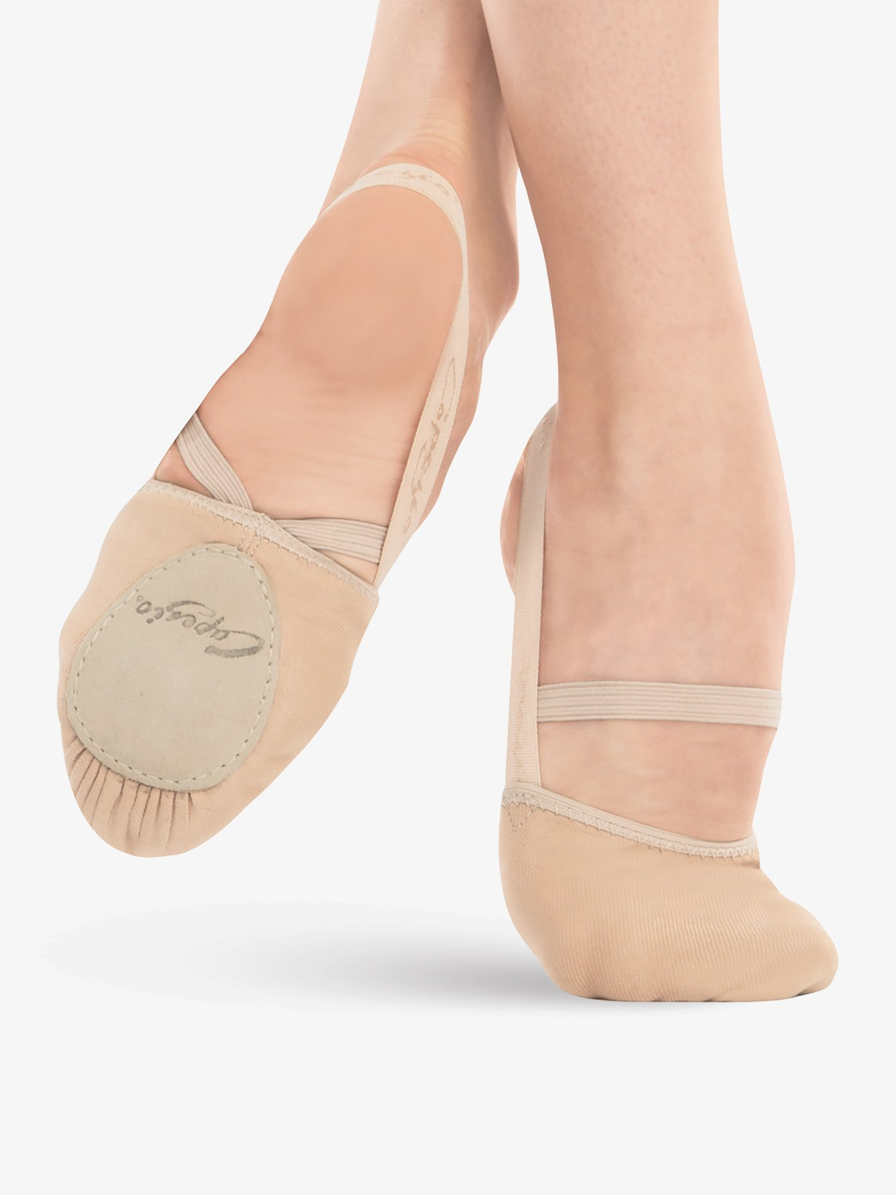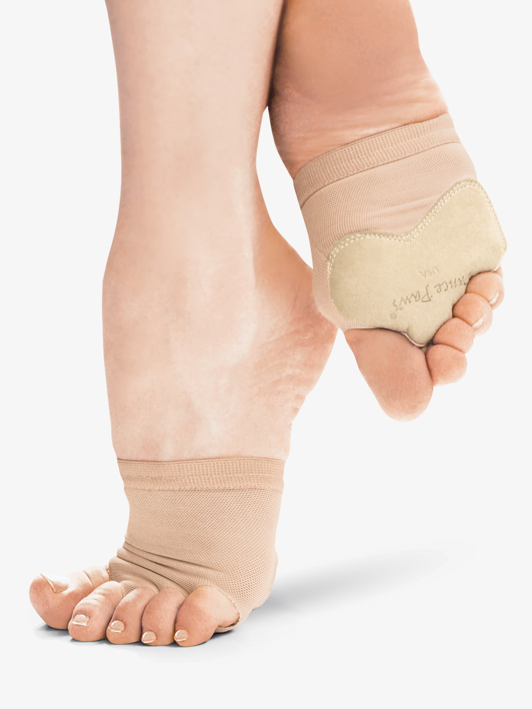

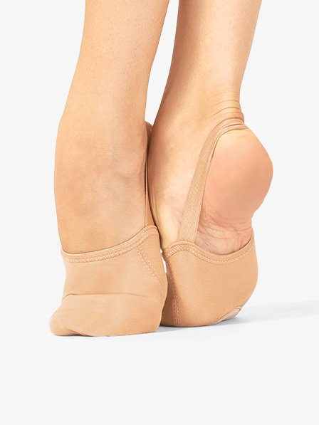

**Tap**

Comfortable clothing & black tap shoes

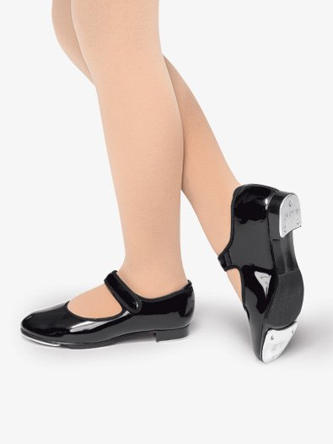

**Jazz**

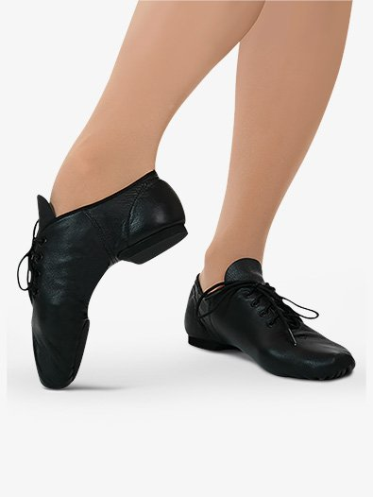Comfortable clothing & black Jazz shoes

**Ballroom**

Comfortable clothing

*Suggested Shoes*

Ballroom dance shoes : 1.5- 2inch heel

Cuban or Latin heel

**Recommended Stores:**

-Shelly’s

2089 Westwood Blvd. Los Angeles, CA 90025

P: (310)475-1400

-The Dance Store

2509 South Robertson Blvd. Los Angeles, CA 90034

P: (310)271-3664

Tel:(310) 979-9929

[www.WLADance.com](http://www.WLADance.com)

[Admin@wladance.com](mailto:Admin@wladance.com)