Payment & Cancellation Policy
- Confirmation of class placement will only made once full payment has been made.
- Please be aware that classes and gift vouchers are non-refundable unless cancelled by Simply Sourdough.
- Cancellations received more than 14+ days of your booked class are entitled to reschedule to another class, a refund will not be given.
- Cancellations made 14 days & less of class date are non-refundable and non-transferable to another date unless spot can be filled from waiting list.
Want to send someone in your place? No problem – just let me know your friends name and contact details by either email, messaging or phoning through the details.
- If you cancel a class that has been booked using a gift voucher, the same terms and conditions as above will apply.
- It is extremely unlikely however in the unlikely event that a class is cancelled or re scheduled by Simply Sourdough, a future class date will be offered and a refund made if alternative dates don’t suit.
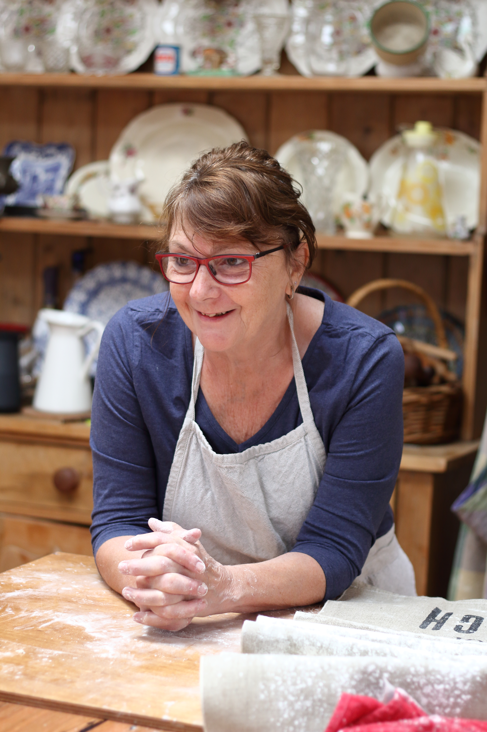
Follow me on Instagram @simply_sourdough or like my Facebook Simply Sourdough Page

