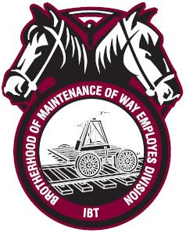
(Your Federation) Local Lodge (000)
Brotherhood of Maintenance of Way Employes Division International Brotherhood of Teamsters

