
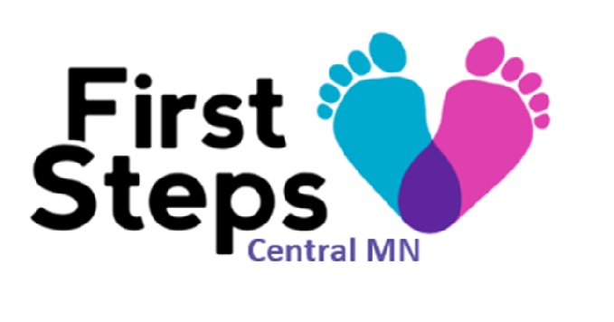
First Steps Central MN Community Advisory Committee Meeting
Monday, July 26, 2021 1:30p-2:30p Via Zoom
Attendees (Agency):

AGENDA ITEM | TIME | NOTES | FOLLOW UP NEEDED
Welcome & Member Updates  - Name  - Agency represented  - Updates from your agency | 30
First Steps Central MN Updates  - Transition to MECSH-what this means for clients and our teams  - Next steps for our collaborative and this Committee | 15
Other | 15

