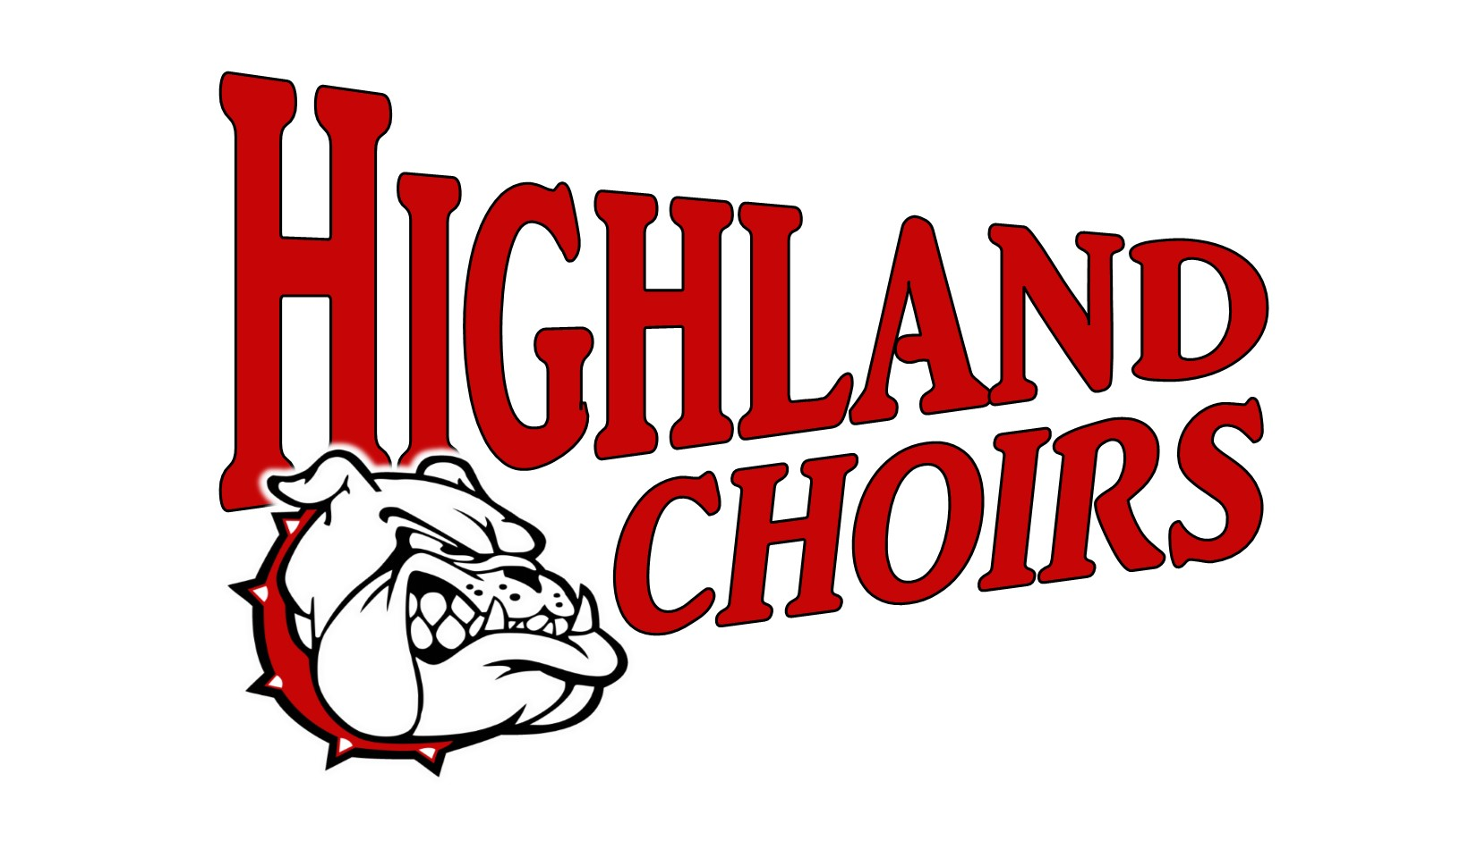

HIGHLAND HIGH SCHOOL CHOIR
STUDENT HANDBOOK
2026-2027

Ms. Shannon Miller
Choral Director

School Phone: (618) 654-7131 ext. 4167 Email: swesselmann@highlandcusd5.org

Mission Statement
The Mission of the Highland Choral Department is to create well-rounded student-musicians through an inclusive, comprehensive, and multifaceted choral program dedicated to achieving excellence.

HHS Choral Ensembles

A cappella Choir - A cappella Choir is an auditioned ensemble of around 40 students. This ensemble performs at multiple concerts throughout the year. Students in this ensemble also have the opportunity to audition and participate in the ILMEA District and All State Festivals.
Concert Attire: Black dress clothes, choir robes for contest/festivals.

Madrigal Singers - Madrigal Singers are an auditioned ensemble of around 20 students. This ensemble performs at the Kansas City Renaissance Festival annually, as well as at prestigious events in the St. Louis area. The Madrigal Singers are an integral part of the HHS Madrigal Dinner each year. They also perform multiple times in the Highland Community.
Concert Attire: Renaissance costumes, black dress clothes.

Chamber Choir - Chamber Choir is an auditioned ensemble of around 20 students. This ensemble performs at the Kansas City Renaissance Festival annually and is an integral part of the HHS Madrigal Dinner each year. They also perform out in the Highland Community.
Concert Attire: Renaissance costumes, black dress clothes.

Mixed Choir - Mixed Choir is open to all students at HHS and does not require an audition. This ensemble is currently around 20 students and performs at multiple concerts throughout the school year.
Concert Attire: Black dress clothes.

Jazz Choir - Entitled "Dissonance" the Highland High School Jazz Choir is an auditioned ensemble that rehearses weekly after school. This ensemble consists of around 30 students and performs at concerts in Highland and travels to competitions. Jazz Choir is directed by David Wilton.
Concert Attire: Jazz Choir Costumes
Choral Department Expectations

Self-discipline is an important element of choir rehearsal and performance. Students in the choral program represent themselves, the program, the school, and the Highland Community. All students in the choral program will be held to a high standard of behavior and decision making.

Choir Room

- Follow all student handbook rules
- Treat teacher and all peers with respect
- Follow directions the first time they are given
- Do not chew gum or consume food/drinks in the choir room.
Water is allowed.
- Be in place with appropriate materials when class begins
- Show respect for all property
- Phones are in phone pouch during rehearsals, school policy will be enforced

Consequences

Any student who does not follow the stated routines, expectations, and boundaries may
receive any of the following consequences:

Verbal warning
Change of seating
Reduction in grade
Director/Student meeting
Parent phone call/email
Meeting with guidance counselor
Loss of choral field trip privileges
Temporary removal from classroom activity
Office referral
Meeting with Principal/Director/Student/Guardians
Other appropriate consequences

There is a zero tolerance policy for the use of E-Cigarettes/Tobacco, Alcohol, and any illegal drugs. Please refer to the Highland High School Code of Conduct. If drugs or alcohol are discovered on a trip the proper authorities will be notified and the student will be sent home on their own/parents expense.
Class Supplies

Pencil – Students should have a sharpened pencil at the beginning of each
class. Since choral music is used for many years, markings in the music must not
be permanent.

Choral Music – Students will be provided with choral music belonging to the HHS Choral Department. They are responsible for all copies of music, just as they are responsible for textbooks in other classes. All music is turned in at the end of the year. Any lost or damaged music must be paid for by the student ($3 per piece of music). Students are encouraged to take home music for practicing purposes.

Black Binder – Students will need a black binder for select concert performances. It is recommended that they use this as their daily music binder so they are prepared come concert time.

Grading Policy

Performances – 100 pts each (35%)
Necessary Attire and Materials – 30 pts
Concert Etiquette – 20 pts
Participation – 50 pts

Individual Assessments – Points vary per assignment (15%)
Written Assignments
Vocal Evaluations
Sight Reading Assignments
Music Theory Assignments

Rehearsals (50%)
In-school rehearsals – 10 pts each
Materials (music, pencil, etc.) – 5 pts
Participation (ex: phone put away, not distracting others, listening/singing) – 5 pts
After-school rehearsals – 25 pts each
Materials (music, pencil, etc.) – 10 pts
Participation (ex: phone put away, not distracting others, listening/singing) – 15 pts

*Note: Music folders/binders must be put away in folder cabinets or taken home, not left on top of cabinets or in seats. Any music found not properly put away may result in a 1pt in-school rehearsal deduction.
Attendance Policy

Attendance at after school rehearsals is required. Any conflicts must be communicated to Ms. Miller (swesselmann@highlandcusd5.org) no less than 48 hours prior to the rehearsal. The schedule for the year has been communicated to students and is on the choir website. Missing rehearsals or not communicating a conflict in time can result in a reduction of the students grade. Most conflicts can be worked out with proper notice.

Attendance at concerts and performances is required. The schedule for the year has been given to the students and is on the choir website.

Excused absences require at least 48 hours notice for rehearsals
and two week’s notice for performances.

Excused Absences are…

- An excused illness from school. A parent note, email, or voicemail is required, for performances, to ensure that the director notes the excused absence.

- A personal problem explained with a parental note and authorized by the director at least 48 hours prior to the event.

- An emergency problem that cannot be addressed before the event. This must be explained with a parental note or email the day following the scheduled event.

- Another school or “once in a lifetime” event that has been approved by Ms. Miller at least a week prior to the performance.

Students with an excused absence from a performance will be given a short assignment to receive the points for their performance grade.

Unexcused Absences are…

- Failure to attend a scheduled event with no explanation.

- Non-school related activities/events, including work.

- Family vacations or trips that are not an emergency.

These absences cannot be made up and
the student will receive a 0 for the performance.
Tardiness to after school rehearsals and events will have a negative impact upon a student’s grade. Choir members are expected to be in place, ready to participate at the scheduled time. Students arriving late will immediately be docked three (3) points. If a student is more than ten (10) minutes late, participation points will be deducted in proportion to the amount of missed rehearsal time.

In the event a change or addition is made to a scheduled performance or rehearsal, students are encouraged to make every effort to adapt to that change. If ample notice of the change (2 weeks) is not possible, the policy on absence will be adjusted accordingly.

At the directors’ discretion, students may be pulled from a performance for any of the following reasons: (Each of these negatively affects the entire ensemble.)
- Student does not have complete, presentable costume/attire
- Student does not know their music
- Student has behavior infractions
- Student does not have their music when required
- Student fails to complete and return forms/information
- Student is unprepared due to an extended absence
- Student has missed a practice prior to a performance

If a student is excluded from a performance, the effect on their grade for that performance will be discussed with the student on a case-by-case basis.

Concert Attire

A cappella Choir -
Black dress clothes, choir robes for contests/festivals.

Madrigal Singers -
Renaissance costumes, black dress clothes. (Most Madrigal costumes are provided by the student. There are some that can be checked out from the high school costume closet.) All costumes must be approved!

Chamber Singers -
Renaissance costumes, black dress clothes. (Chamber costumes can be checked out from the high school costume closet or provided by the student.) All costumes must be approved!

Mixed Choir -
Black dress clothes.
Please sign and return this form by Friday, August 21, 2026.
*This is an assignment for a grade*

I have read the Highland High School Choir Handbook and agree to comply with the rules and regulations as outlined in this document throughout my involvement in the Highland High School Choir Program. It is my understanding that I will be subject to consequences as a result of my actions, and I accept this responsibility.

Student Name (please print): ________________________________________

Student Signature: ________________________________________ Date: ________________

I, the parent/guardian of the above-named student, have read the rules and regulations outlined in this document and understand the responsibilities and possible penalties of any violations to these policies.

Parent/Guardian Name (please print): ______________________________________

Parent/Guardian Signature: ___________________________________ Date: _______________

Parent/Guardian Email: _________________________________________________________

