|  |  |  |
| --- | --- | --- |
| Redbacks Dress 2021.pngPLAYING DRESS  **$70** | PLAYING SINGLET  **$40** | A picture containing text, clothing, underpants  Description automatically generated  PLAYING SHORTS  **$40** |
| Training Shirt.pngTRAINING SHIRT  **$40** | UMPIRE SHIRT  **$40** | Supporter Polo.pngSUPPORTER POLO  **$40** |
| Hoodie 2021.pngHOODIE  **$60** | Hoodie 2021.png  JACKET  **$65** | BIKE SHORTS  **$30** |
| Ankle sock.pngANKLE SOCKS  **$15** | Crew sock.pngCREW SOCKS  **$15** | SUN  VISOR  **$10** |
| BACKPACK  **$35** | SCARF  **$25** |  |

**ORDER FORM**

|  |  |  |  |  |  |  |
| --- | --- | --- | --- | --- | --- | --- |
| **Player Name(s):** | | | **Player DOB:** | | | |
| **Email Address:** | | | | | | |
| **Contact Phone Number:** | | | **Date Ordered:** | | | |
|  | | | | | | |
| **ITEMS** | **SIZE** | **QUANTITY** | | | **PRICE** | **AMOUNT TO PAY** |
| PLAYING DRESS |  |  | | | $70 |  |
| PLAYING SINGLET |  |  | | | $40 |  |
| PLAYING SHORTS |  |  | | | $40 |  |
| BIKE SHORTS (limited stock) |  |  | | | $30 |  |
| TRAINING SHIRT |  |  | | | $40 |  |
| UMPIRE SHIRT |  |  | | | $40 |  |
| SUPPORTER POLO SHIRT |  |  | | | $40 |  |
| CLUB HOODIE |  |  | | | $60 |  |
| CLUB JACKET |  |  | | | $65 |  |
| ANKLE SOCKS |  |  | | | $15 |  |
| CREW SOCKS |  |  | | | $15 |  |
| BACKPACK |  |  | | | $35 |  |
| SCARF |  |  | | | $25 |  |
|  | | | | | | |
| **TOTAL AMOUNT DUE TO BE PAID** | | | | **$** | | |

|  |  |  |  |  |  |  |  |  |  |  |
| --- | --- | --- | --- | --- | --- | --- | --- | --- | --- | --- |
| **METHOD OF PAYMENT** | | | | | * DIRECT DEBIT | | * CREDIT CARD | | | |
|  | | | | | | | | | | |
| ***DIRECT DEBIT DETAILS*** | | | | BSB: 062-640 ACCOUNT NO: 1026 0403 | | | | | | |
| Date Paid: | |  | | | | Receipt No. | | |  | |
| Payment Description: | | |  | | | | | | | |
|  | | | | | | | | | | |
| ***CREDIT CARD PAYMENT*** | | | | * Master card | | | | * Visa | | |
| *Card Details* | **Name on card:** | | | | | | | | | **Exp date:** |
| **Card No:** | | | | | | | | | **CVC:** |

Thank you for your order.

**PLEASE EMAIL YOUR COMPLETED ORDER FORM TO:**[**brncuniforms@gmail.com**](mailto:brncuniforms@gmail.com)

*Please note, BRNC do not keep a large stock of uniforms and order from our suppliers when we receive orders. We will be in contact once your order arrives to arrange pick 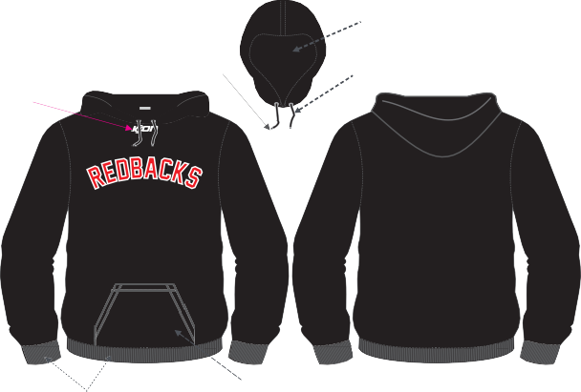 up/delivery.*

**SIZING CHART**

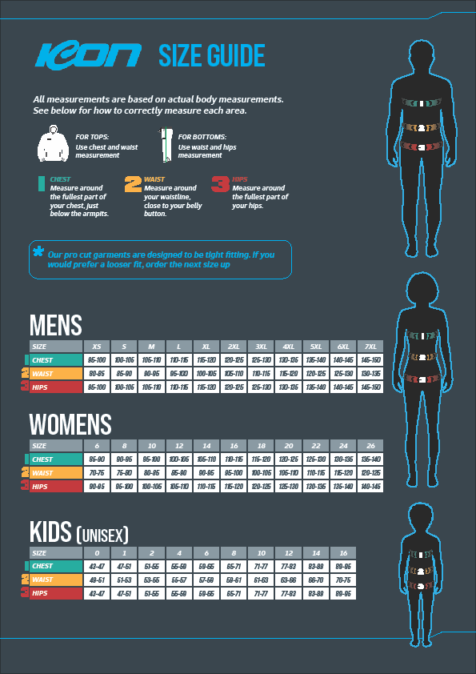

|  |  |  |  |  |
| --- | --- | --- | --- | --- |
| **Sock Size Guide** | | | | |
| *Size* | XS | S | M | L |
| *Shoe size* | 12-2 | 3-5 | 6-8 | 9-11 |