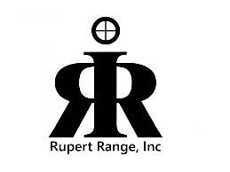Rupert Range, Inc.

A 501C-3 Corporation

Rupert, Idaho

Minutes of the

Rupert Range Board Meeting

Held July 9, 2025

Minutes of the Rupert Range Board, held at the Freedom Hall, July 9, 2025, at 7:00 p.m.

Board members present: Jeff Heins, Mel Snyder, Milt Banner, Elliott Owen, and Tina Morris.

Additional attendees: Lori Harrison, Nikki West, Morgan West, Mark Harrison.

Call to order 7:00p.m.

Pledge and invocation.

Approvals: Motion to approve minutes from June 2025, and financial report, unanimously approved.

Chairman’s Comment: Jeff read a thank you card received from the Mini Cassia Chamber.

Officer’s Report: Milt Discussed the 4th of July parade in Rupert. The parade in Burley is the 18th of August.

Committee Chair Report: Our 1st recipient of the Rupert Range scholarship is Cody Carslon, a very impressive young man. He was awarded $500.

Old Business:

The rope on the flagpole at the road, is fixed.

Tactical Games: they are planning on coming back, working on a 200 yd range with the city.

4H had 60 hours of volunteer time picking up brass. The total for the brass was divided up between 4H and the range.

Lori Harrison along with Nikki West, from the Mountain Maker’s 4H Club, discussed the youth range.

Discussion was had on the Zombie Shoot.

501c3, it is still in progress

New Business:

Adjourn 20:23