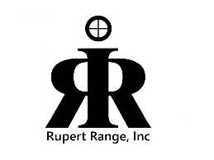Rupert Range, Inc.

A 501C-3 Corporation

Rupert, Idaho

Minutes of the

Rupert Range Board Meeting

Held February 12, 2025.

Minutes of the Rupert Range Board, held at the City Hall, February 12, 2025, at 7:00 p.m.

Board members present: Jeff Heins, Mel Snyder, Milt Banner, Elliott Owen, Tina Morris.

Additional attendees: Jeff Weinstock

Call to order 7:00p.m.

Pledge and invocation.

Approvals: Motion to approve minutes from January 8, 2025, and financial report, unanimously approved.

Committee Chair Report: Discussed the grants we applied for, youth range, target stands and RR ties needing to be protected by steel. A hazmat placard is needed on the storage building. (propane)

Insurance for RSO’s, and USCCA partnership, in progress.

501c3 is still being looked at.

Annual RSO training dates: Feb. 15th at 10:30am, March 26th at 6pm and April 7th at 6pm. Location to be emailed to attendees who RSVP to the secretary.

Discussion on SOP’s will be tabled to April.

Discussion on the scholarship; Mel will update info as needed, two scholarships to be given out. It was suggested to go to the shooting instructors for advertising, not the school counselors.

Discussion on finding and updating the red binder for emergencies.

Adjourned at 20:03.