REVIEW OF Open Spaces
Consideration of the open spaces within the plan area, and whether they should be given special protection through the Coldean Neighbourhood Development Plan.
PUBLISHED: 28 May 2023
BY: COLDEAN NEIGHBOURHOOD PLANNING FORUM

INTRODUCTION
  - Open and green spaces within the neighbourhood plan area are important and significant features valued by the community.
  - A Community Consultation was undertaken by the Coldean Neighbourhood Plan Forum (From hereon referred to as “the Forum”) comprising two consultation events on the 10th November 2022 and 11th November 2022. The aim of this consultation was for the community to identify what the key issues are that affect Coldean, and to prioritize these issues. The natural environment emerged as a high priority and was referenced in 23 responses (26%) and placed in either rank 1 or rank 2 by 25% of all participants across both events.
  - In response to this, members of the Forum have prepared this document as a means of identifying Local Green Spaces and Local Community Spaces that are considered important enough to be afforded a level of protection in the Neighbourhood Plan. This is so that they are preserved for current and future residents of the parish.
  - The document will be used to inform the Coldean Neighbourhood Plan which will set planning policies to be used in determining planning applications. The Neighbourhood Plan will need to be in conformity with national policy, in general conformity with Brighton City Council’s development plan and meet the aspirations of the community.
  - The Forum has identified a way in which it may seek to protect Local Green Spaces within Coldean from inappropriate development, through the allocation of Local Green Spaces. This is a designation provided for by the National Planning Policy Framework (NPPF).
  - Paragraph 101 of the NPPF states that ‘The designation of land as Local Green Space through local and neighbourhood plans allows communities to identify and protect green areas of particular importance to them’. Once designated, Local Green Spaces have protection consistent to that of Green Belt, but otherwise there are no new restrictions or obligations on landowners.
  - The Local Green Space designation is the greatest level of protection that could be afforded to spaces through the Neighbourhood Plan, but it should be noted that this designation will only be appropriate for the most important green areas or open spaces within Coldean.
  - Where spaces do not meet all of the criteria for designation as a Local Green Space, but are still valued by the community, they may be designated as a Local Community Space offering some protection from inappropriate development.
  - The designations that are considered in this document are:
Designation | About
Local green space | A designation set out in the National Planning Policy Framework and is a way to provide special protection against development for green areas of particular importance to local communities. Can only be designated where the area is demonstrably special to the local community. Once designated as a Local Green Space, an area has protection consistent with that of Green Belt, but otherwise there are no new restrictions or obligations on landowners.  The Local Green Space designation will not be appropriate for most green areas or open space. The designation should only be used:  - where the green space is in reasonably close proximity to the community it serves;  - where the green area is demonstrably special to a local community and holds a particular local significance, for example because of its beauty, historic significance, recreational value (including as a playing field), tranquillity or richness of its wildlife; and  - where the green area concerned is local in character and is not an extensive tract of land.
Local Community Space | Whilst not a designation set out in the National Planning Policy Framework, communities are able to designate Local Community Spaces that do not meet the criteria for designation as a Local Green Space, but are still special to the local community and warrant some protection through a neighbourhood plan.  Whilst these spaces are not protected to the same degree as Local Green Space, they may still be protected from inappropriate development that would usually diminish the public benefit that these spaces provide.

METHODOLOGY
  - This section will set out a methodology for how Local Green Spaces and Local Community Spaces were identified, assessed and validated.

Identification of Spaces
  - Coldean is predominantly urban in nature but there are a number of undeveloped spaces that could be designated as Local Green Spaces or Local Community Spaces within the Neighbourhood Plan.
  - Sites were identified through the initial community consultation and Open Forum meetings. In these meetings, residents were able to identify and discuss with the Forum sites of ecological value or value to the community that could warrant protection.
  - The Forum also identified additional sites that they thought could be assessed in this report and could potentially be designated as Local Green Space or Local Community Space, including Green Verges.
  - The Forum decided that these Green Verges would not warrant protection under Local Green Space or Local Community Space and were therefore omitted from the assessment. The Forum acknowledges that these Green Verges are important for the character of the plan area and will explore options for their protection through the neighbourhood plan. The Green Verges have been mapped and can be viewed in APPENDIX 2 – COLDEAN OPEN SPACES MAP,
  - The remaining sites were then ready for assessment.

Assessment
  - All identified areas were assessed against each of the below criteria. The criteria are based on NPPF paragraph 102 which states:
‘The Local Green Space designations should only be used where the green space is:
- in reasonable proximity to the community, it serves.
- demonstrably species to a local community and holds a particular local significance, for example because of its beauty, historic significance, recreational value (including as a play field), tranquility of richness of its wildlife; and
- local in character and is not an extensive tract of land.
  - If the site was considered to meet a criteria, then it is marked as such. The criteria considered for the assessment were:
- Reasonably close proximity to the community it serves.
- Holds particular local and special significance.
- The area is local in character and is not an extensive tract of land.
- The area is actively used by the community.
  - Where a space meets all of the above criteria, it can then be designated as a Local Green Space in the Neighbourhood Plan.
  - Where a space met criteria 1, 3 and 4, it can be designated as a Local Community Space in the Neighbourhood Plan.
  - For the purpose of this assessment, land ownership is not a consideration as the legal ownership of areas being considered would not impact consideration against the criteria.

Guidance for Assessing the Criteria
  - The following guiding principles were used when assessing the open spaces against the criteria set out in this methodology.

1. Reasonably close proximity to the community it serves
  - The proximity of a Local Green Space or Local Community Space to the community it serves will depend on local circumstances, including why the green area is seen as special, but it must be reasonably close. For example, if public access is a key factor, then the site would normally be within easy walking distance of the community served. In assessing against these criteria, ‘Reasonably Close’ has, in most cases, been taken to mean one mile.

2. Holds particular local and special significance
  - It should be judging how important the space is to the local community, this can be shown through consultation responses. Local significance can relate to a wide range of things such as its beauty, historic significance, recreational value (including as a playing field), tranquility or richness of its wildlife. The space could act to enhance the wider setting, perhaps as a consequence of views afforded either into or out of the area. Other factors that have been considered including: Reports from residents that the site is valued; Evidence that people access the site or in the case of play areas use them; and evidence that the local community voluntarily look after the sites or the absence of vandalism or absence of fly tipping of garden waste and litter.

3. The area is local in character and not an extensive tract of land
  - This can be open to interpretation but generally it should refer to the scale of the space and whether it reflects the surrounding locality. If an area covers a large area (such as multiple fields for example) it should be considered an extensive tract of land.

4. The area is actively used by the community
  - In assessing whether a space is ‘actively’ and ‘currently’ used (whether that use is formal or informal) the frequency of use, who the site is being used by, and whether it is well maintained for that use should be considered. Just because a footpath passes through an area does not necessarily mean the whole space is actively and currently in use.
  - With a few exceptions, open spaces in Coldean do not offer seating or benches. The Residents’ Association has been campaigning for increased provision, particularly for the elderly and disabled. We note the increased use of Roundway open space since a bench was provided. Therefore, in our assessment of use we have had regard to those spaces which residents have identified as benefiting from provision of a bench(s) and have designated them RESERVE. A final decision will be made before publication of the draft Neighbourhood Plan.

Validation
  - The outcome of the assessments will be a list of sites considered suitable for each proposed designation. It will then be necessary to validate these proposed designations to ensure that they conform with the NPPF and associated Planning Practice Guidance.
  - Each site, once assessed and found to comply with the criteria required of a Local Green Space or Local Community Space designation, is then validated against the following checklist to ensure:
- That the site does not have planning permission for development.
- The Landowner has been consulted at an early stage.
- The site is not ‘Already Protected’ under a different form of designation that provides the same or more protection than that of a Local Green Space.
  - The checklist is elaborated below.

1. Planning permission
  - Designation will rarely be appropriate where the land has planning permission for development. Exceptions could be where the development would be compatible with the reasons for designation or where planning permission is no longer capable of being implemented. The same exceptions apply to all of the designations being considered.

2. Contacting the landowner
  - The designations being considered can be applied regardless of land ownership. However, the Forum should contact the relevant landowners at an early stage about proposals to designate any part of their land as Local Green Space or Local Community Space. Landowners will have opportunities to make representations in respect of proposals in a draft plan.

3. Other protection
  - Different types of designations are intended to achieve different purposes. If land is already protected by International, National, Regional or District designation then consideration should be given to whether any additional local benefit would be gained by designation as Local Green Space or Local Community Space. Existing protections could be from planning policy or legislation.

IDENTIFICATION OF SPACES
  - The following open spaces have been identified by the local community, through consultation exercises, and by Forum members.
  - In the Open Forum meetings of the consultation, residents stated that they would like to ‘Keep 39 Acre’ which is a large open space to the west of Coldean. This space has been included for assessment within this report.
  - Residents also stated that they would like ‘No more development on Coldean Woods’. In discussion, two participants expressed concern about the security and degradation of Coldean Woods. It is evident that Coldean Woods is of local importance and therefore it is assessed.
  - At the Open Forum meeting on the 10th November, at the invitation of the Chair, Deborah Yuill, participant and ex-Committee member, gave a brief account of the historical and ecological significance of chalk grassland, particularly in relation to Site 21a and Site 21c behind Varley Park. These spaces currently support several endangered and at-risk species of flora and fauna. The Forum is also very supportive of the Coldean Community Organization’s work to restore the land of these sites. The Forum have therefore included both sites within this assessment.
  - The Forum also identified several other open spaces and green verges within the plan area that may be of significance and warrant protection within the plan.
  - As discussed, the Forum determined that Green Verges would not be assessed against the same criteria as Local Green Space and Local Community Space, however they have been identified and mapped.
  - A map of the identified spaces and Green Verges can be seen in Appendix 2 and for clarity are listed below:
Ref. | Name
OS1 | A270 Parkland (as referred to as “The Park”)
OS2 | Coldean Woods Field
OS3 | Coldean Woods (Varley Park south eastwards to highway)
OS4 | Land north of Varley Park (North Glade and Long Glade)
OS5 | 47 Hectare (SDNP)
OS6 | Roundway Open Space
OS7 | Roundway / Reeves Hill Open Space
OS8 | The Meads / Reeves Hill Open Space
OS9 | Highfields Open Space
OS10 | Saunders Hill / Crawley Road Open Space
OS11 | Beatty Avenue Green Verge
OS12 | Coldean Lane, South Side (Forest Road to St Mary Magdalen Church Hall)
OS13 | Standean Close Open Space
OS14 | Hawkhurst Place Open Space
OS15 | Hawkhurst Road / Saunders Hill Open Space
OS16 | Beatty Avenue Northern Open Space
OS17 | Wolseley Road Northern Open Space
OS18 | Beatty Avenue Southern Open Space
OS19 | Talbot Crescent Open Space
OS20 | Waldron Avenue / Hawkhurst Road Open Space
OS21 | Arlington Crescent Open Space
OS22 | Haig Avenue Open Space
OS23 | The Charltons Allotment Gardens
OS24 | Selham Close Open Space
OS25 | Wolseley Road Southern Open Space and Play Area
OS26 | Nanson Road / Reeves Hill Open Space
OS27 | Arlington Crescent Green Verge
OS28 | Ashburnham Drive Green Verge
OS29 | Walton Bank Green Verge
OS30 | Forest Road Green Verge
OS31 | Haig Avenue Green Verge
OS32 | Ingham Drive Green Verge
OS33 | Kenwards Green Verge
OS34 | Rushlake Road Green Verge
OS35 | Saunders Hill / Wolseley Road / Reeves Hill Green Verge
OS36 | Selham Close Green Verge
OS37 | Selham Drive Green Verge
OS38 | The Charltons Green Verge
OS39 | Waldron Avenue Green Verge
OS40 | Nanson Road Green Verge
OS41 | Coldean Lane, South Side (No. 29 to Forest Road Junction)
OS42 | Beatty Avenue Shopping Parade

ASSESSMENT
  - All areas, with the exception of Green Verges, have been assessed in accordance with the above methodology and these assessments can be found in Appendix 1.
  - The table below shows a summary of the assessment findings (Red = No, Green = Yes as a Local Green Space, Yellow = Yes as a Local Community Space):
Ref | Name / Location | Reasonably close proximity to the community it serves | Holds particular local and special significance | The area is local in character and not an extensive tract of land | The area is actively used by the community | Does the site proceed to the validation stage?
OS1 | A270 Parkland (as referred to as “The Park”) | ✓ | ✓ | ✓ | ✓
OS2 | Coldean Woods Open Space | ✓ | ✓ | ✓ | ✓
OS3 | Coldean Woods (Varley Park south eastwards to highway) | ✓ | ✓ | × | ✓
OS4 | Land north of Varley Park (North Glade and Long Glade) | ✓ | ✓ | ✓ | ✓
OS5 | 47 Hectares (SDNP) | ✓ | ✓ | × | ✓
OS6 | Roundway Open Space | ✓ | ✓ | ✓ | ✓
OS7 | Roundway / Reeves Hill Open Space | ✓ | × | ✓ | ✓
OS8 | The Meads / Reeves Hill Open Space | ✓ | × | ✓ | ✓
OS9 | Highfields Open Space | ✓ | × | ✓ | ✓
OS10 | Saunders Hill / Crawley Road Open Space | ✓ | × | ✓ | ×
OS12 | Coldean Lane, South Side (Forest Road to St Mary Magdalen Church Hall) | ✓ | ✓ | ✓ | ✓
OS13 | Standean Close Open Space | ✓ | × | ✓ | ×
OS14 | Hawkhurst Place Open Space | ✓ | × | ✓ | ×
OS15 | Hawkhurst Road / Saunders Hill Open Space | ✓ | × | ✓ | ×
OS16 | Beatty Avenue Northern Open Space | ✓ | × | ✓ | ×
OS17 | Wolseley Road Northern Open Space | ✓ | × | ✓ | ×
OS18 | Beatty Avenue Southern Open Space | ✓ | × | ✓ | ✓
OS19 | Talbot Crescent Open Space | ✓ | × | ✓ | ×
OS20 | Waldron Avenue / Hawkhurst Road Open Space | ✓ | × | ✓ | ×
OS21 | Arlington Crescent Open Space | ✓ | × | ✓ | ×
OS22 | Haig Avenue Open Space | ✓ | ✓ | ✓ | ✓
OS23 | The Charltons Allotment Gardens | ✓ | × | ✓ | ✓
OS24 | Selham Close Open Space | ✓ | × | ✓ | ×
OS25 | Wolseley Road Southern Open Space and Play Area | ✓ | ✓ | ✓ | ✓
OS26 | Nanson Road / Reeves Hill Open Space | ✓ | × | ✓ | ✓
OS41 | Coldean Lane, South Side (No. 29 to Forest Road Junction) | ✓ | ✓ | ✓ | ✓
OS42 | Beatty Avenue Shopping Parade | ✓ | ✓ | ✓ | ✓

VALIDATION

  - In accordance with the methodology, the sites considered appropriate for designation have been put through the validation process.
Ref | Site Name | - Planning Permission? | - Contacting the landowner | - Other Protection?
OS1 | A270 Parkland (as referred to as “The Park”) | No permission on site | City Council. To be informed | - South Downs National Park  - Local Nature Reserve  - Nature Improvement Area  - All Open Spaces Areas
OS2 | Coldean Woods Open Space | No permission on site | City Council. To be informed | - South Downs National Park  - Local Wildlife Site  - Registered Park and Garden  - Nature Improvement Area
OS4 | Land north of Varley Park (North Glade and Long Glade) | No permission on site | City Council. To be informed | - Archaeological Notification Area  - Local Wildlife Site  - Registered Park and Garden  - Nature Improvement Area  - All Open Space Areas
OS6 | Roundway Open Space | No permission on site | City Council. To be informed | - Nature Improvement Area  - All Open Space Areas
OS7 | Roundway / Reeves Hill Open Space | No permission on site | City Council. To be informed | - All Open Space Areas
OS8 | The Meads / Reeves Hill Open Space | No permission on site | City Council. To be informed | - Nature Improvement Area  - All Open Space Areas
OS9 | Highfields Open Space | No permission on site | City Council. To be informed | - All Open Space Areas
OS12 | Coldean Lane, South Side (Forest Road to St Mary Magdalen Church Hall) | No permission on site | City Council. To be informed | - All Open Space Areas
OS18 | Beatty Avenue Southern Open Space | No permission on site | City Council. To be informed | - All Open Space Areas
OS22 | Haig Avenue Open Space | No permission on site | City Council. To be informed | - Nature Improvement Area  - All Open Space Areas
OS23 | The Charltons Allotment Gardens | No permission on site | City Council. To be informed | - All Open Space Areas
OS25 | Wolseley Road Southern Open Space and Play Area | No permission on site | City Council. To be informed | - Archaeological Notification Area  - South Downs National Park  - Local Nature Reserve  - Nature Improvement Area  - All Open Space Areas
OS26 | Nanson Road / Reeves Hill Open Space | No permission on site | City Council. To be informed | - Archaeological Notification Area  - All Open Space Areas
OS41 | Coldean Lane, South Side (no. 29 to Forest Road Junction) | No permission on site | City Council. To be informed | - All Open Space Areas
OS42 | Beatty Avenue Shopping Parade | No permission on site | City Council. To be informed | - Archaeological Notification Area

CONCLUSION
  - Following the review of open spaces contained within this document, a number of spaces are considered to meet the criteria for designation as Local Green Space and Local Community Space.
  - The conclusions set out below set out which spaces could be designated by the Neighbourhood Forum in the neighbourhood plan. A map showing the spaces can be found at Appendix 2.
  - In accordance with the methodology set out below, the following spaces could be designated as Local Green Space in the neighbourhood development plan as they comply with the criteria set out at paragraph 77 of the NPPF:
Ref. | Name / Location
OS1 | A270 Parkland (as referred to as “The Park”)
OS2 | Coldean Woods Open Space
OS4 | Land north of Varley Park (North Glade and Long Glade)
OS6 | Roundway Open Space
OS12 | Coldean Lane, South Side (Forest Road to St Mary Magdalen Church Hall)
OS22 | Haig Avenue Open Space
OS25 | Wolseley Road Southern Open Space and Play Area
OS41 | Coldean Lane, South Side (No. 29 to Forest Road Junction)
OS42 | Beatty Avenue Shopping Parade
  - The following spaces do not meet the criteria to be designated as a Local Green Space, but still hold significant local value, and are designated as Local Community Space:
Ref. | Name / Location
OS7 | Roundway / Reeves Hill Open Space
OS8 | The Meads / Reeves Hill Open Space
OS9 | Highfields Open Space
OS18 | Beatty Avenue Southern Open Space
OS23 | The Charltons Allotment Gardens
OS26 | Nanson Road / Reeves Hill Open Space
  - The Local Green Space and Local Community Space designations are available to view in Appendix 3.

APPENDIX 1 – DETAILED OPEN SPACE ASSESSMENTS
Ref No. | OS1
Name | A270 Parkland (as referred to as “The Park”)
Description | Parkland, with mature trees and multi-use sports area (installed 2022); may be subject to tree management and replacement planting.
Area | 3.71ha
Site Map | 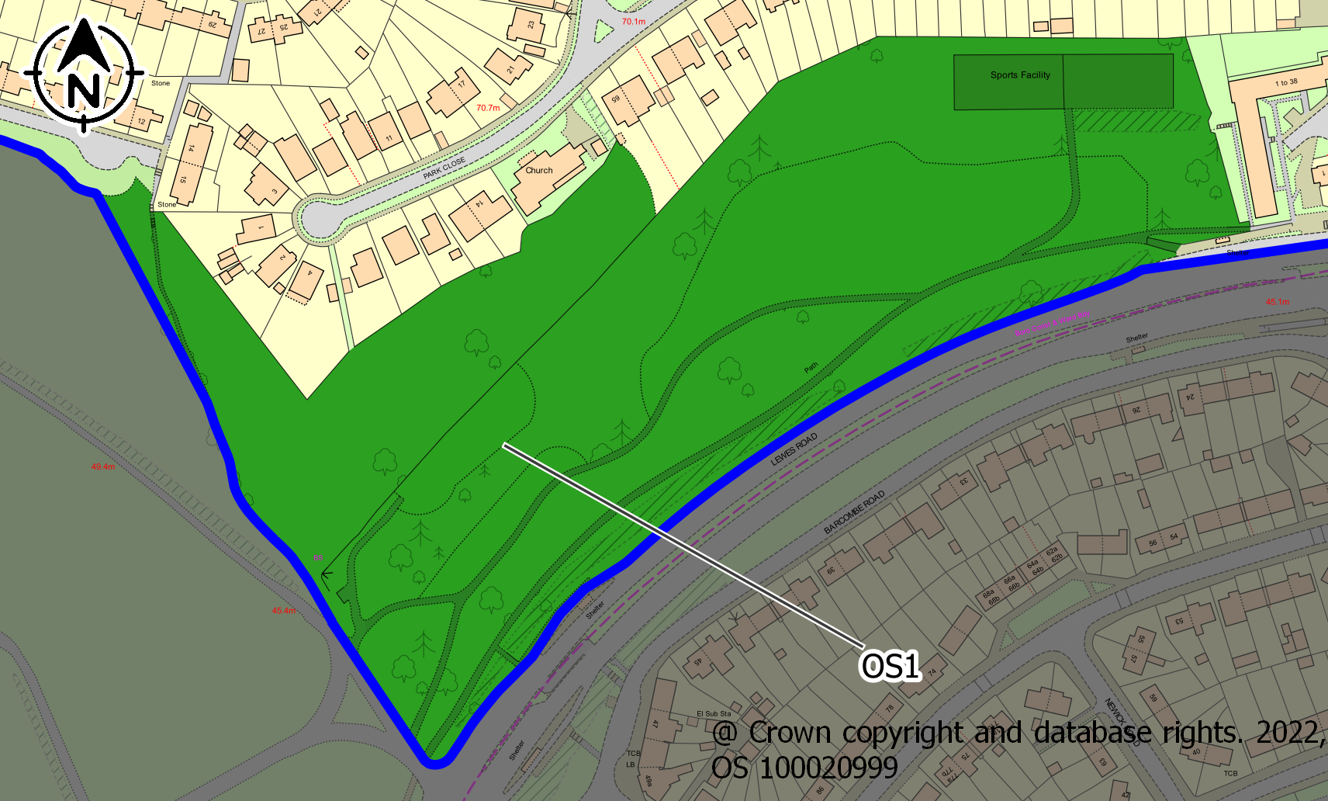
ASSESSMENT CRITERIA |  | COMMENTS | CRITERIA MET?
1. Reasonably close proximity to the community it/they serve(s) |  | Within Neighbourhood Area and adjacent to major bus routes. | ✓
2. Demonstrably special to a local community and holds a particular local significance. |  | Within "Wild Park" Local Nature Reserve Area. Provides 'green lung' alternative to road for pedestrians and cyclists; exercise facilities; wildlife and biodiversity resource | ✓
3. The area is local in character and is not an extensive tract of land. |  | Continuation of Wild Park; access via footpath in Neighbourhood Area. | ✓
4. Actively and currently used by the community |  | Yes (access to nature, sports and exercise facilities). | ✓
Conclusion: |  | This space meets the criteria for designation as a Local Green Space

Ref No. | OS2
Name | Coldean Woods Open Space
Description | Formerly arable land on rotation, now open grassed area within Coldean Woods.
Area | 4.68ha
Site Map | 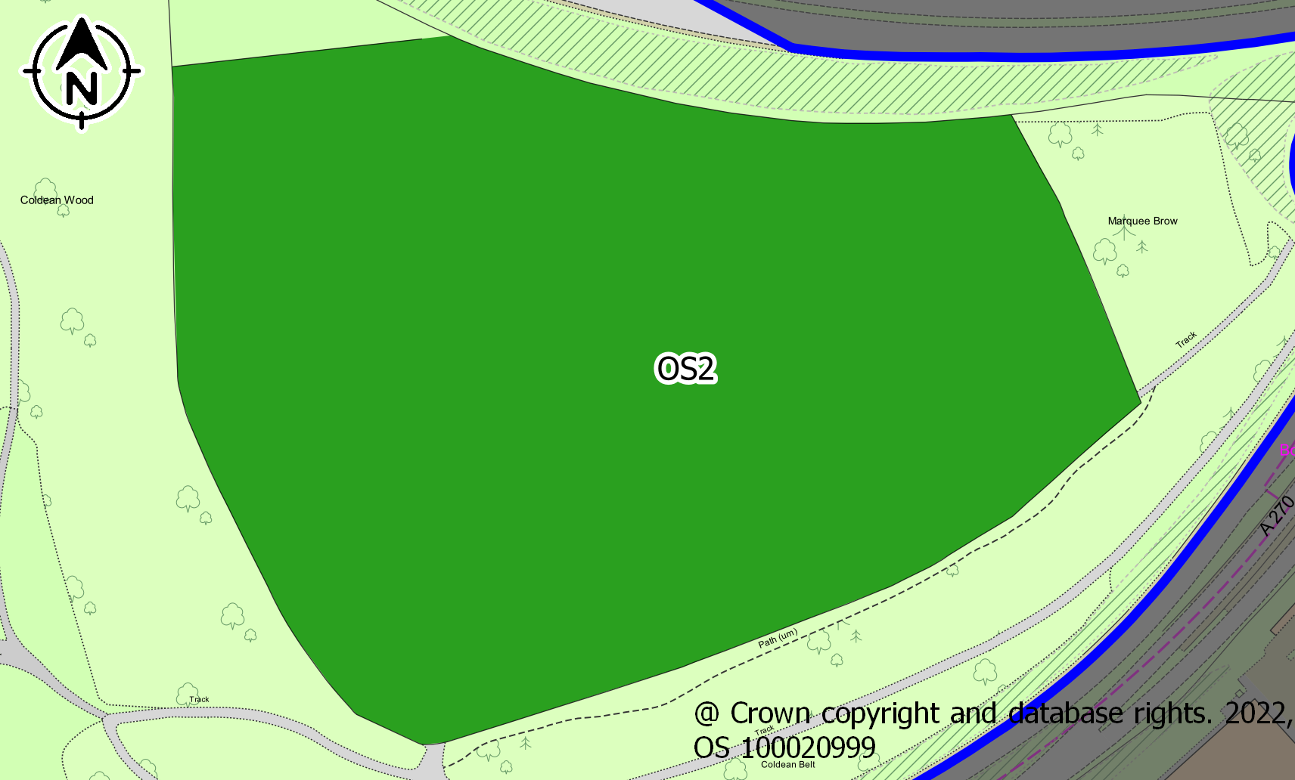
ASSESSMENT CRITERIA |  | COMMENTS | CRITERIA MET?
1. Reasonably close proximity to the community it/they serve(s) |  | Within Neighbourhood Area; access via Coldean Lane; served by footpaths to Stanmer. | ✓
2. Demonstrably special to a local community and holds a particular local significance. |  | Archaeological and historical significance: human settlement throughout Paeolithic (8,500 BC), Mesolithic (8000 to 2700 BC) and Neolithic (4300 to 2000 BC) periods; part of Stanmer Estate; 1700s-1850s part of Coldean Farm and farm workers' cottages; 1930s-1940s some private buildings and pub ('Hikers' Rest) built opposite (Park Road/Coldean Lane); rich legacy of wildlife as a result of previous arable cultivation on this site, e.g. residents report Little Owls, Buzzards; 19 species of butterflies identified (2017); at risk of encampment/ illegal occupation. | ✓
3. The area is local in character and is not an extensive tract of land. |  | Part of Coldean Woods. | ✓
4. Actively and currently used by the community |  | Yes: footpath access to Stanmer Great Wood; Friends of Coldean Woods | ✓

Conclusion: | This space meets the criteria for designation as a Local Green Space

Ref No. | OS3
Name | Coldean Woods (Varley Park south eastwards to highway)
Description | Chiefly woodland (has been subject to Ash dieback and invasive species, especially Sycamore); remaining rare chalk grassland contains protected and red-list flora and fauna of ecological significance.
Area | 10.18ha
Site Map | 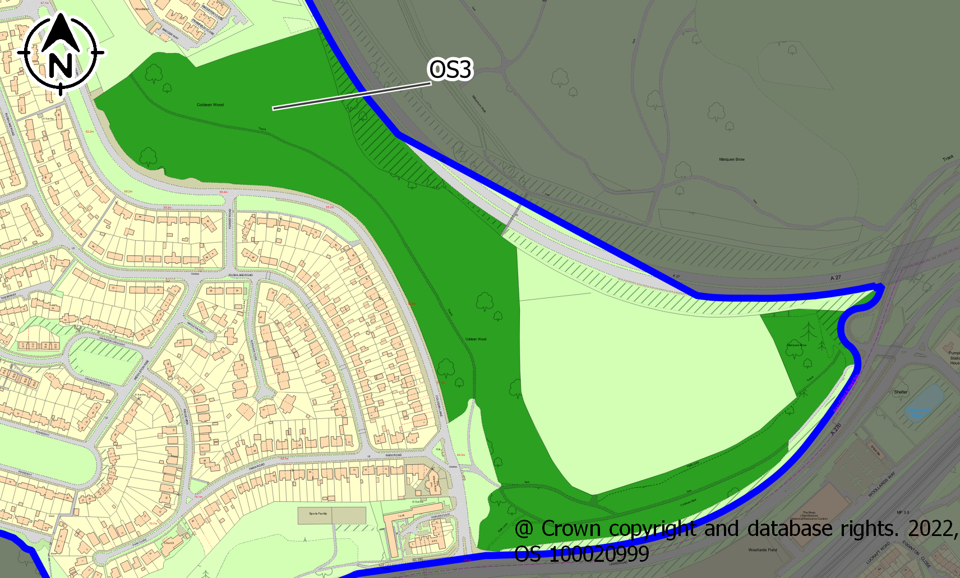
ASSESSMENT CRITERIA |  | COMMENTS | CRITERIA MET?
1. Reasonably close proximity to the community it/they serve(s) |  | Within Neighbourhood Area; footbridge access over A27 bypass to Stanmer Great Wood. | ✓
2. Demonstrably special to a local community and holds a particular local significance. |  | Very significant ecological value, with expert ecological reports recording extensive sightings of rare and protected species; badger setts/latrines; fox earths; very strong potential for regenerative management e.g., grazing (as per Wild Park and Stanmer); chalk streams and Brighton's aquifer supported by this rare environment. | ✓
3. The area is local in character and is not an extensive tract of land. |  | Part of Coldean Woods however it is a long stretch which could be considered an extensive tract of land. Whilst the space is local in character, it fails this criterion. | ×
4. Actively and currently used by the community |  | Used very extensively by hikers, local walkers and some mountain bikers, and birdwatchers and ecologists; very highly valued by local residents for access to nature, exercise and as a pedestrian, car-free route to Stanmer; historical community memory of 1987 storms; much distress caused to residents by removal of trees due to ash dieback and elm disease, and loss of species due to development on Site 21 (Bluebell Heights). | ✓
Conclusion: |  | This space does not meet the criteria for designation.

Ref No. | OS4
Name | Land north of Varley Park (North Glade and Long Glade)
Description | Ancient, rare chalk grassland containing protected and red-list flora and fauna of great ecological significance; at risk of invasive species unless restored and maintained; also at high risk of development (City Plan 2).
Area | 4.10ha
Site Map | 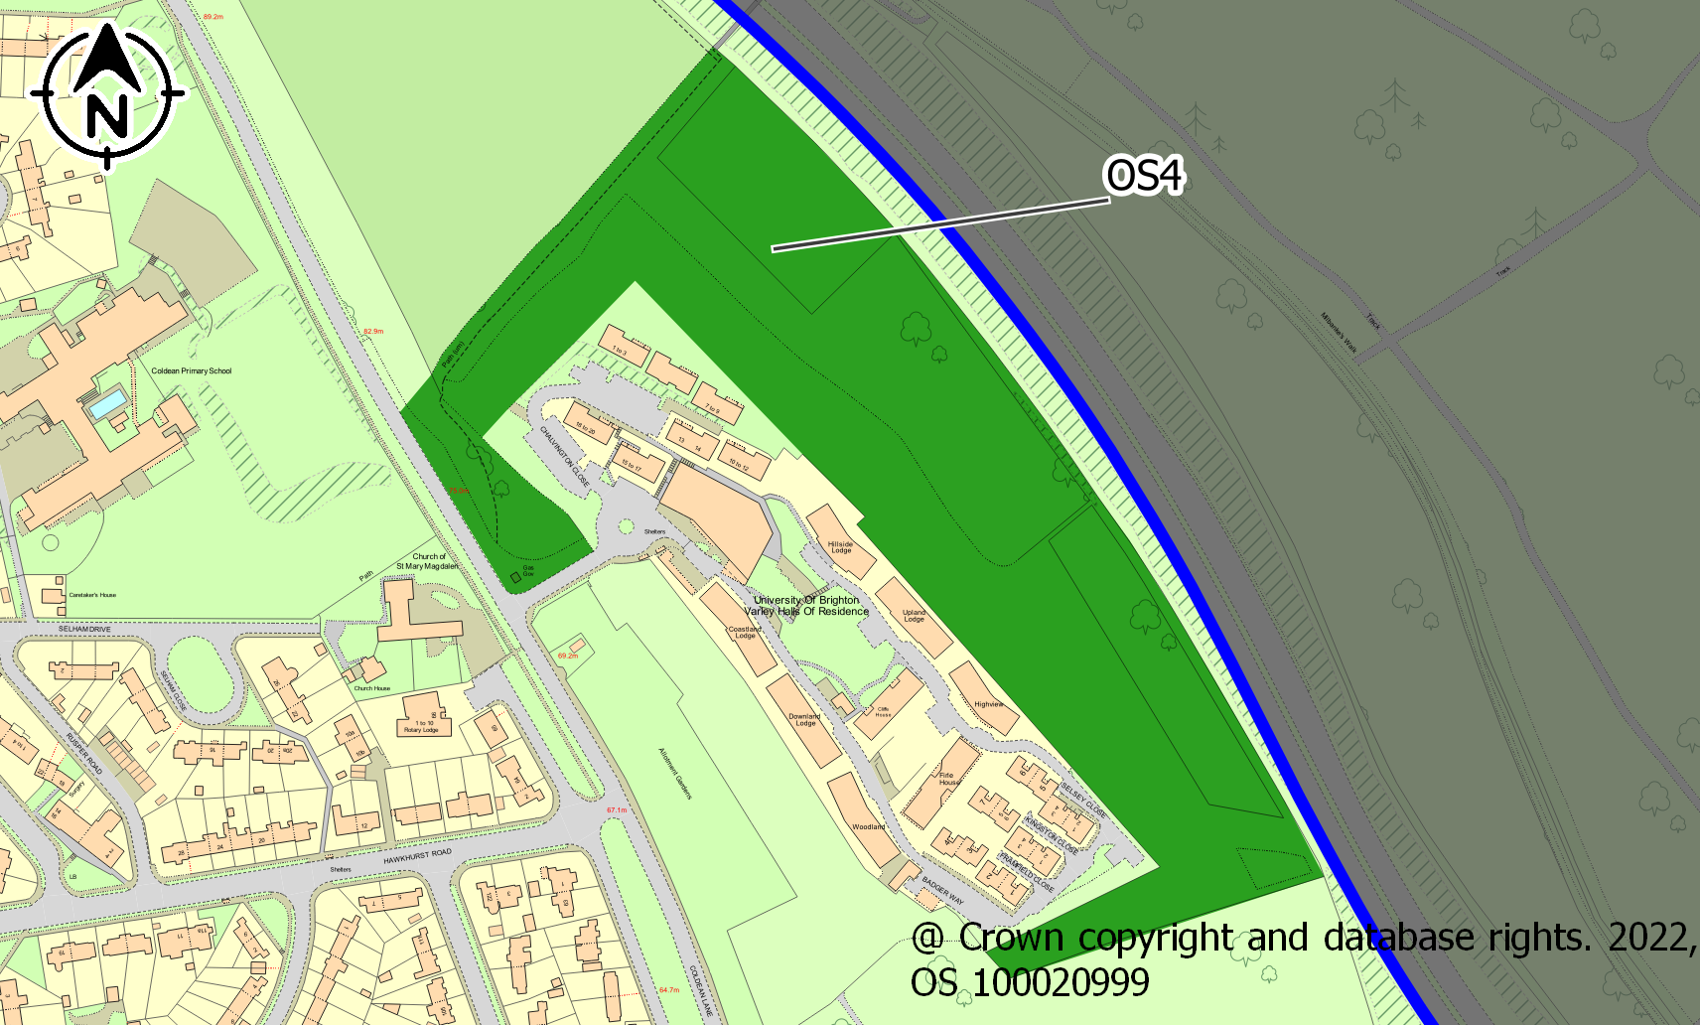
ASSESSMENT CRITERIA |  | COMMENTS | CRITERIA MET?
1. Reasonably close proximity to the community it/they serve(s) |  | Within Neighbourhood Area; footbridge access over A27 bypass to Stanmer Great Wood. | ✓
2. Demonstrably special to a local community and holds a particular local significance. |  | Very significant ecological value as rare chalk grassland is typical of the area; sustains numerous rare and threatened species of flora and fauna; strong potential for regenerative management, e.g. grazing (as per Wild Park and Stanmer). | ✓
3. The area is local in character and is not an extensive tract of land. |  | Extension of Coldean Woods; source of natural local history; protection considered by residents to be of the utmost importance (rated 1 or 2 at all Consultation events). | ✓
4. Actively and currently used by the community |  | Yes: access for recreation; footpaths to Stanmer; bird-watchers and ecologists (e.g. local residents set up a butterfly transect in 2021 to measure populations). | ✓
Conclusion: |  | This space meets the criteria for designation as a Local Green Space

Ref No. | OS5
Name | 47 Hectares (SDNP)
Description | Two contiguous parcels of land to north of Neighbourhood Area: 39 Acre and Pasture. 39 Acre is a meadow rich in wildlife (particularly fauna) and is home to rare butterflies and ground nesting birds (skylarks) Pasture is agricultural use (cattle).
Area | 45.04ha
Site Map | 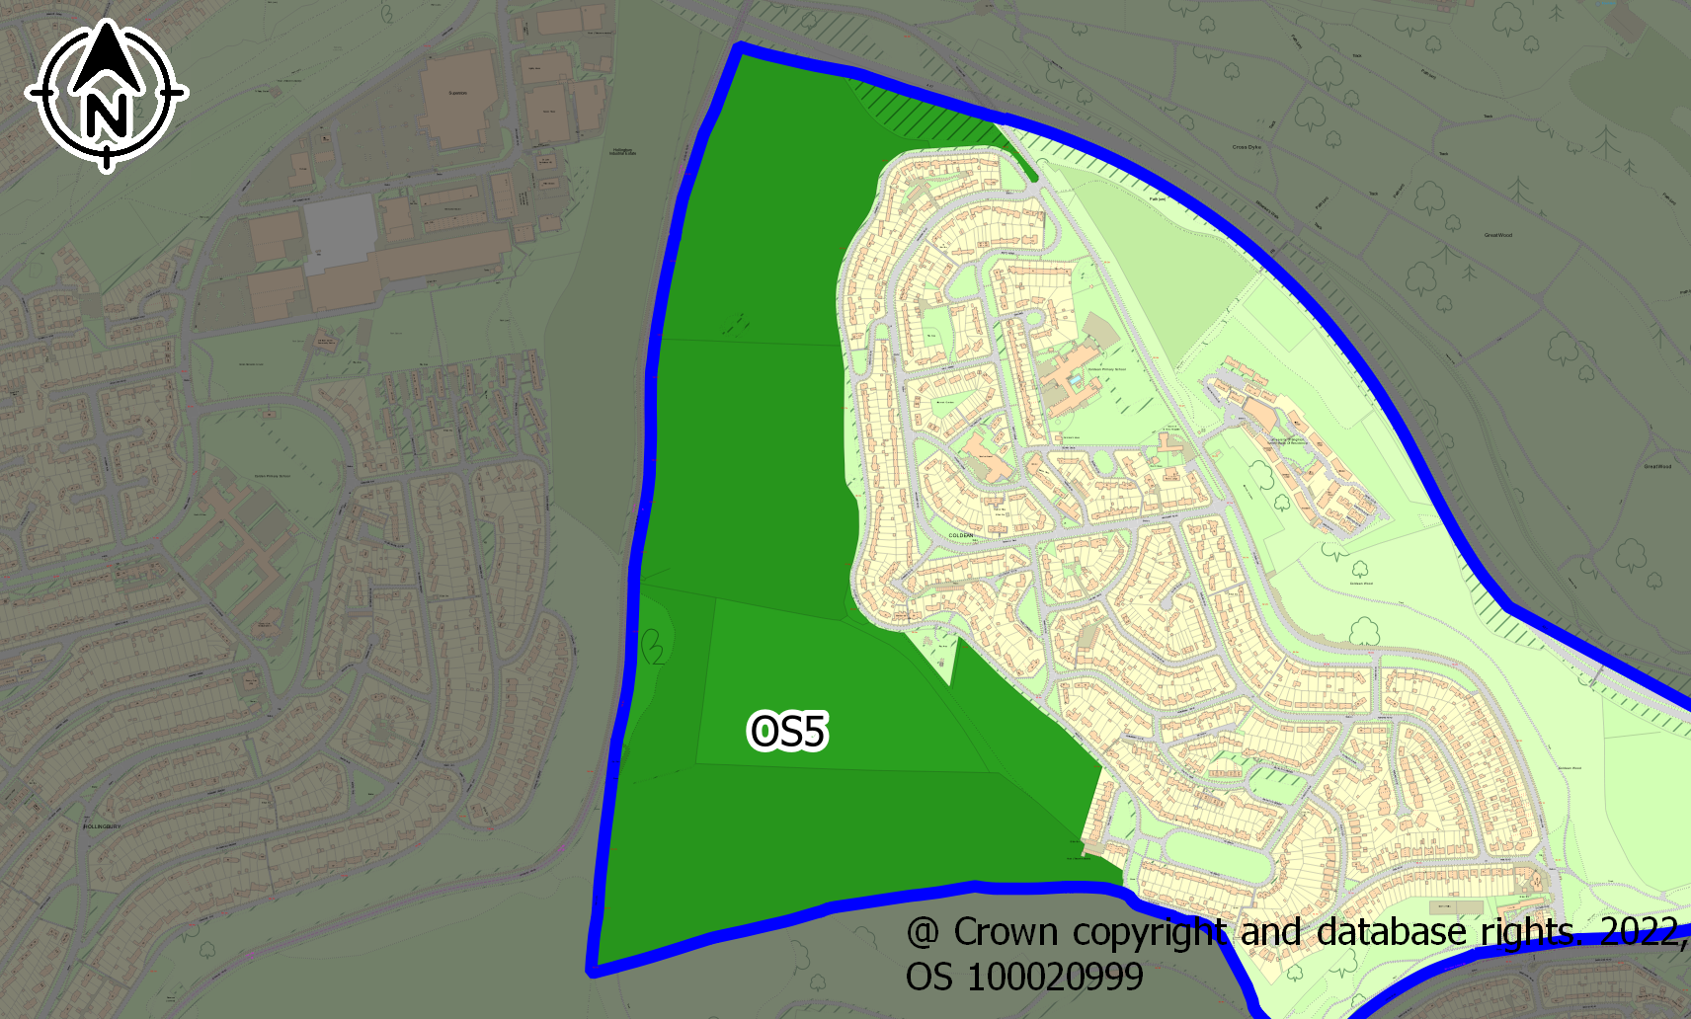
ASSESSMENT CRITERIA |  | COMMENTS | CRITERIA MET?
1. Reasonably close proximity to the community it/they serve(s) |  | Within Neighbourhood Area; bounds western edge. | ✓
2. Demonstrably special to a local community and holds a particular local significance. |  | Extensive views over South Downs to the east and seascape to the south; archaeological dig early 1990s with significant finds logged. 39 Acre was designated by Brighton and Hove Council as part of Hollingbury/Wild Park Local Nature Reserve in its Wild Park Management Plan 2012-2022. | ✓
3. The area is local in character and is not an extensive tract of land. |  | Extensive tract taken together; 39 Acre generally regarded as separate by residents. | ×
4. Actively and currently used by the community |  | Used extensively by local walkers and residents; very popular beauty spot with views; residents have requested new steps access and bench on 39 Acres; used by Coldean residents to access Hollingbury shops, local secondary schools and golf club on foot and also for access to Hollingbury Hill, dewpond, Hollingbury Hillfort and Moulsecoomb Station; very well used for recreation. | ✓
Conclusion: |  | This space fails to meet the criteria for designation.

Ref No. | OS6
Name | Roundway Open Space
Description | Sloping grassed area with pedestrian traffic, mainly dog walkers. Frequent use for football and other games by children and young people
Area | 0.58ha
Site Map | 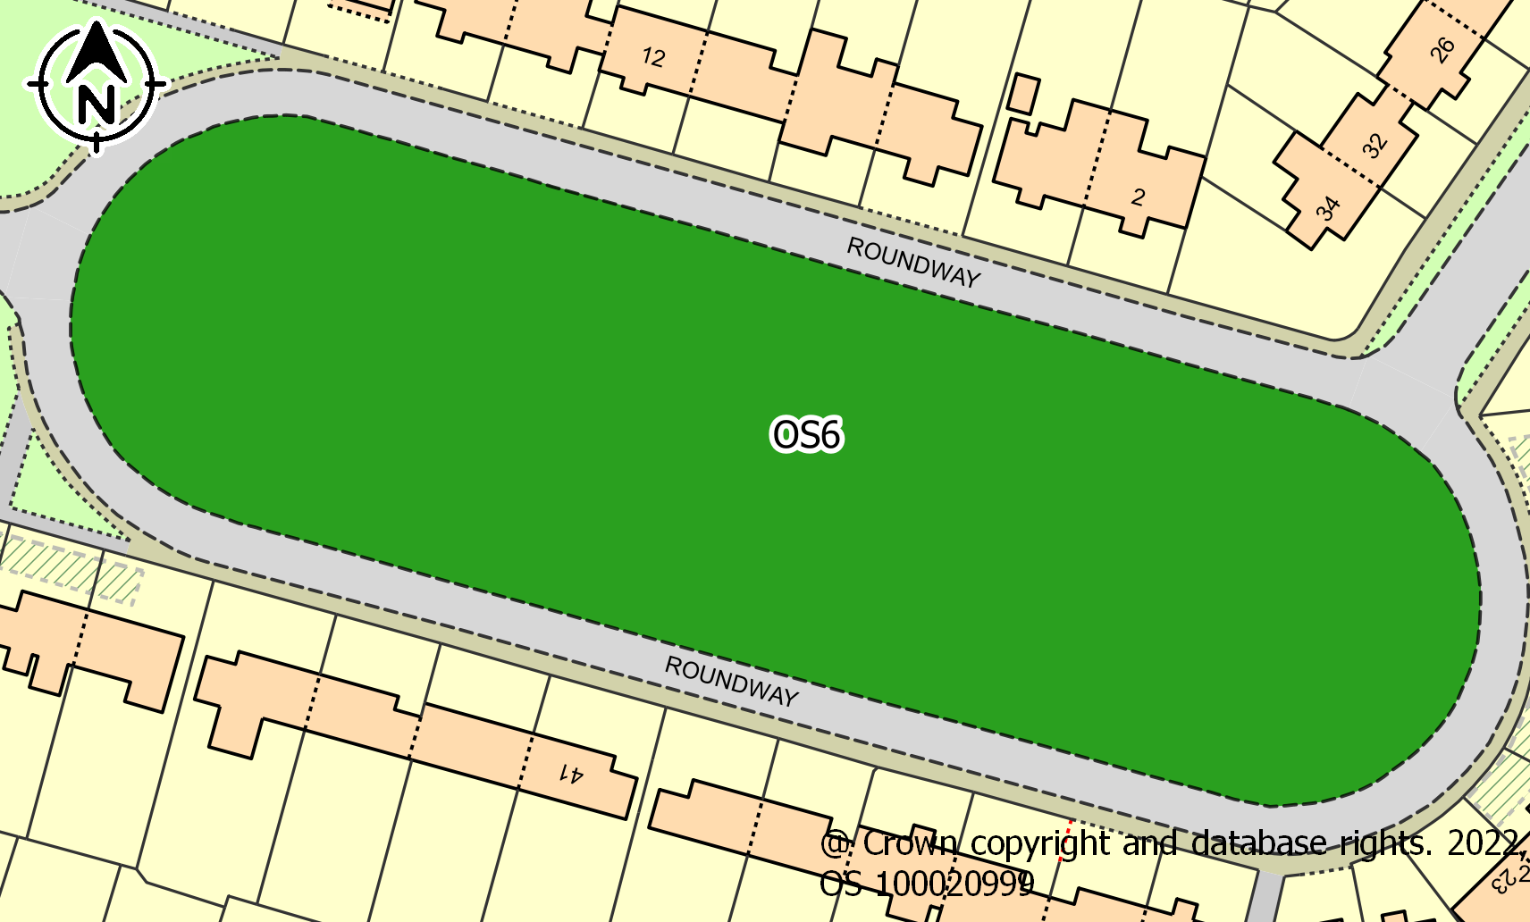
ASSESSMENT CRITERIA |  | COMMENTS | CRITERIA MET?
1. Reasonably close proximity to the community it/they serve(s) |  | Surrounded by dwellings. | ✓
2. Demonstrably special to a local community and holds a particular local significance. |  | As the largest open space within the developed area and it’s connection to the Highfields open space (OS5) and Public footpath. Unique to Brighton. | ✓
3. The area is local in character and is not an extensive tract of land. |  | Bounded by roads. Eight Trees planned by Brighton Permaculture in 2018 together with bench and football goal posts. Areas not mowed for seasonal wilding. | ✓
4. Actively and currently used by the community |  | Children regularly use the goal posts and other games. Attracts young people. The bench is in frequent use. Many dog walkers – 50 counted in one hour from 8am to 9am. | ✓
Conclusion: |  | This space meets the criteria for designation as a Local Green Space

Ref No. | OS7
Name | Roundway / Reeves Hill Open Space
Description | Small, level triangular shaped grassed area connecting to Reeves Hill (road).
Area | 0.11ha
Site Map | 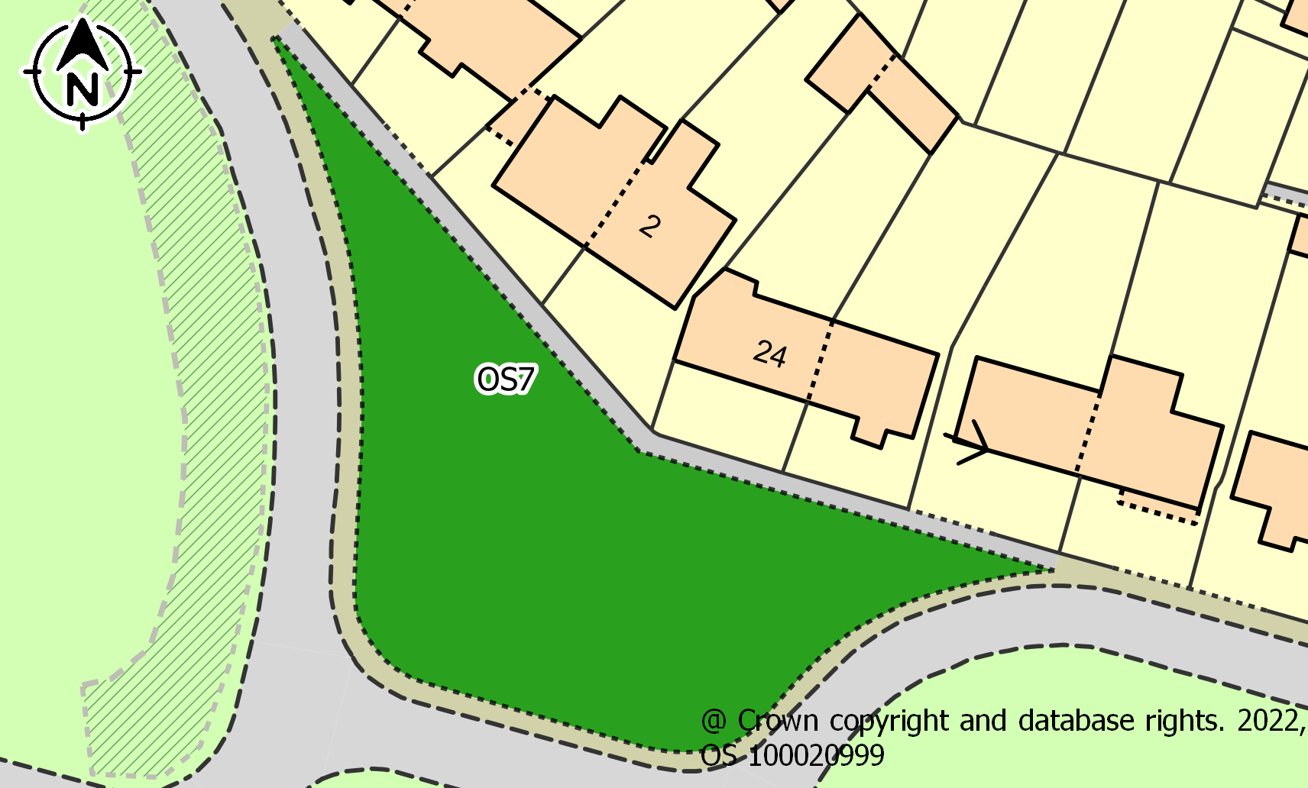
ASSESSMENT CRITERIA |  | COMMENTS | CRITERIA MET?
1. Reasonably close proximity to the community it/they serve(s) |  | Surrounded by dwellings. | ✓
2. Demonstrably special to a local community and holds a particular local significance. |  | Part of the Roundway, Meads landscape. Significant to the open aspect of the developed area. Space does not hold local significance however. | ×
3. The area is local in character and is not an extensive tract of land. |  | Small, adds sense of space and garden suburb to the area. | ✓
4. Actively and currently used by the community |  | Actively used in connection with OS6. Community Notice board is frequently examined. | ✓
Conclusion: |  | This space meets the criteria for designation as a Local Community Space

Ref No. | OS8
Name | The Meads / Reeves Hill Open Space
Description | Small area of grassland between the Meads and Reeves Hill. Evidence of cars parking on the kerb and on the space
Area | 0.17ha
Site Map | 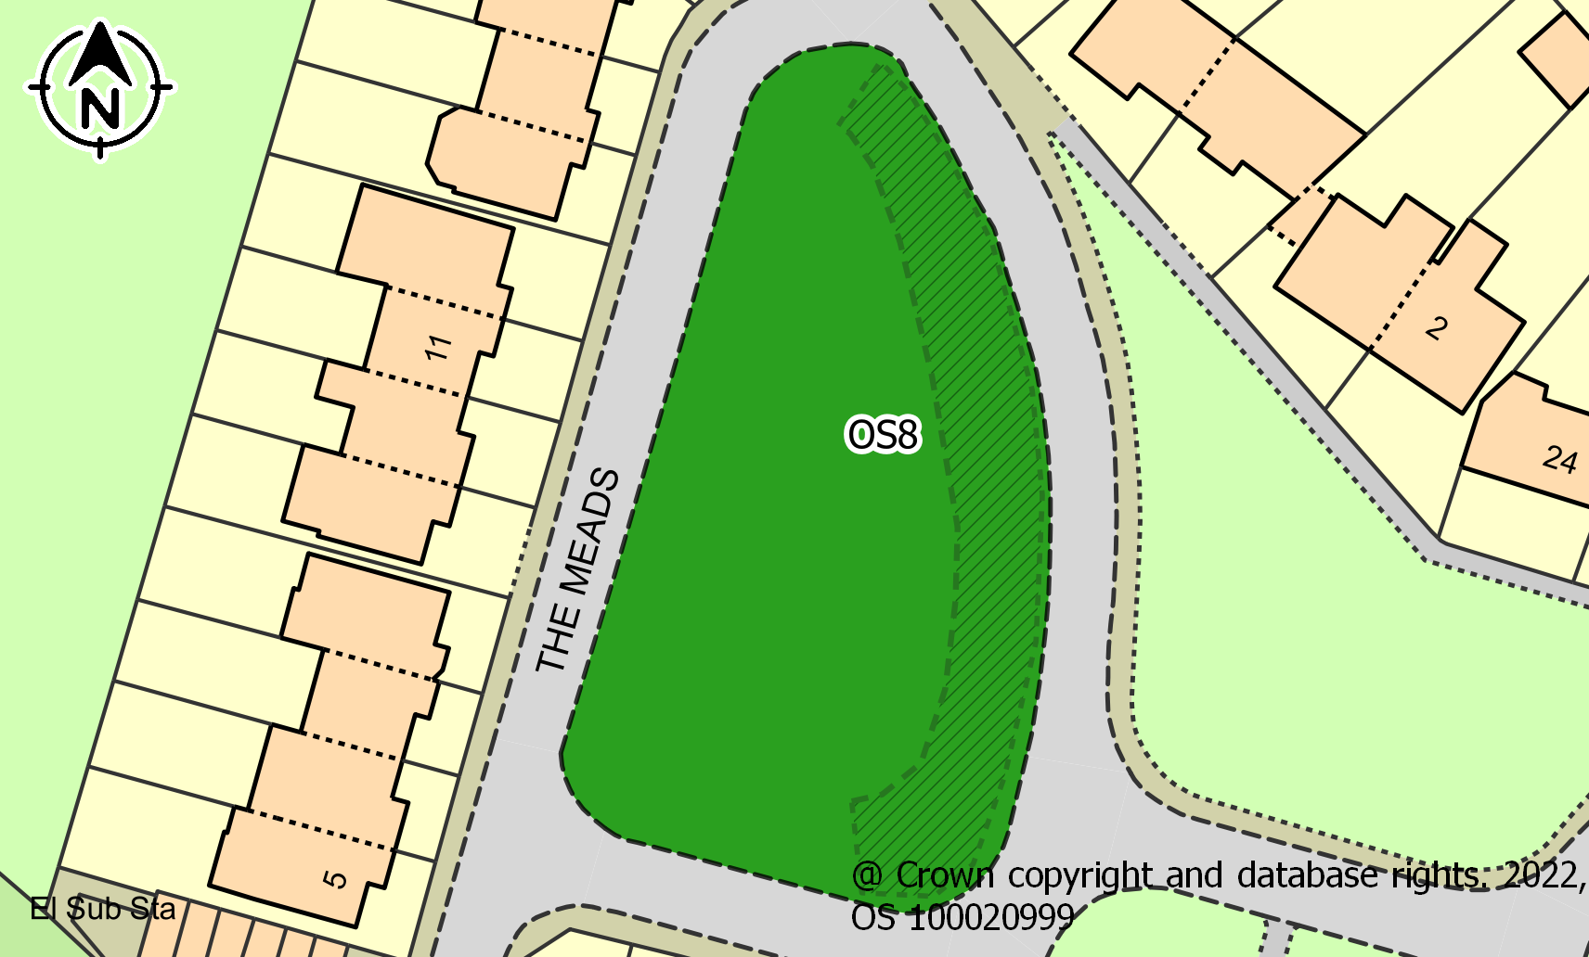
ASSESSMENT CRITERIA |  | COMMENTS | CRITERIA MET?
1. Reasonably close proximity to the community it/they serve(s) |  | Fronts The Meads 1960s development. | ✓
2. Demonstrably special to a local community and holds a particular local significance. |  | This area as grass, rather than tarmac, maintains the village tone of The Meads. Regarded by residents as an asset but is not demonstrably special enough to meet the requirement. | ×
3. The area is local in character and is not an extensive tract of land. |  | Small, but significant to The Meads. Maintains garden suburb identity. | ✓
4. Actively and currently used by the community |  | In conjunction with OS6 and some residents sit on  Deck chairs on warm days. | ✓
Conclusion: |  | This space meets the criteria for designation as a Local Community Space

Ref No. | OS9
Name | Highfields Open Space
Description | Irregular shaped open space parallel to Highlands. Space is separated by a driveway and pathway serving the residents of Highfields.
Area | 0.16ha
Site Map | 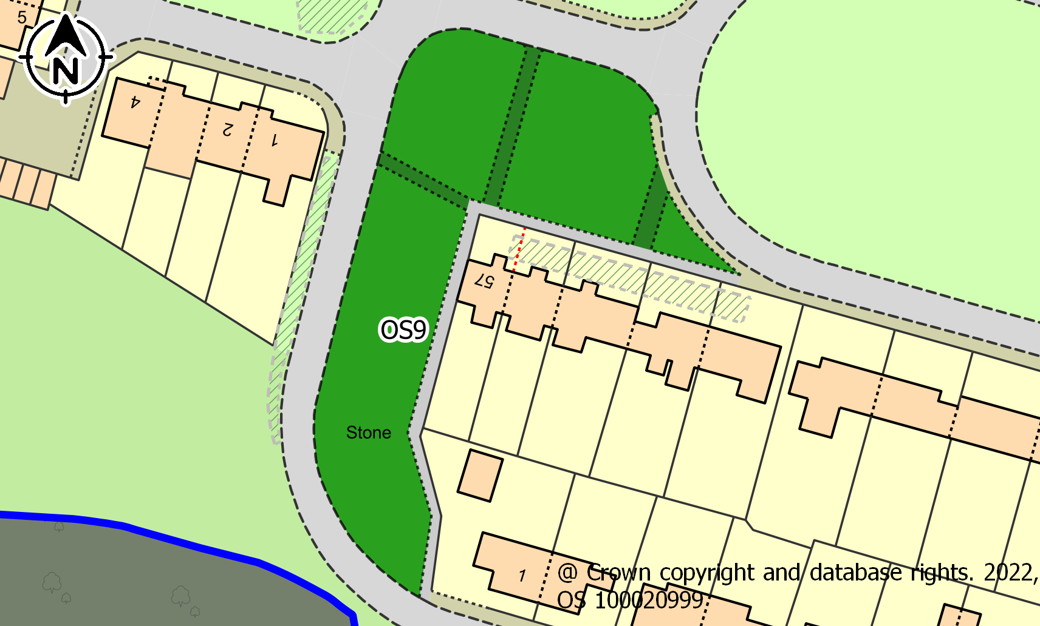
ASSESSMENT CRITERIA |  | COMMENTS | CRITERIA MET?
1. Reasonably close proximity to the community it/they serve(s) |  | Close to Dwellings in Roundway, The Meads and Highfields. | ✓
2. Demonstrably special to a local community and holds a particular local significance. |  | No evidence to confirm this criteria. | x
3. The area is local in character and is not an extensive tract of land. |  | Fruit trees planted 2018 and maintained by Brighton Permaculture. | ✓
4. Actively and currently used by the community |  | Access to OS5 by walkers, dog owners. | ✓
Conclusion: |  | This space meets the criteria for designation as a Local Community Space

Ref No. | OS10
Name | Saunders Hill / Crawley Road Open Space
Description | Very small open space on the junction between Crawley Road and Saunders Hill, situated on a steep hill. Features two trees, dog waste bin and pathway along the northern boundary.
Area | 0.06ha
Site Map | 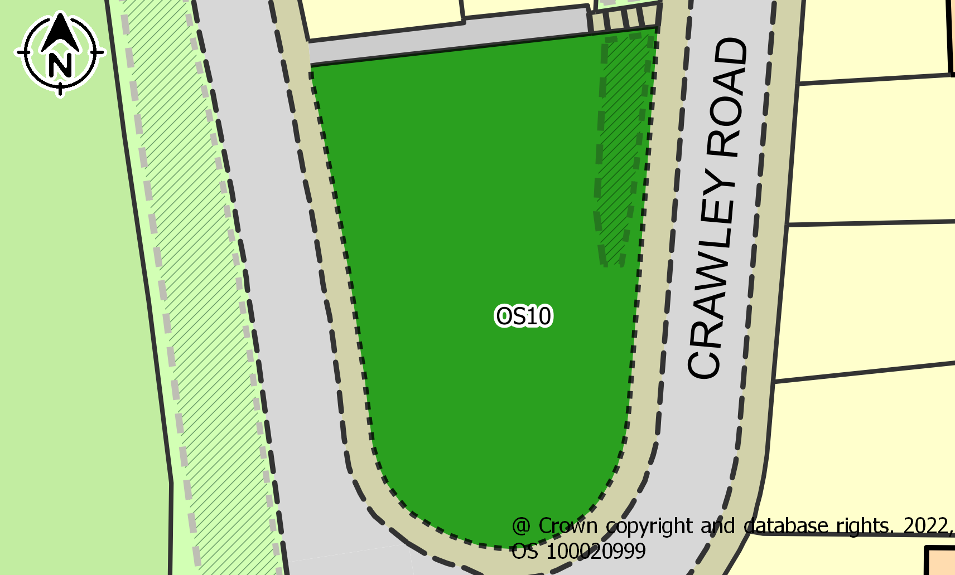
ASSESSMENT CRITERIA |  | COMMENTS | CRITERIA MET?
1. Reasonably close proximity to the community it/they serve(s) |  | Close to dwellings. | ✓
2. Demonstrably special to a local community and holds a particular local significance. |  | No special features identified. A student hanged himself from a tree in 2022 and the tree is considered a memorial | x
3. The area is local in character and is not an extensive tract of land. |  | Serves as a green break between developments. | ✓
4. Actively and currently used by the community |  | No activity observed that meets assessment criteria. | x
Conclusion: |  | This space does not meet the criteria for designation.

Ref No. | OS12
Name | Coldean Lane, South Side (Forest Road to St Mary Magdalen Church Hall)
Description | A large continuous grassed area, with mature trees and young trees planted in 2018. Spring flowers originally planted have now established over the area. The area is separated by a service road to the dwellings.
Area | 0.57ha
Site Map | 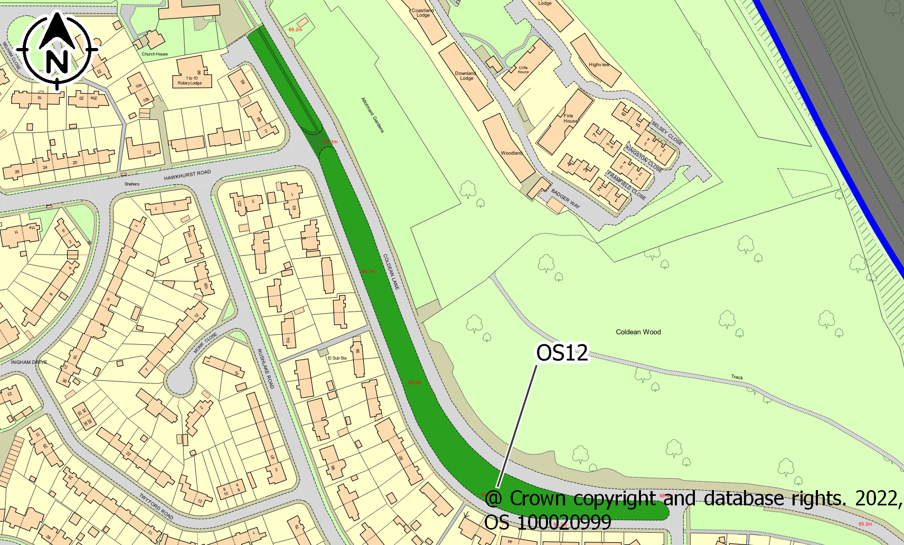
ASSESSMENT CRITERIA |  | COMMENTS | CRITERIA MET?
1. Reasonably close proximity to the community it/they serve(s) |  | Fronting dwellings. Providing distance from Coldean Lane traffic. | ✓
2. Demonstrably special to a local community and holds a particular local significance. |  | This area gives the impression of an area isolated from the rest of Brighton and the area has the character of a quiet garden suburb. | ✓
3. The area is local in character and is not an extensive tract of land. |  | Visitors report that this is a feature of Coldean that they associate with Coldean. Regarded by residents as making Coldean different from other housing estates in the city. | ✓
4. Actively and currently used by the community |  | Tree planting. Absences of grass cutting in the summer months are issues discussed in Residents’ Association meetings and reported to ward councillors. Used by walkers to Coldean woods/ Varley Park. | ✓
Conclusion: |  | This space meets the criteria for designation as a Local Green Space.

Ref No. | OS13
Name | Standean Close Open Space
Description | Two small parcels of land to the east and west of Standean Close, at the junction with Hawkhurst Road.
Area | 0.10ha
Site Map | 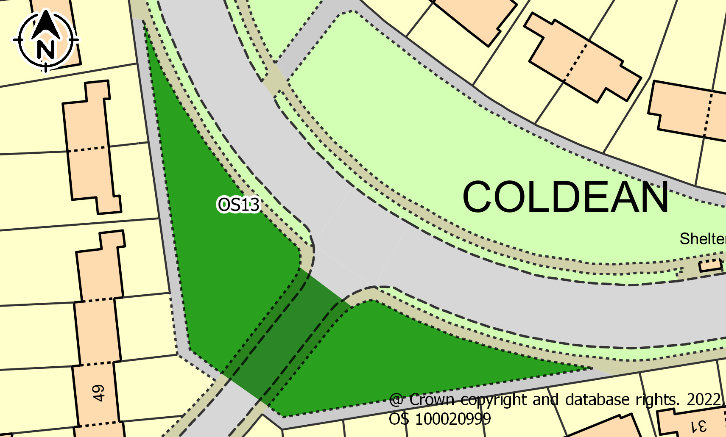
ASSESSMENT CRITERIA |  | COMMENTS | CRITERIA MET?
1. Reasonably close proximity to the community it/they serve(s) |  | Close to dwellings | ✓
2. Demonstrably special to a local community and holds a particular local significance. |  | No local significance | x
3. The area is local in character and is not an extensive tract of land. |  | Serves as a density break between developments. | ✓
4. Actively and currently used by the community |  | No activity observed that meets the criteria. | ×
Conclusion: |  | This space does not meet the criteria for designation RESERVED

Ref No. | OS14
Name | Hawkhurst Place Open Space
Description | Area of grassland to the north of Hawkhurst Road, opposite Standean Close. Situated on a downwards slope and comprises a couple of trees and a pathway parallel to the road.
Area | 0.13ha
Site Map | 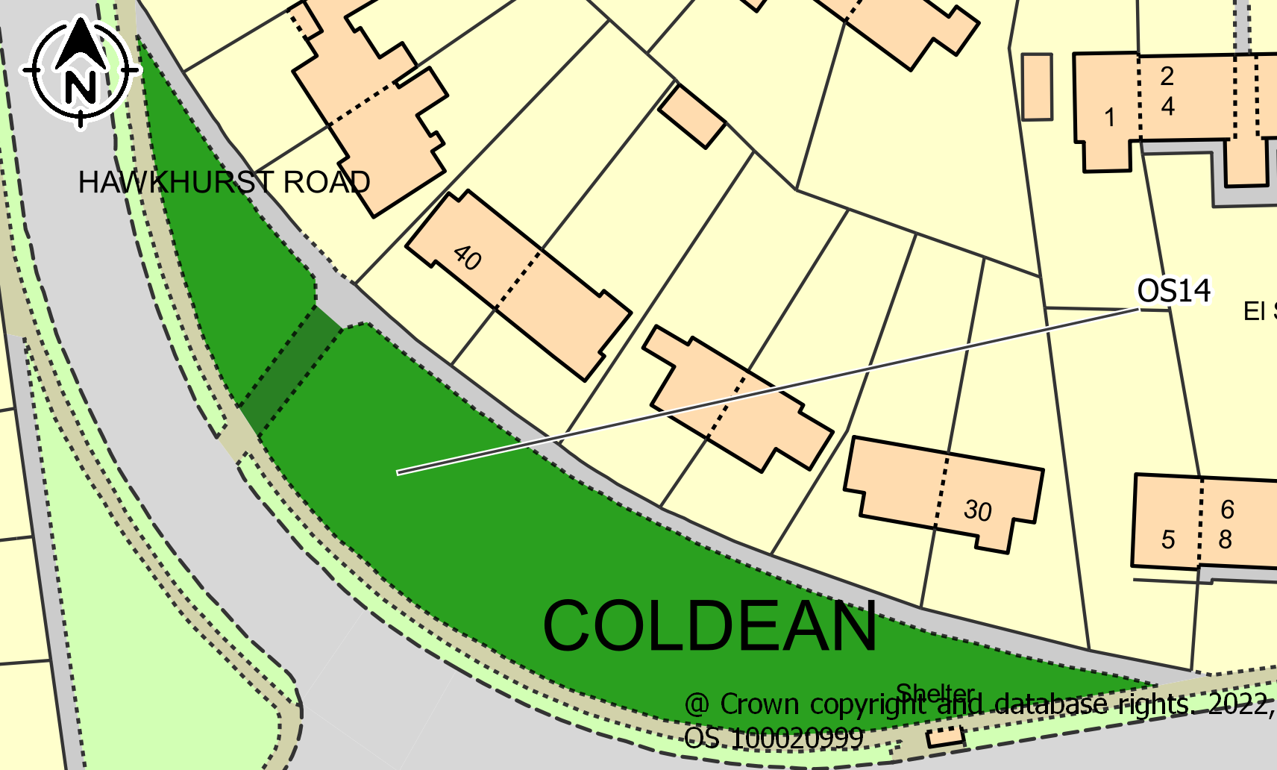
ASSESSMENT CRITERIA |  | COMMENTS | CRITERIA MET?
1. Reasonably close proximity to the community it/they serve(s) |  | Close to dwellings. | ✓
2. Demonstrably special to a local community and holds a particular local significance. |  | Does not have local significance | x
3. The area is local in character and is not an extensive tract of land. |  | Serves as a break between developments. | ✓
4. Actively and currently used by the community |  | No activity observed that meets the criteria. | x
Conclusion: |  | This space does not meet the criteria for designation.

Ref No. | OS15
Name | Hawkhurst Road / Saunders Hill Open Space
Description | Small open space to the north of Coldean, at the junction between Saunders Hill and Hawkhurst Road. Situated on a downwards slope and consists of several trees, a pathway/pavement parallel to the road and a bus stop.
Area | 0.10ha
Site Map | 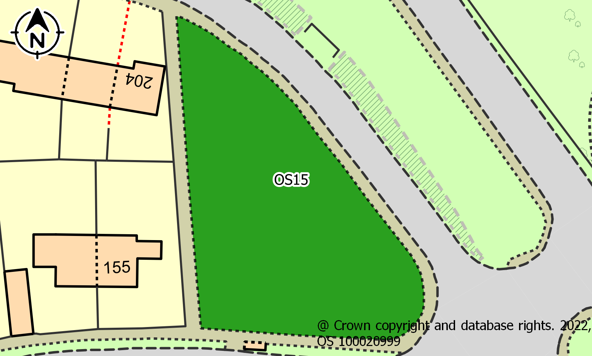
ASSESSMENT CRITERIA |  | COMMENTS | CRITERIA MET?
1. Reasonably close proximity to the community it/they serve(s) |  | Close to dwellings | ✓
2. Demonstrably special to a local community and holds a particular local significance. |  | Historically, this space does not hold significance, other than the identity as a garden suburb. However, this space may become special to the residents of Bluebell Heights | x
3. The area is local in character and is not an extensive tract of land. |  | Serves as a break between developments | ✓
4. Actively and currently used by the community |  | Not at present | x
Conclusion: |  | This space does not meet the criteria for designation.

Ref No. | OS16
Name | Beatty Avenue Northern Open Space
Description | Small area of grassland between 113 and 115 Beatty Avenue and the Beatty Avenue road. Situated on a downwards slope and consists of a pathway with steps and occasional planting.
Area | 0.05ha
Site Map | 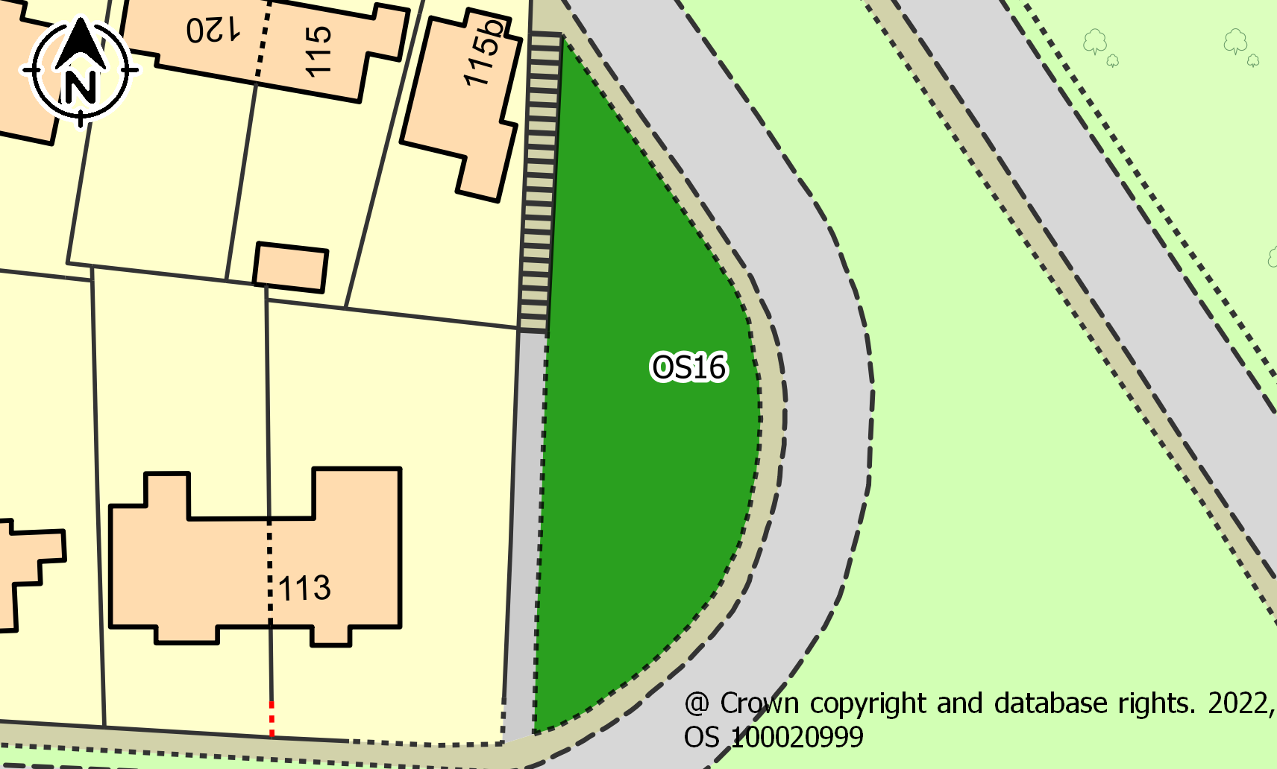
ASSESSMENT CRITERIA |  | COMMENTS | CRITERIA MET?
1. Reasonably close proximity to the community it/they serve(s) |  | Close to dwellings. | ✓
2. Demonstrably special to a local community and holds a particular local significance. |  | No significance | x
3. The area is local in character and is not an extensive tract of land. |  | Green break between developments. | ✓
4. Actively and currently used by the community |  | No regular activity observed. | x
Conclusion: |  | This space does not meet the criteria for designation.

Ref No. | OS17
Name | Wolseley Road Northern Open Space
Description | Small area of grassland between Wolseley Road and nos. 48 to 64 Wolseley Road. Space is separated by the driveways of the dwellings.
Area | 0.08ha
Site Map | 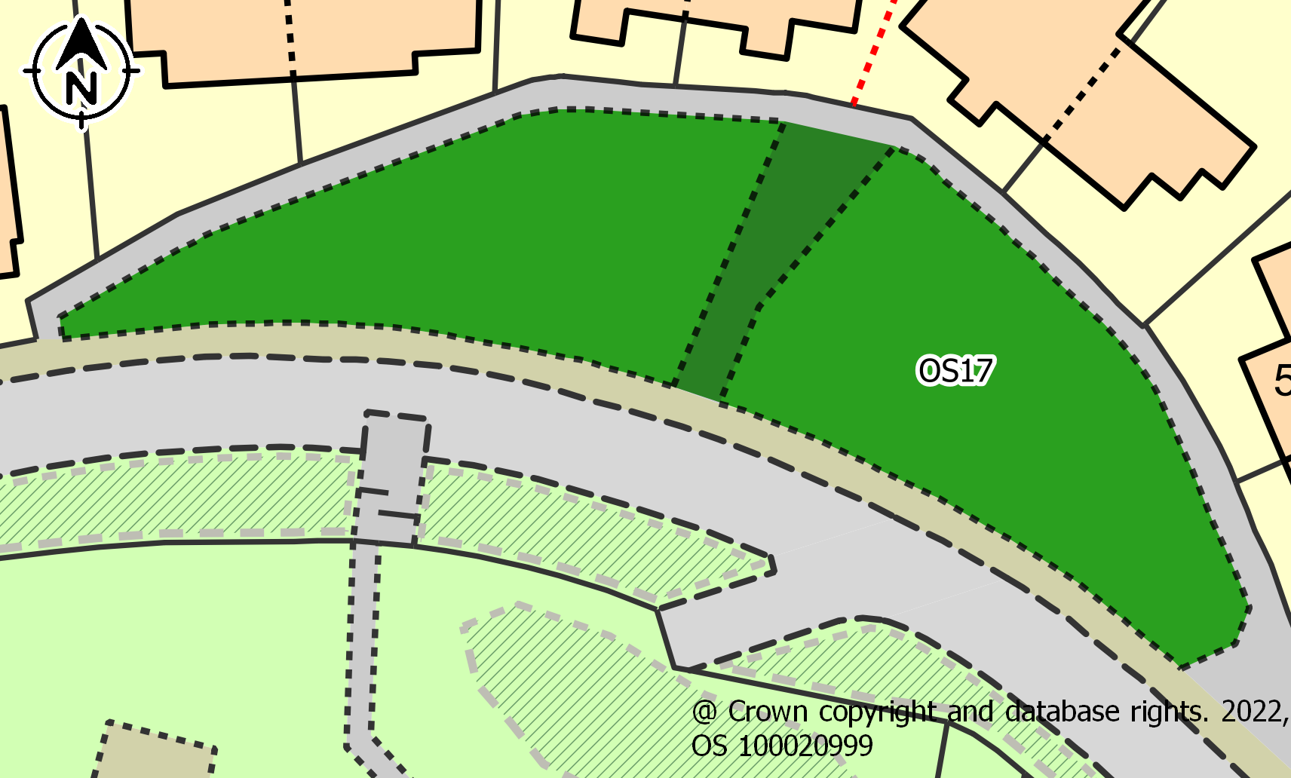
ASSESSMENT CRITERIA |  | COMMENTS | CRITERIA MET?
1. Reasonably close proximity to the community it/they serve(s) |  | Close to dwellings | ✓
2. Demonstrably special to a local community and holds a particular local significance. |  | No particular significance | x
3. The area is local in character and is not an extensive tract of land. |  | Green break | ✓
4. Actively and currently used by the community |  | No regular activity observed | x
Conclusion: |  | This space does not meet the criteria for designation.

Ref No. | OS18
Name | Beatty Avenue Southern Open Space
Description | Circular shaped open space between Beatty Avenue and nos. 59 to 93 Beatty Avenue. Comprises several trees, pathway parallel to Beatty Avenue and there is evidence that cars park on the space.
Area | 0.13ha
Site Map | 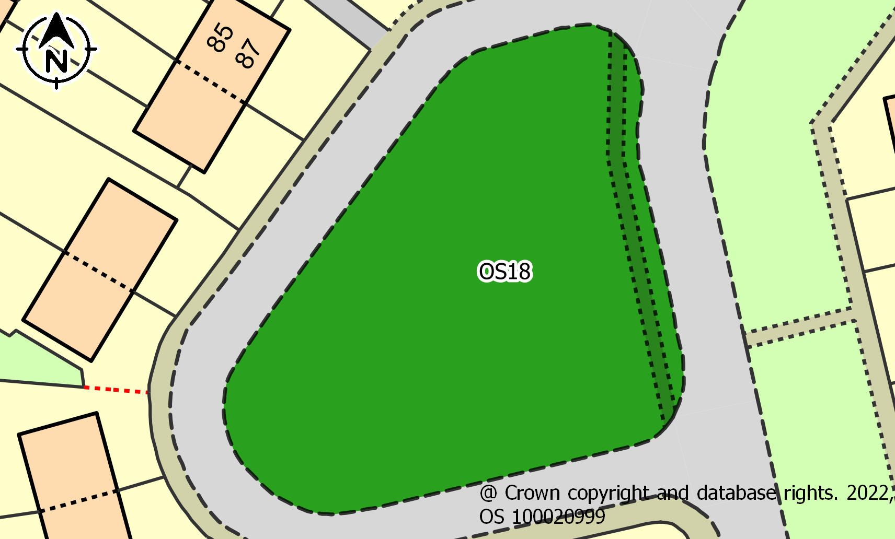
ASSESSMENT CRITERIA |  | COMMENTS | CRITERIA MET?
1. Reasonably close proximity to the community it/they serve(s) |  | Surrounded by dwellings | ✓
2. Demonstrably special to a local community and holds a particular local significance. |  | Seating (in Disrepair) is the focal point of use by the community and attracts residents from Hawkhurst Road via public footpath. It is not however demonstrably special to the community. | ×
3. The area is local in character and is not an extensive tract of land. |  | Mature trees and seating | ✓
4. Actively and currently used by the community |  | One of the “Hot spots” of community interaction | ✓
Conclusion: |  | This space meets the criteria for designation as a Local Community Space

Ref No. | OS19
Name | Talbot Crescent Open Space
Description | Semi-circular space situated between Talbot Crescent and Nanson Road. Situated on a gentle slope and comprises grassland and a pathway that runs parallel to Nanson Road.
Area | 0.12ha
Site Map | 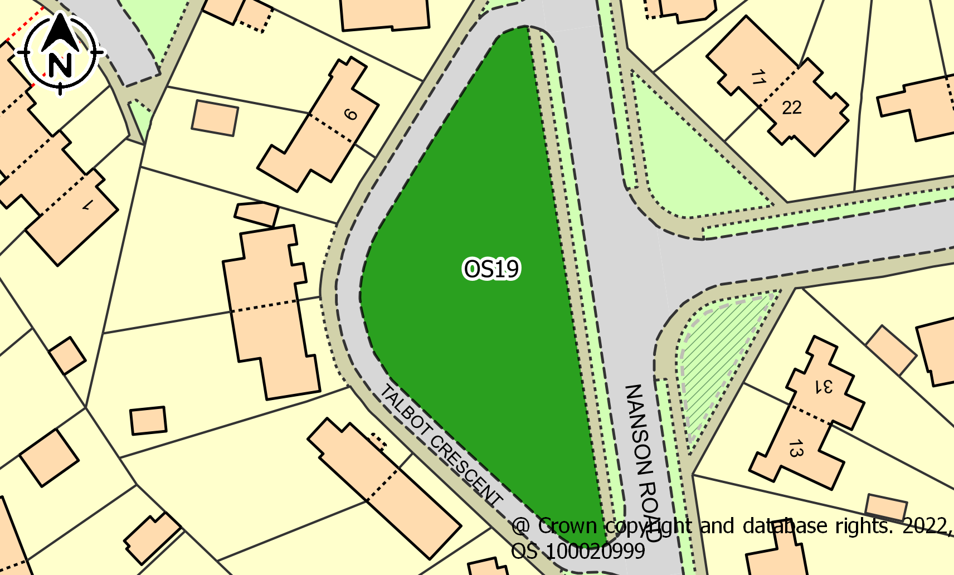
ASSESSMENT CRITERIA |  | COMMENTS | CRITERIA MET?
1. Reasonably close proximity to the community it/they serve(s) |  | Close to dwellings. | ✓
2. Demonstrably special to a local community and holds a particular local significance. |  | No particular significance | x
3. The area is local in character and is not an extensive tract of land. |  | Green break | ✓
4. Actively and currently used by the community |  | No regular activity observed | x
Conclusion: |  | This space does not meet the criteria for designation.

Ref No. | OS20
Name | Waldron Avenue / Hawkhurst Road Open Space
Description | Small semi-circular area of grassland on the junction between Waldron Avenue and Hawkhurst Road. Situated on a gentle slope and comprises a few trees and a pathway that runs parrel to both roads.
Area | 0.07ha
Site Map | 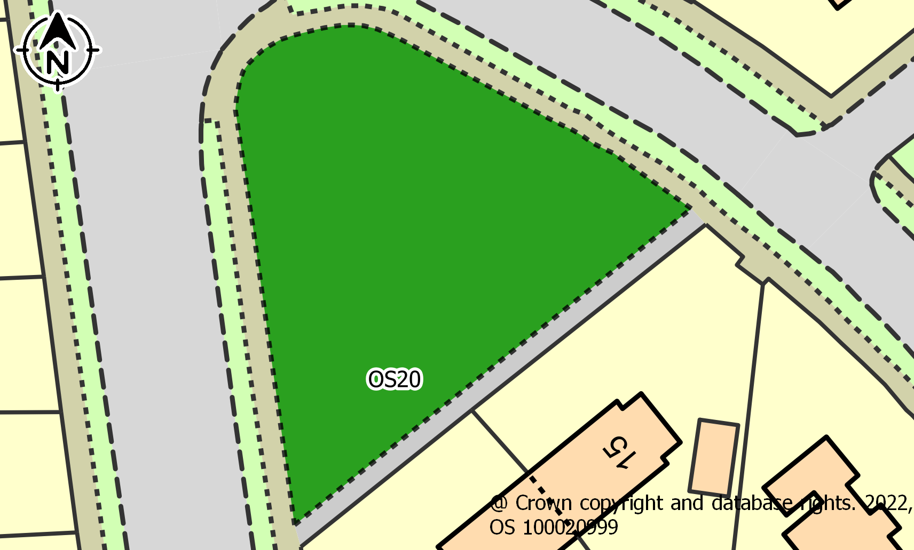
ASSESSMENT CRITERIA |  | COMMENTS | CRITERIA MET?
1. Reasonably close proximity to the community it/they serve(s) |  | Close to dwellings | ✓
2. Demonstrably special to a local community and holds a particular local significance. |  | No particular significance | x
3. The area is local in character and is not an extensive tract of land. |  | Green break | ✓
4. Actively and currently used by the community |  | No regular activity observed | x
Conclusion: |  | This space does not meet the criteria for designation.

Ref No. | OS21
Name | Arlington Crescent Open Space
Description | Fairly large circular open space situated between Middleton Rise and Arlington Crescent. Situated on a steep slope and comprises a pavement running parallel to Middleton Rise a number of trees and a dog waste bin.
Area | 0.28ha
Site Map | 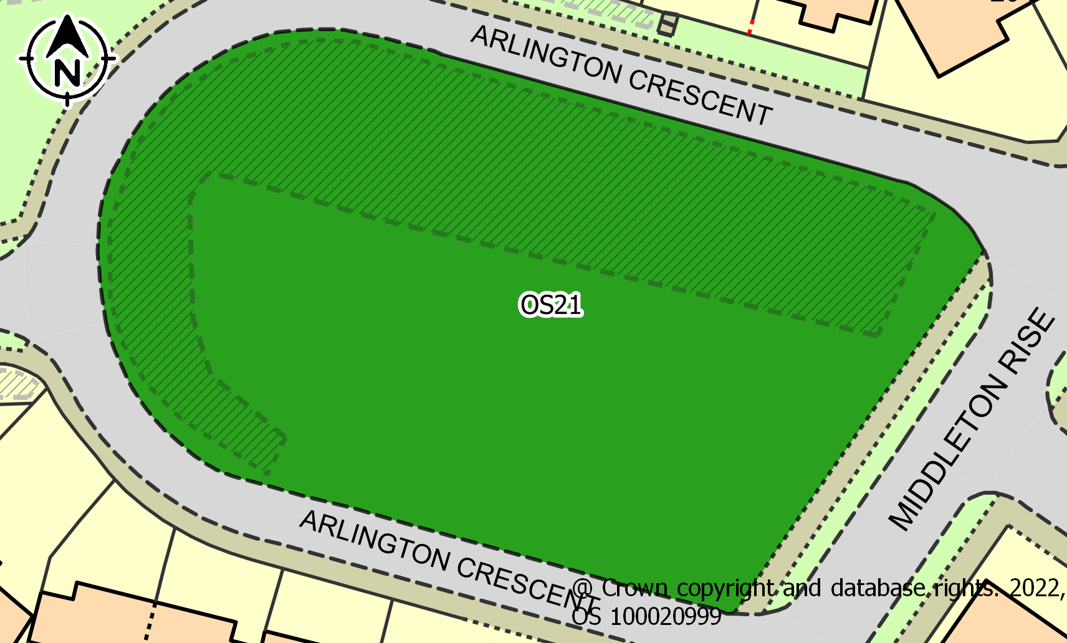
ASSESSMENT CRITERIA |  | COMMENTS | CRITERIA MET?
1. Reasonably close proximity to the community it/they serve(s) |  | Close to dwellings | ✓
2. Demonstrably special to a local community and holds a particular local significance. |  | No particular significance | x
3. The area is local in character and is not an extensive tract of land. |  | Green break | ✓
4. Actively and currently used by the community |  | No regular activity observed | x
Conclusion: |  | This space does not meet the criteria for designation.

Ref No. | OS22
Name | Haig Avenue Open Space
Description | Fairly large open area of grassland to the north of Haig Avenue comprising a pathway to the east of the space, connecting to Beatty Avenue. To the west of the space is a play area with several pieces of equipment.
Area | 0.25ha
Site Map | 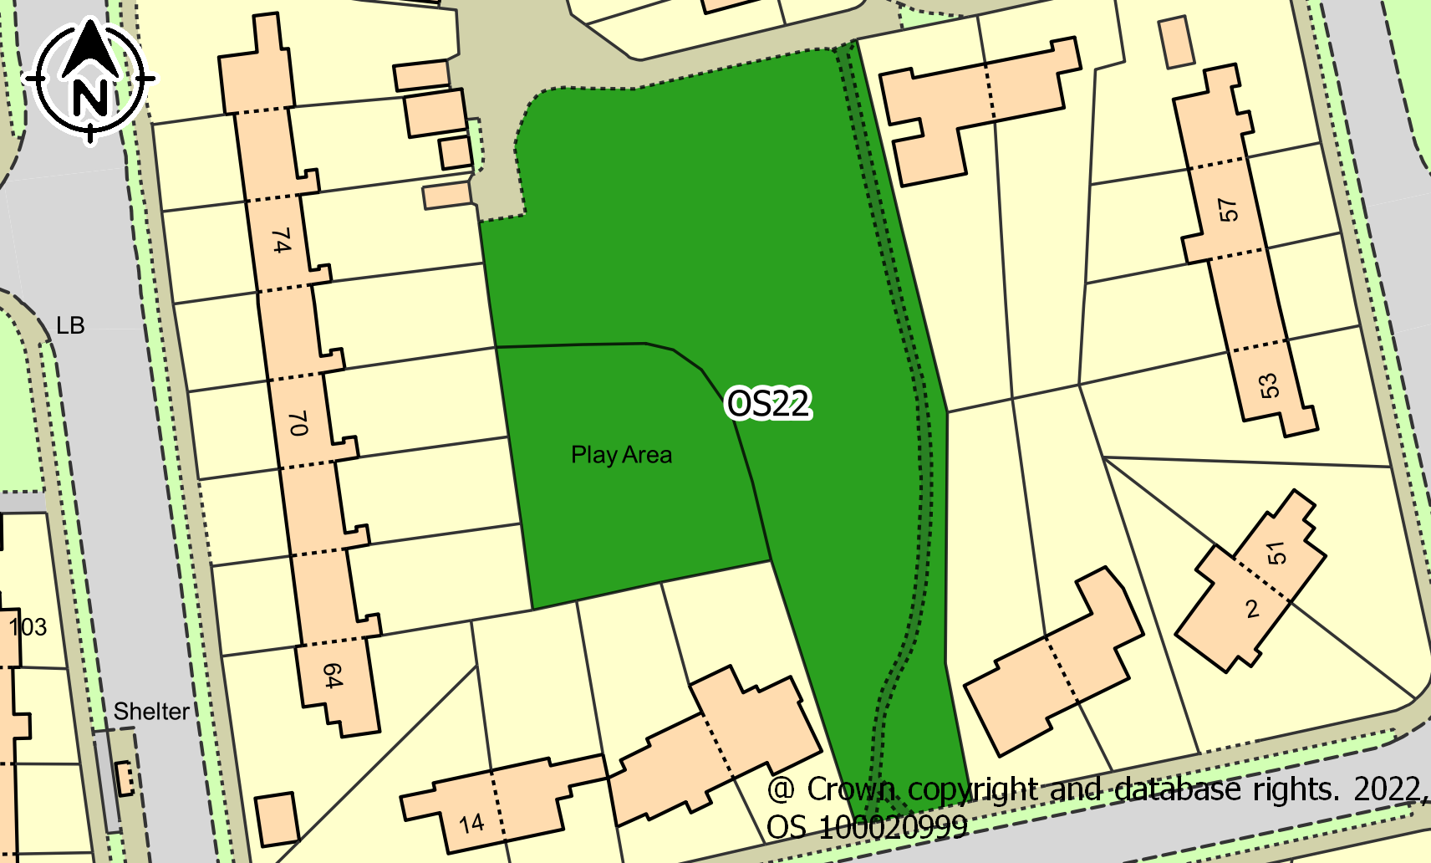
ASSESSMENT CRITERIA |  | COMMENTS | CRITERIA MET?
1. Reasonably close proximity to the community it/they serve(s) |  | Surrounded by dwellings | ✓
2. Demonstrably special to a local community and holds a particular local significance. |  | Council funding 2022 to improve facilities. Used extensively for community outdoor events and fairs, e.g. Golden Jubilee, Coronation. Acts as a village centre | ✓
3. The area is local in character and is not an extensive tract of land. |  | An enclosed area created with the housing development | ✓
4. Actively and currently used by the community |  | One of the “Hot spots” of community interaction. 2023 wild flower planting project | ✓
Conclusion: |  | This space meets the criteria for designation as a Local Green Space

Ref No. | OS23
Name | The Charltons Allotment Gardens
Description | Allotment gardens set within The Charltons, Beatty Avenue, Haig Avenue and Hawkhurst Road comprising small plots for growing produce.
Area | 0.11ha
Site Map | 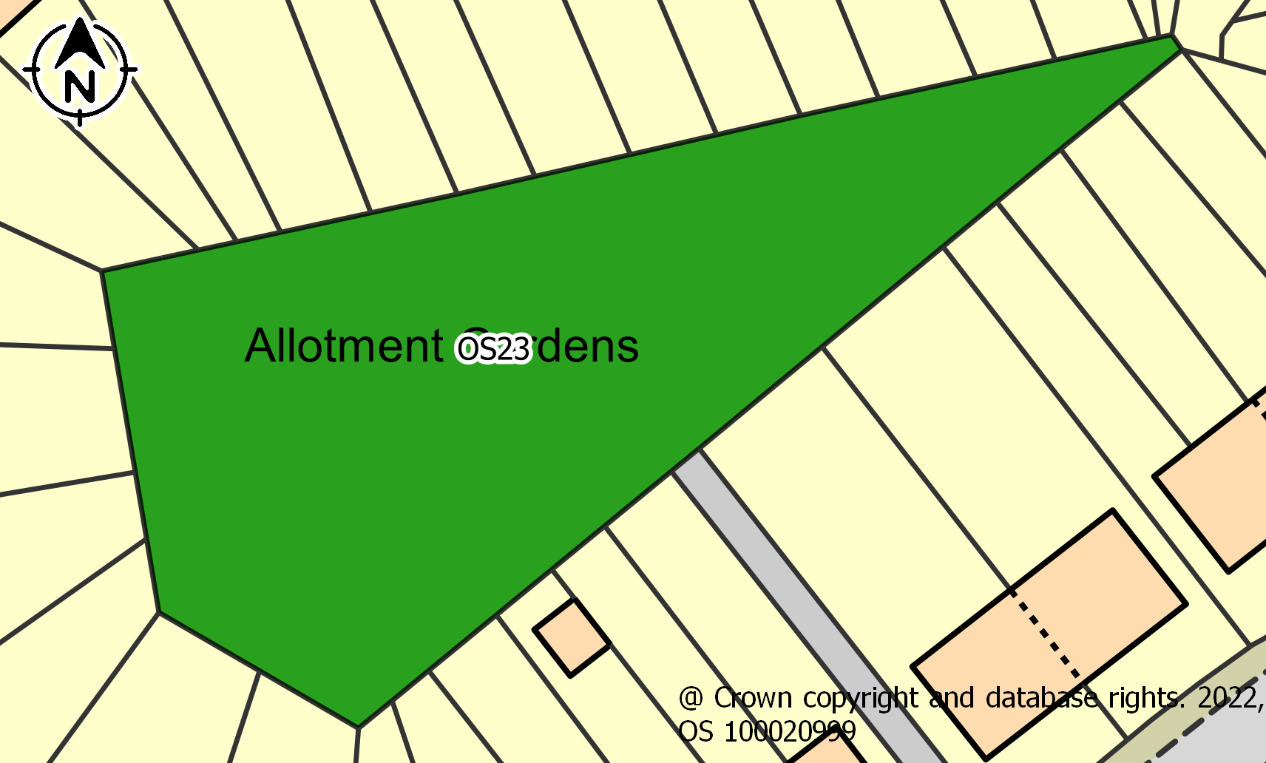
ASSESSMENT CRITERIA |  | COMMENTS | CRITERIA MET?
1. Reasonably close proximity to the community it/they serve(s) |  | Surrounded by dwellings | ✓
2. Demonstrably special to a local community and holds a particular local significance. |  | One of two Allotment Gardens in Coldean but does not hold particular local significance | ×
3. The area is local in character and is not an extensive tract of land. |  | About 10 non-standard Allotments | ✓
4. Actively and currently used by the community |  | In active use | ✓
Conclusion: |  | This space meets the criteria for designation as a Local Community Space

Ref No. | OS24
Name | Selham Close Open Space
Description | Very small, circular area of grassland on Selham Close comprising a couple of trees and flat land.
Area | 0.06ha
Site Map | 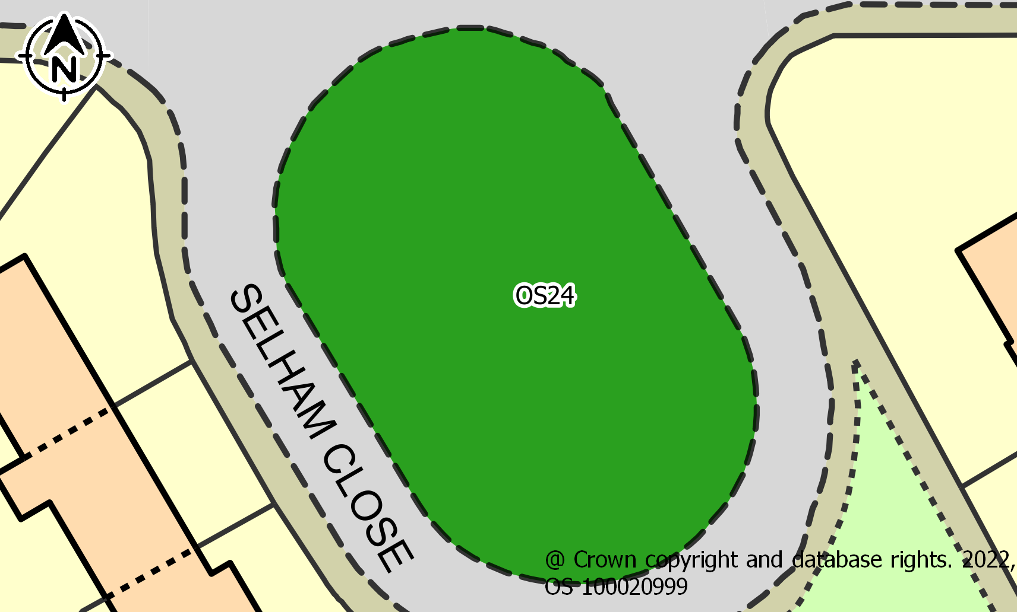
ASSESSMENT CRITERIA |  | COMMENTS | CRITERIA MET?
1. Reasonably close proximity to the community it/they serve(s) |  | Surrounded by dwellings | ✓
2. Demonstrably special to a local community and holds a particular local significance. |  | Not special to the community | ×
3. The area is local in character and is not an extensive tract of land. |  | Green break | ✓
4. Actively and currently used by the community |  | No regular activity observed | x
Conclusion: |  | This space does not meet the criteria for designation.

Ref No. | OS25
Name | Wolseley Road Southern Open Space and Play Area
Description | Area of grassland on a steep slope to the south of Wolseley Road. Comprises a main play area and other play equipment dotted around the space.
Area | 0.29ha
Site Map | 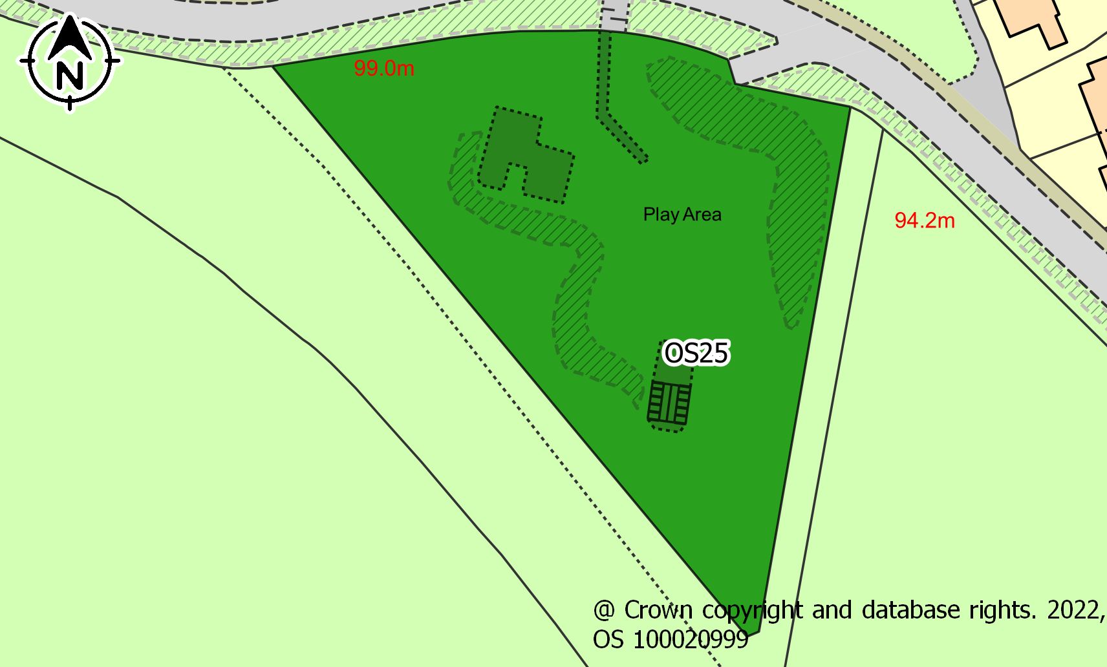
ASSESSMENT CRITERIA |  | COMMENTS | CRITERIA MET?
1. Reasonably close proximity to the community it/they serve(s) |  | Close to dwellings | ✓
2. Demonstrably special to a local community and holds a particular local significance. |  | One of two children’s play areas. Has been refurbished. Also attracts young people in the evenings | ✓
3. The area is local in character and is not an extensive tract of land. |  | Enclosed children’s play park | ✓
4. Actively and currently used by the community |  | Mostly daily use | ✓
Conclusion: |  | This space meets the criteria for designation as a Local Green Space

Ref No. | OS26
Name | Nanson Road / Reeves Hill Open Space
Description | Two small parcels of grassland either side of Nanson Road and to the north of Wolseley Road. Comprises a number of trees and pathway that runs parallel to the two roads.
Area | 0.13ha
Site Map | 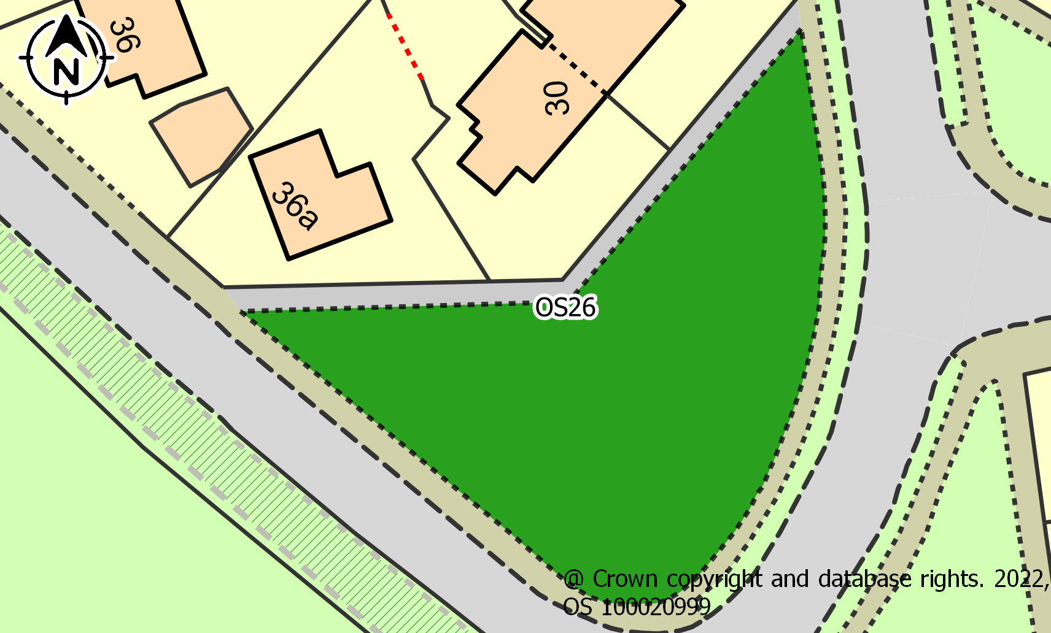
ASSESSMENT CRITERIA |  | COMMENTS | CRITERIA MET?
1. Reasonably close proximity to the community it/they serve(s) |  | Adjacent to dwellings | ✓
2. Demonstrably special to a local community and holds a particular local significance. |  | Has large mature tree which children play on and around but is not demonstrably special to the local community. | ×
3. The area is local in character and is not an extensive tract of land. |  | The area is typical of Coldean street grassed spaces. Often used by Estate Agents in sales particulars to represent Coldean | ✓
4. Actively and currently used by the community |  | Children frequently play on the tree during summer months | ✓
Conclusion: |  | This space meets the criteria for designation as a Local Community Space

Ref No. | OS41
Name | Coldean Lane, South Side (No. 29 to Forest Road Junction)
Description | Large grassed areas intersected with tarmac driveways to dwellings. A mature tree. Some residents, in agreement with the Council, have allowed these areas to grow seasonally wild.
Area | 0.20ha
Site Map | 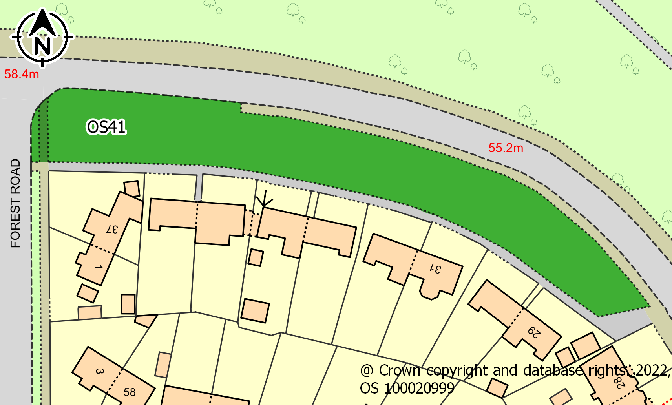
ASSESSMENT CRITERIA |  | COMMENTS | CRITERIA MET?
1. Reasonably close proximity to the community it/they serve(s) |  | Fronting dwellings. | ✓
2. Demonstrably special to a local community and holds a particular local significance. |  | This area gives the impression of an area isolated from the rest of Brighton and the area has the character of a quiet garden suburb. Residents claim it is unique to Brighton to have a wooded area on one side. It a favourite spectator point by residences for the London to Brighton bicycle races | ✓
3. The area is local in character and is not an extensive tract of land. |  | Visitors report that this is feature of Coldean that they associate with Coldean. Since 2022 has wild flower plots | ✓
4. Actively and currently used by the community |  | Some residents encourage insect life by agreeing with the Council not to mow these areas during summer months. | ✓
Conclusion: |  | This space meets the criteria for designation as a Local Green Space.

Ref No. | OS42
Name | Beatty Avenue Shopping Parade
Description | Small area of grassland outside of the Beatty Avenue shops on the junction with Hawkhurst Road. Consists of a tree, a bench, grit container and a post box.
Area | 0.04ha
Site Map | 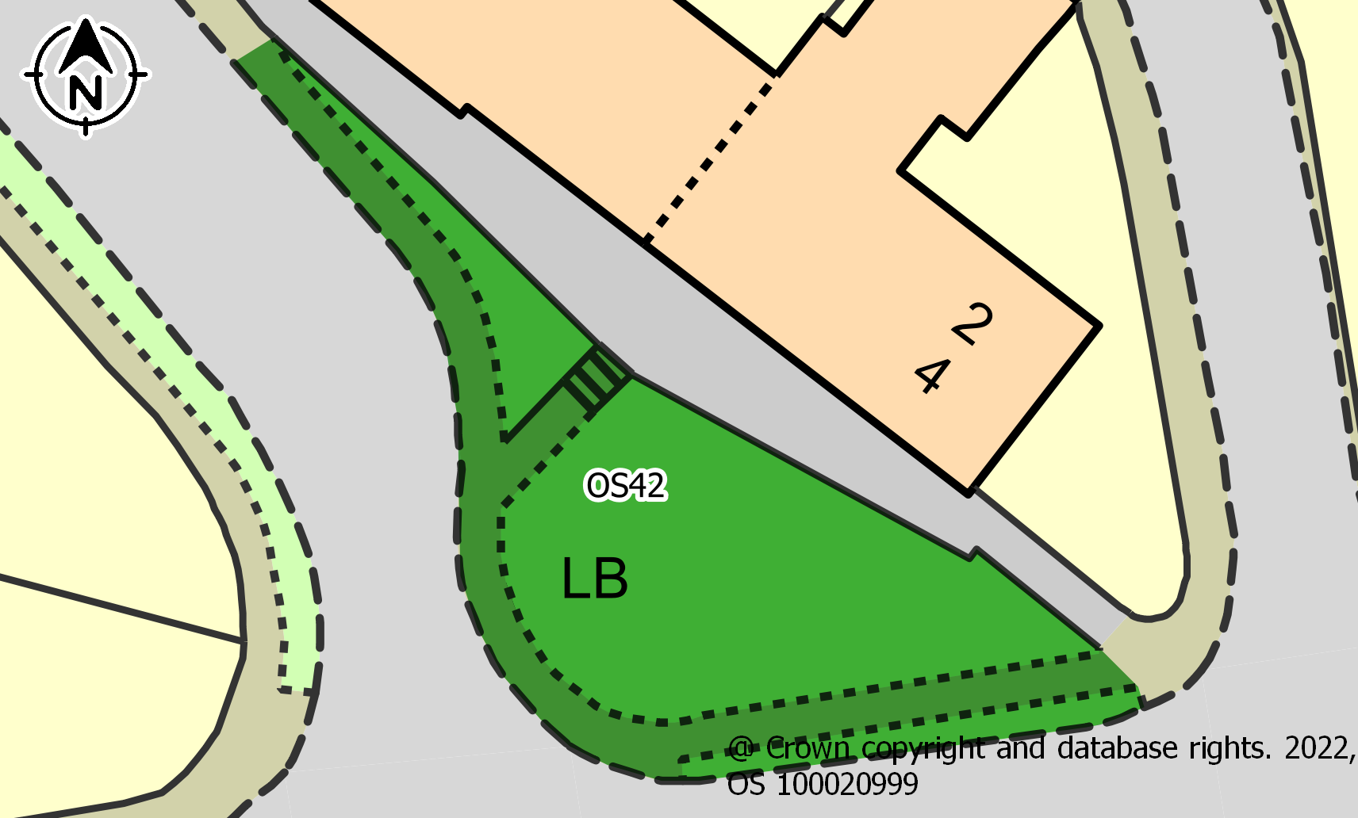
ASSESSMENT CRITERIA |  | COMMENTS | CRITERIA MET?
1. Reasonably close proximity to the community it/they serve(s) |  | In front of one of two parades of shops in Coldean
2. Demonstrably special to a local community and holds a particular local significance. |  | Residents associate this area with the identity of Coldean. A meeting point for the village.
3. The area is local in character and is not an extensive tract of land. |  | Seen as an appurtenance to the parade of shops
4. Actively and currently used by the community |  | Daily use by residents meeting each other
Conclusion: |  | This space meets the criteria for designation as a Local Green Space

APPENDIX 2 – COLDEAN OPEN SPACES MAP
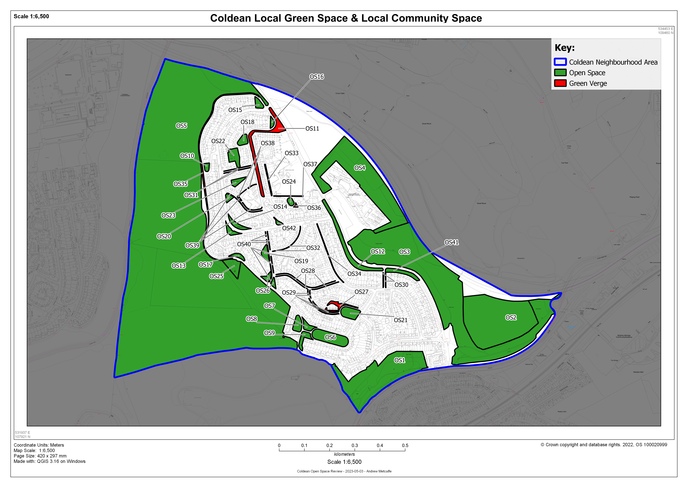

APPENDIX 3 – COLDEAN LOCAL GREEN SPACE & LOCAL COMMUNITY SPACE MAP

