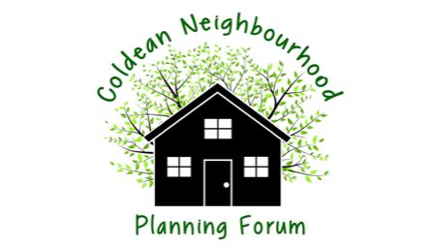

**Minutes of Committee meeting 7.15pm on 24th July 2025 by Zoom**

|  |  |  |
| --- | --- | --- |
| 1 | **Apologies**  Jean Thomas, Manish Suchak  **Present** Debbie Annells (Minutes); Patrick Lowe (Chair); Anant Suchak(Treasurer) and Jack Moxley (Publicity) |  |
| 2 | **Minutes of Forum Committee meeting on 3rd June 2025.**  **T**hese were agreed by all with no amendments. |  |
| 3 | **Dates for future Committee meetings.**  See below. |  |
| **Part B** | **Main Business** |  |
| 4 | **Feedback from BHCC on moving forward and the Regulation 16 Consultation.**  Documents including v20 of the Plan had previously been submitted to the BHCC Council Planning team, early on. with links to the following documents already on the CNPF website, under a new Final documents tab. The Council had responded and asked for a separate Equalities Impact Assessment which PMR produced, and which is now also on the CNPF website, along with more information and evidence from the Regulation 14 Consultation :-.  Under a new Evidence Tab sub-section called Regulation 14 Consultation Responses:-   *Regulation 14 online survey summary (anonymised)  * Individual feedback response (anonymised)   *Southern Water response  * SDNPA response (South Down National Park Authority)  * BHCC response 35 pages with extra column for CNPF actions: and  * A summary of the paper responses to the Reg 14 survey.    *Under the Evidence tab of the CNPF website there are also three new documents namely:  *Anonymised data from the Traffic and Travel online survey done in June 2023  * OCSI Coldean  Insights Data Summary June 2023: and  * Outcomes of the Forum  Vision meetings in November 2022  The Council had requested their detailed Comments document should be included within the text of the Consultation Statement and also the SDNPA detailed comments and our response column. We plan to write to the Council Planning team about whether it is really necessary to include these full documents within the Consultation Statement. Patrick to contact West Saltdean about their experience with the Council and the Consultation Statement as theirs is only about 30 pages long.  If necessary we can ask our printers to print one set of all CNPF meeting minutes rather than including all the individual pages in the Consultation Statement. On line readers prefer hyperlinks, although we appreciate the documents need to be printed in paper format for Library reviews during the Regulation 16 Consultation.  Possibly the Devolution of the Council is affecting timings of Consultations on our NP.  We shall issue a further Update to Forum Members, on progress, and the many new documents loaded, on to the CNPF Website. | **Patrick to contact West Saltdean NP team**  **Debbie to draft letter to BHCC Planning Team about the amount of detail within the Consultaion Statement when it is mainly on line already.** |
| **5.** | **Planning Applications Update**  There had been objections lodged for HMO applications in Park Rd, and both these objections had been upheld, which was good news. |  |
| **6.** | **AOB**   * It was noted that the SDNPA Plan Review feedback was now available, including our comments on the Stanmer Park Car Park planning application process * Coldean Community Organisation have verbally confirmed they will write to the Council, the owner of Site 21a, to designate that site as an Asset of Community Value, especially now that it has been included by the National Trust as Chalk Downland in its Changing Chalk map (as from March 2025). We shall follow this up at the CCOrg AGM expected in September 2025. |  |
|  | **Meeting closed at 7.45 pm** |  |