OPIATE ADDICTION
PATHOPHYSIOLOGY AND HERBAL INTERVENTIONS
Dr Jillian Stansbury

CHASING THE DRAGON
Opiate addiction is an enormous and devastating health problem worldwide, with over 4 million active addicts in the US alone, and over 1.5 million heroin addicts undergoing treatment each year. And not only the addict is affected as of course, marriages suffer or are ruined, jobs are lost, meaningful relationships to people, other hobbies, nature, and the world at large are lost, and most of all, the mind and body are destroyed bit by bit from heroin use. Many addicts become homeless once loved ones can no longer tolerate the thefts and behaviors, and employers cannot forgive the absenteeism. The homeless population is subject to its own vast litany of problems, being at risk for violent deaths among them.
Prescriptions for opiate-based analgesics has skyrocketed in the last decade according to DEA statistics , which many people report is an inciting factor that ultimately leads to heroin addiction. The opiate industry itself is almost nothing but dark - troubled by the limited availability of raw material, low yields, and the by-product of toxic wastes, in addition to the addiction, crime association, and high mortality and morbidity. Furthermore, an attempt to gain access to poppy raw materials the US may be a hidden agenda in US’s efforts to muscle its presence into Afghanistan. Canadian economics professor, Michel Chossudovsky reported that “Heroin is a multibillion dollar business supported by powerful interests, which requires a steady and secure commodity flow. One of the “hidden” objectives of the war [in Afghanastan] was precisely to restore the CIA sponsored drug trade to its historical levels and exert direct control over the drug routes.”
Most users begin their use of heroin by smoking it, a practice which rapidly loses the high or reward first experienced, causing them to progress to intravenous use. This too loses

its satisfying effects, so users imbibe greater and greater quantities of heroin over time. Many users experience such bliss, comfort, and sense of satisfaction and belonging upon the first use of heroin that they pursue that feeling again and again, a phenomenon referred to as chasing the dragon, where escalating quantities of drug are necessary to achieve the same level of satisfaction. Many heroin overdose deaths, of which there are around 30-40,000 per year in the US, follow a period of abstinence, whether voluntary or due to incarceration, where users no longer have the tolerance that they once did, but return to using the same quantity.
The expense of heroin combined with the physical dependence characterized by substantial debilitating withdrawal symptoms, enslaves users. Those without the disposable income necessary to fuel the habit often turn to selling possessions or even stealing to keep the habit going and keep from becoming devastatingly ill.
Current treatments rely on easing immediate withdrawal symptoms and most commonly replacing illicit drug use with long-acting opiate drugs. However, the success of this approach is poor, often reported as 3-6%, about the same percentage of people who manage to quit opiates of their own volition, without treatment. Clearly, there is much to be learned about shifting the addicted brain and biochemistry in ways that may improve the dismal success rates of the current treatments for heroin addiction. Although this paper will explore herbs and discuss them in terms of the current neurological research, there is much to be said for any and all spiritual and nature-based endeavors and creating extreme shifts in friends, daily routines, and habits of all types as essential complements to the herbs discussed in this document.
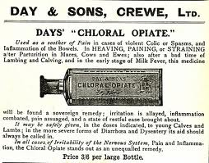

AN OPIATE EPIDEMIC IN THE US
The US consumes more opiate prescription drugs than any other country. Rampant opioid abuse is a public health crisis and many communities and public health organizations report an opiate epidemic. The CDC reported in 2011 that opiate sales, substance abuse admissions, and opiate overdose deaths had all risen in the decade between 1999 and 2008. The number of deaths per year by drug or other poisoning has tripled in the last 30 years and now exceeds motor vehicle deaths per year. New York City health statistics reported 21,600 incidents of inpatient and emergency room admissions for opiate related issues all years prior to 2006, and over 126,000 in a 6 year period after 2006. Some communities report waiting lists for admission to methadone maintenance treatment programs.

PAIN AND ADDICTION
The Sweet Sister of Sleep
Opiates ease both physical and emotional pain and poppy-based herbal remedies have historically been embraced for their ability to bring on blissful sleep. Some users find their way to heroin following a long relationship with prescription opiates, such as oxycontin prescribed for chronic pain. Yet sensitivity to pain is exacerbated upon withdrawal from opiates. Furthermore, the chronic use of opiates causes a tolerance to anti-nociceptive agents (pain-relievers) of all types to develop, all causing physical pain to escalate overtime. The opiates do nothing but offer a band-aid for pain relief, do nothing to address the underlying cause of pain, and make it increasingly difficult to not rely on pain-relievers in ever increasing amounts. Emotional pain appears to predispose to addiction as well. As discussed below, the majority of addicts also have a history of anxiety, and especially depression. Therefore those treating opiate addiction should be well armed with effective non-opiate therapies for pain, as well as cognitive, neurological support, and behavioral, spiritual, and social interventions to manage mental-emotional states.

THE OPIATE SYSTEM BASICS
The opioid system on the brain helps regulate pain, temperature, mood, and hormones. Evolutionary biologists report that the endogenous opioid system has played a role in complex social behaviors including the formation of committed emotional and reproductive pair relationships and attachment in bonding between and mother and child/offspring. The opioid system also plays a role in the “reward pathway”. Opiate drugs are exogenous agents able to bind to opiate receptors and activate the “reward” sensation, unfortunately, the opiate drugs seems to be a higher priority reward than the emotional bonding opiate pathways have evolved to encourage.

TYPES OF OPIATES: ENDOGENOUS AND EXOGENOUS

THE ENDOGENOUS OPIATES
Enkephalins – mediate reward pathway
Dynorphins – mediate general mood, tone, and emotional affect.
Endorphin – help temper the discomfort of stress and trauma, both mental and physical.
Nociceptin – helps mediate pain
Morphine – occurs endogenously but its role as yet unclear.

THE PRESCRIPTION OPIATES
(There are over 250, following is a sample)
Paregoric – an early opiate derived drug used to treat diarrhea
Laudanum – an early alcohol macerated tincture of opium used to treat pain and induce sleep.
Vicodan – Commonly prescribed analgesic
Hydrocodone - Analgesic
Oxycontin/Oxycodone - Analgesic
Hydromorphone (Dilaudid, Hydal)
Oxymorphone (Numorphan, Opana)
Codeine and Dextromethorphan - Anti-tussives
Loperamide - Anti-diarrheals
Fentanyl
Pethidine/meperidine
Morphine – usually used in hospital settings for extreme pain.
The Morphinan family of agonist-antagonist drugs (levorphanol, dextromethorphan and others)
Trivalin - a European drug combining morphine and a Valerian derivative used for sleep.
Tetravalin – A compound combining codeine and valerates.
“Krokodril Korrosion” from gallopingbeaver blogspot
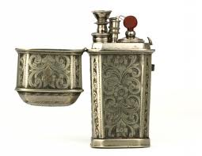
THE NATURALLY OCCURING PLANT OPIATES
Opium
Codeine
Morphine
Thebaine
Papaverine

THE OPIATES OF ABUSE
Opium -
Heroin - is classified as a short acting opiate.
Desomorphine (Krokodril) Russian semi-synthetic opiate, 8 times more potent than morphine and associated with horrifying decay of tissue called “Krokodril Korrosion”, Hydromorphinol

OPIOID ANTAGONISTS INCLUDE:
Naloxone (Narcan) - typically used parenterally in research.
Naltrexone (Vivitrol, Trexan) - administered as a long acting injection
Naltrexonediprenorphine (M5050, the reversing agent for the Immobilon dart)
Nalorphine (Nalline)

THE OPIOID MAINTENANCE THERAPY (OMT) DRUGS
Methadone – long acting opiate agonist
l-alpha-acetylmethadol (LAAM) – long acting opiate agonist
Buprenorphine (Suboxone) – long acting opiate agonist
Buprenorphine-Naloxone combination - Partial agonist and partial antagonist.

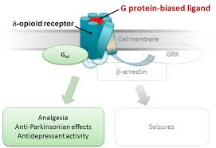

OPIATE RECEPTORS AND OPIATE RECEPTOR LIGANDS
Endogenous opioids in the brain include dynorphins, enkephalins, endorphins, endomorphins and nociceptin that bind to various opioid receptors and are further discussed below. Opioid pathways are widely distributed in the brain and particularly concentrated in the “reward pathways” of the nucleus accumbens and amygdala – two limbic system structures. Opioid receptors are also concentrated in the digestive tract. Opiate receptors are proteins that occur on neuronal membranes and receive the endogenous opiates, as well as mediate the pharmacological effects of various opiate drugs. Examination of brain extracts for substances that mimic the effects of opiates on the opiate receptor first permitted the identification of the enkephalins, a dominant endogenous opiate.
Like many receptors, the opiate receptors are associated with G-proteins which help transduce the signal from the opiate receptors to the inside the cell, where the cell can respond. Also similar to other receptor types, (Insulin and Adrenocorticotropin for example) when repeatedly stimulated, opiate receptors may become desensitized and less responsive – a phenomena commonly referred to as “down regulation” in chemistry, and in terms of heroin and opiate addiction, “tolerance.”.
There are various sub-types of opiate receptors that help fine tune and offer varying degrees of responsiveness. Different ligands (molecules capable of binding opiate receptors), because of varying 3-dimensional structures can agonize (bind and stimulate) and antagonize (bind but block) the receptors to varying degrees. Opiate maintenance drugs may act as antagonists……. And some act as antagonists.
Both G protiens and Beta arrestins, intracellular proteins, play a role in transducing the opiate receptor signals inward. Down regulation involves diminished recruitment of Beta Arrestins to the receptor complex.

OPIOID RECEPTORS ARE OF THE FOLLOWING TYPES:
Delta Opiate Receptors (DOR)
These receptors are named Delta after the d in vas deferens, the tissue in which this receptor type was first identified. Delta receptors are found in the brain, especially in the amygdala and olfactory bulb, and peripheral sensory nerves. DORs play a role in pain and mood. DOR agonism also plays a role in analgesia. DOR stimulation can promote convulsions when in excess. Enkephalins especially have a high affinity to bind to DORs.

Kappa Opiate Receptors (KOR)
Named K because ketocyclazocine was first found to bind to this receptor type. KORs are
found in the hypothalamus, various brain tissues, and peripheral sensory nerves.
The κ-opioid's agonism is responsible for the pinpoint pupils, and in back pain patients, the spinal analgesia occurring with opiates. KORs
play a role in pain, diuresis, mood and nerve tone. May offer neuroprotection and abolish convulsions.

Mu Opiate Receptors (MOR/μ-OR)
Named Mu because morphine was first found to bind to this receptor type.
Found throughout the brain and in peripheral sensory neurons, as well as in the intestinal tract
The highest densities of MORs are found in the posterior amygdala, hypothalamus, thalamus, nucleus caudatus, putamen, and certain cortical areas. MORs are also found on the terminal axons of primary afferents of the spinal cord and in the spinal nucleus of the trigeminal nerve.
Human endothelia also possess MORs that play a role in the release of Nitric Oxide.
Morphine is a weak agonist of MORs and enkephalins are strong agonists of MORs.
Salvinorin A, from Salvia divinorum can be used to semi-synthesize Herkinorin, a substance shown to antagonize MORs
Anandamide – binds MORs
The Mu receptors are the most studied and discussed of all opiate receptors and play a role in pain and are the most noted to be involved in exogenous opiate addictive disorders.
There are several subtypes of MORs:
μ1: involved in analgesia and physical dependence
μ2: can depress respiration and GI motility, can promote euphoria and is associated with physical dependence.
μ3: May help control vasodilation

Zeta Opioid Receptor/ Opioid Growth Factor Receptor (OGFr)
This receptor binds met-enkephalins and has been shown to be a cellular growth factor modulator.

Nociceptin Receptors (NOP)
(check out pyridines as agonists)
Nociception is the phenomena of recognizing and responding to various noxious influences. Nociceptin is synonomous with Orphanin FQ. Orphan receptors are so named when they have been identified to exist but their physiological role and function are unknown. Nociceptin was renamed as such when the FQ receptor was “deorphanized” in 1995 as the agonists and antagonists of this receptor became elucidated.
Nociceptin is an opiate-like neurotransmitter and Nociceptin receptors can be grouped with the opiate receptors or classified independently. Nocieptin receptors are most abundant in the hypothalamus, amygdala, hippocampus, habenula and spinal cord and play a role in mood, anxiety states and depressive disorders, and appetite. Nociceptin receptors are also involved in the development of a tolerance to MOR agonist – i.e. opiate addiction.
Some herbs may reduce opiate tolerance via activity at nociception receptors and thereby reduce the consumption of escalating quantities – a practice philosophically considered to be “Harm reduction”.
Some opioid analgesics are referred to as agonist-antagonists because they first relieve pain, but within several hours, worsen pain. NOPs appear to be the site of action of agonist-antagonist analgesics. NORs are not suppressed by Naloxone as are the other opiate receptors.

(Sigma Receptors)
These were once considered to be a type of opioid receptor as some early opioid drugs were found to bind to these receptor types, however, since endogenous opiates do not bind sigma receptors, they have been removed from the opiate group.

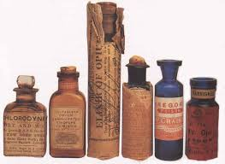

ENDOGENOUS OPIATE AGONISTS
ENKEPHALINS are opiate neurotransmitters that occur naturally in the human brain and are contained in specific neurons localized to areas rich in opiate receptors. Enkephalins are particularly strong agonists of the Mu Opiate Receptors, but also bind to delta opioid receptors. ????? Enkephalin-containing neurons are concentrated in portions of the brain that mediate pain perception, emotional behavior, and other functions altered by opiates.
Enkephalins are involved in nociception in the body - neural processing and interpreting noxious stimuli. Enkephalins help the body to respond to things that are potential threats to health or injurious to the tissues. Special nociceptive pain receptors detect mechanical, thermal, and chemical threats and transmit the information via the spinal cord for interpretation by the autonomic nervous system via delta opioid receptors. The greater the noxious trigger, the faster the nociceptive neurons fire and the greater the sensation of pain intensity.

ENDORPHINS are produced in the pituitary gland and released into the blood stream when we experience love, as well as in response to pain, stress and excitement, exercise, sexual activity, and consumption of hot and spicy foods. Endorphins are released as part of the pro-opiomelanocortin (POMC) complex, which is also the precursor hormone for adrenocorticotrophic hormone (ACTH). Therefore, both endorphins and stress hormones have traits and triggers in common. Beta- Endorphins are found in high amounts in the hypothalamus, like stress regulators and released from the pituitary gland, like the adrendocorticotropin, the major stress modulating pituitary hormone.
The word endorphin is derived from it being an “endogenous morphine” and is one molecule of the reward system, helping to encourage food seeking effort and to enjoy sexual activity. Endorphins are often mentioned in the context of the “runner’s high” when extended muscular exertion releases this endogenous opiate and promotes a feeling of elation, even in the face of physically challenging or even uncomfortable activity. Endorphins accomplish this “high” by promoting dopamine release, the other main molecule of the reward pathway.
Endorphins are also released in response to pain, presumably to help us endure, prevent panic, and support emotional recovery from trauma. Beta-endorphin (β-endorphin) is the most studied and has a high affinity for the mu opiate receptor and slightly less affinity for the delta opiate receptor and a low affinity for the K opiate receptor.

ANANDAMIDE was isolated in brain tissue in 1992 beginning research to accept it as a bona fide human neurotransmitter involved in the regulation of stress responses and pain. Anandamide was so-named after the Sanskrit word for bliss, Ananda. Anandamide binds to cannabinoid receptors in the brain.
Anandamide is degraded by the serine hydrolase enzyme, fatty acid amide hydrolase. This enzyme is rapidly mobilized at times of stress to inactivate the anadamide signals, allowing for greater neuronal excitability in the amygdala. Animals experience greater stress symptoms when these enzymes are blocked. In cases of long standing fear, such as post-traumatic stress disorders, blockade of this enzyme may be therapeutic by promoting cannabinoid signaling in the amydala.
Anadamide may also bind to Transient Receptor Potential (TRP) Vanillioid receptors and researchers believe that this also may mitigate conditioned fear responses. Anadamide may help mitigate and lasting effects from negative events to help prevent them from becoming emotionally crippling.

DYNORPHIN and PRODYNORPHIN are lesser known endogenous opiates that appear to help temper a depressive and negative outlook. Dynorphins bind to kappa opiate receptors (KORs). Postmortem examinations of brain cortex in the region of the amaydala in heroin abusers and those suffering from major depression both show reduced levels of prodynorphin. Furthermore, suppression of prodynorphin neurons increases metabolic activity in the amygdala as the region attempts to mitigate this emotional stress. Thus, it has been hypothesized that prodynorphin can promote a positive outlook and suppression of prodynorphin promotes a negative affect.
Those with innately low levels of prodynorphin may be prone to both depression and vulnerable to opiate addiction. Animal studies suggest that dynorphin activity in the nucleus accumbens mediates the increasing motivation for heroin taking and compulsive-like responding for heroin, suggesting that KOR antagonists may be promising targets for the treatment of opioid addiction.

MORPHINE Although long suspected to occur endogenously due to the existence of morphine receptors in the brain, innate morphine was not proven until 2003 when trace amounts of morphine could finally be demonstrated. Most commonly, morphine is discussed as an exogenous compound obtained from Opium poppies and considered the gold standard pharmaceutical, for severe pain such passing kidney stones, metastatic cancer, nerve-impingement, severe burns etc.

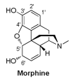

NOCICEPTIN is a neuropeptide identified in the last decade and now classed as part of the opiate system, even though it is physiologically distinct and the other endogenous opiates do not display a strong affinity for nociceptin receptors. In addition to nociception, other peptides and non-peptide compounds have been shown to agonize and antagonize nociceptin receptors and play roles in pain modulation, anxiety, food intake, learning, memory, neurotransmitter release, reward pathways, and tolerance development, similar to the other endogenous opiates and the opiate receptors. Therefore, nociception can be classed with the opiates or independently.
Nociceptin activation inhibits the release of several neurotransmitters, including serotonin and dopamine thereby inhibiting the reward pathways activated in addictive disorders – the opposite of what endogenous opiates and opiate drugs of abuse do. Of importance to heroin and opiate addiction, nociceptin activation will reduce morphine’s binding affinity and inhibit dopamine release in the nucleus acumbens. The promotion of nociceptive pathways may therefore be beneficial in opiate addiction, however excessive promotion may inhibit normal memory formation. Researchers are now experimenting with various peptide and non-peptide agonists of these receptors in search of new pain medications, as well as new possible therapies for opiate addiction.
In 1998, a Pfizer patented a series of morphinan acids claimed to be nociception antagonists while being agonists to at the μ, δ, and κ opioid receptors, hoping to develop the compounds into new analgesics. Benzimidazopiperidine is a nonpeptide nociceptin antagonist and patented by Banyu Pharmaceutical Co. in 1998.

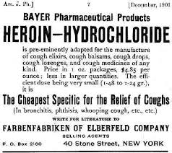

OPIATE DRUGS OF ABUSE
Morphine and Heroin
Morphine is the precursor to the illegal manufacture of heroin, and the legal manufacture of hydromorphone and oxymorphone, however thebaine and codeine can also be used as a raw material in the pharmaceutical industry. There are at least 250 different drugs derived from morphine that have been developed over the last century. By manipulating the morphine molecule it is possible to produce substances over a thousand times as powerful as morphine, such as the Immobilin tranquilzer dart used to fall a charging rhino or elephant.
The analgesic effects of morphine last around 3 or 4 hours when given parenterally and 3 to 6 hours when given orally. Morphine can be taken orally, sublingually, bucally, rectally, subcutaneously, intravenously, intrathecally or epidurally, and inhaled via a nebulizer. Morphine is occasionally given as an Opiate Maintenance Therapy for patients who cannot tolerate methadone or buprenorphine, or for those who fail these drugs.
Morphine and heroine are highly addictive substances due to the euphoria they produce. Both tolerance and psychological dependence on this euphoria can develop in only a few exposures. Morphine interacts predominantly with the μ-opioid receptor, but also with κ-opioid and δ-opioid receptors.
Medical morphine is contraindicated in several medical conditions, and heroin addicts may put themselves at great risk when self-administering drugs concomitant with acute respiratory depression, renal failure, chemical toxicity, biliary colic, and elevated intracranial pressure, pre-existing conditions which can contribute to heroin and morphine-related fatalities.

Heroin is also known as morphine diacetate, diamorphine or di-acetyl-morphine. Heroin is an ester of morphine and a morphine pro-drug and the substances have identical effects. Upon consumption, whether smoked or injected, heroin is converted to morphine in the body and then binds opioid receptors in the brain and spinal cord, and elsewhere, such as the gastrointestinal tract. Because morphine causes slightly less physical addiction, morphine is preferred in the medical arena. Heroin crosses the blood brain barrier more readily than morphine, making a comparable dose of heroin more powerful than morphine, but also more toxic and with greater tendency to tolerance and abuse. Following heroin’s conversion to morphine, morphine is metabolized into small amounts of normorphine, codeine, and hydromorphone. Most heroin drug screen urinalyses test for these metabolites.

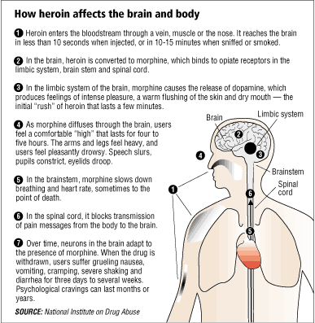

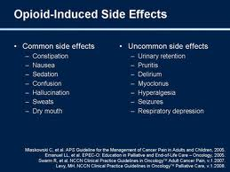

FROM OPIUM TO MORPHINE
TO HEROIN
The English physician Thomas Sydenham developed a remedy easier to administer than crude opium, with the advent of an opiate tincture called laudanum, in 1683. Laudanum became the leading pharmaceutical for pain for several hundred years. Paracelsus, however, used the term “laudanum” 150 years prior for his own opiate-based pain remedy, and chose the name from the Latin verb “laudare”, meaning to praise.
Morphine is said to be the first ever plant alkaloid to be purified and was isolated in 1804 by Friedrich Sertürner. He distributed the substance as an analgesic himself for a decade until it began to be produced and sold commercially by a small independent chemists’ apothecary that has since grown into the pharmaceutical giant Merck. The sale of Morphine became even more popular after the development of the hypodermic needle in 1857. Heroin was first synthesized from Morphine in 1874 and bought to market by Bayer in 1898. It became possible to synthesize morphine from petrochemicals in the 1950s.
Upon its initial discovery, morphine was thought helpful for opium addiction and alcoholism but was quickly realized to be more addictive than either opium or alcohol. Morphine was used widely during the American Civil Was and resulted in some 400,000 soldiers with morphine addiction. Thomas de Quincey published Confessions of an English Opium-Eater in 1821, inciting a national debate on opiate drugs.

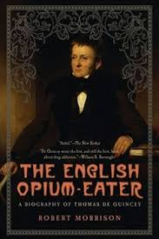
OPIATE TOLERANCE
The euphoria-promoting effects of heroin and other opiates wear off fairly quickly necessitating higher and higher doses to yield results – a phenomena referred to as tolerance. Tolerance occurs due to several mechanisms involving changes in the number of opioid receptors, the phosphorylation responses of the receptors, up-regulation of cyclic AMP pathways, and molecular changes involving the G proteins and beta-arrestins to which the opiate receptors are coupled. cAMP up-regulates as a counter-regulatory mechanisms to oppose the sedating effects of opiates.

AGENTS THAT SLOW OR PREVENT OPIATE TOLERANCE
If someone with an addictive personality or drug and alcohol abuse in the family tree must go on opiate drugs for surgery or severe pain, the use of agents shown to prevent tolerance may help keep the dosage low and make it easier to withdraw from once the ailment has been healed. Researchers believe that rotating pain relievers will reduce tolerance. Otherwise, the following agents are theoretically useful for this purpose.
Proglumide – a CCK-antagonist drug that has been shown to slow the development of tolerance to morphine.
N-methyl-D-aspartate (NMDA) – reduces tolerance at μ-opioid receptors and NMDA is being explored for addictions. NMDA antagonists such as ketamine or dextromethorphan may deter opiate tolerance.
Olea -. Olive leaves contain oleuropein shown to prevent tolerance to morphine by preventing the up-regulation of calcium channels.
Zingiber may potentiate morphine’s analgesic effect via calcium channel blockade and many other mechanisms.

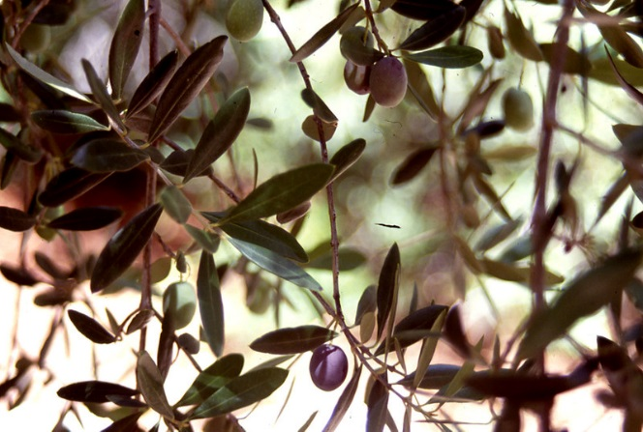
Olea leaves may prevent morphine tolerance

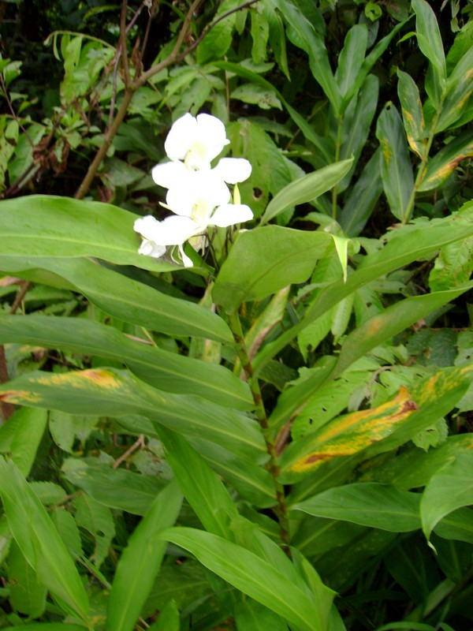
Zingiber potentiate morphine’s analgesia

SYMPTOMS OF
OPIATE WITHDRAWAL
Increased pulse rate
Dilated pupils
Bone and Joint paitn
Runny nose and tearin
Tremors, shaky hands
Yawning, several times per minute at times
Anxiety and Irritability
Goosebumps
Intestinal cramps and diarrhea
Perspiration

OPIATE WITHDRAWAL SYMPTOMS
The cessation of heroin causes marked physical withdrawal symptoms. Anxiety, irritability, dysphoria, drug craving, and possibly perspiration begin between 6 and 14 hours from the previous dose. Around 14 to 18 hours after the last dose, yawning, heavy perspiration, lacrimation and runny nose will follow, and for many addicts, a trance-like state where sleep is desired but rarely achieved. Within a day to a day and half from the last dose, intestinal symptoms begin and include headache, nausea, vomiting and diarrhea, along with intestinal cramps that may worsen or persist for a full 24 to 72 hours. Hot and cold flashes, with goose bumps, where the term cold turkey comes from, and shivering are typical. The pupils become dilated, the pulse is elevated, and restlessness occurs, often with spastic and restless legs, where the term “kicking the habit” is derived. The intestines display a markedly increased transit time and many addicts will lose weight during this phase of withdrawal. A person is much more sensitive to pain during the withdrawal phase making all the above symptoms especially agonizing. Head pain, bone and muscle pain, and severe aching in the back, and extremities are common. Most of the physical withdrawal symptoms, even without any treatment whatsoever, will pass within a week to 10 days. Many nutritional, herbal and other natural remedies can help considerably in easing acute withdrawal symptoms.
While withdrawal is not usually highly dangerous, the acute increases in blood pressure and heart beat rate, heart attacks, blood clots and stokes are possible. As severe as the symptoms are, acute heroin withdrawal is statistically less dangerous that barbiturate, benzodiazepine, or alcohol withdrawal.
The psychological dependence and withdrawal is the most difficult, perhaps a decade or more long process and is complex and individual. Most addicts in recovery experience depression, anxiety, sleep disturbance, confusion, apathy, mood swings, forgetfulness, poor coping behaviors, and an almost endless list of psychological and social difficulties. There is a high probability of relapse, especially in the early months and years, if serious and aggressive behavioral and medical interventions are not implemented. In fact, heroin addicts have the highest relapse rate – a whopping 98% - of all prescription and non-prescription drug abusers.

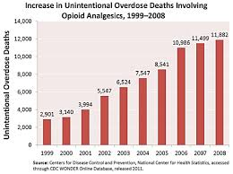

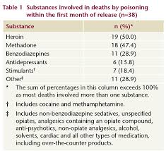

HEROIN OVERDOSE AND MORTALITY STATISTICS
Heroin can be fatal when severe nervous system sedation leads to respiratory depression and ultimately asphyxiation. Heroin dosages of 200 mg is the minimum lethal dose typically seen, but as little as 60 mg has been fatal in some sensitive individuals. Heroin addicts may ingest 2-3 grams of the drug per day while in a state of active addiction and tolerance.
Heroin overdose deaths are mostly associated with the use of other drugs, especially benzodiazepines simultaneously. Many other heroin overdoses occur when an addict has been clean for a period of time, and then relapses and ingests a dose which they were previously tolerant of, and thus the blood level of heroin may be less contributory to overdose deaths than the situation. Opioids account for more drug poisoning than any other substance for men between 45 and 54 years of age with Caucasion and Native Americans being most likely to die from the drug. The CDC reported in 2010 that there had been 36,450 deaths due to drug overdose in 2008, and prescription opiates were most commonly involved. Injecting drugs is associated with increased morbidity and mortality in general. One study in Ireland showed that 63% of a cohort of men aged 20-29 with a history of IV drug use, who had been imprisoned and were unemployed were dead in 15 years, with most deaths associated with the HIV or Hepatitis virus. A similar cohort study on young (under 30 years) San Francisco intravenous drug users showed that the mortality rate of heroin users was 10 times that of young non-IV drug users, with overdose the leading cause of death, followed by suicide, accidents, and IV drug related illness such as viruses and infections.
Naloxone, an opiate blocking drug, is the drug most commonly given for acute heroin and prescription opiate overdose and can be lifesaving. Naloxone is used for acute overdose symptoms, but will, of course, also initiate acute and severe opiate withdrawal symptoms.

PAPAVER SOMNIFERUM
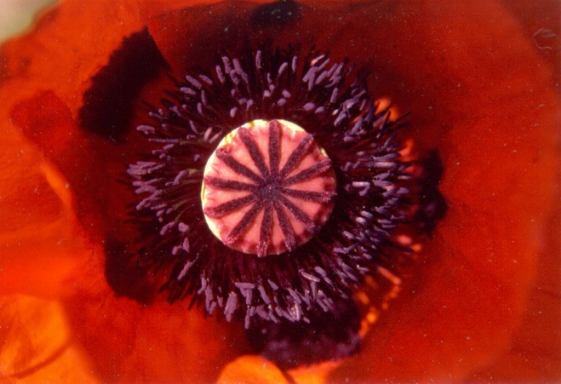

Papaver somniferum, so named for its sleep inducing properties, is lovely flowering plant of the Papaveracea, or Poppy Family. India, Asia, Turkey, and Tasmania are thought to be the original habitat of the Papaver somniferum, also called the Opium Poppy as it has been used to produce crude opium for thousands of years.
The Papaver genus includes many members with a low opiate content, with the P. somniferum species being the most plentiful in opiates including morphine, which accounts for 8 to 14% of the dry weight of opium. Some Papaver somniferum cultivars have been bred to contain as much as 26% morphine. The Norman strain produced in Tasmania and the Przemko strain are cultivars of P. somniferum that have been bred to contain other alkaloids including thebaine and oripavine, both used in the pharmaceutical industry as the raw material to semi-synthesize prescription opiates such as oxycodone. Papaver bracteatum is another species of poppy is used as a natural source of thebaine. In addition to oxycodone, theabaine may be used to produce hydromorphone, dihydromorphine, dihydrocodeine, tetrahydro-thebaine, and hydrocodone. Heroin is diacetylmorphine and produced from morphine as an illicit substance in clandestine labs. Related poppies, Papaver orientale and Papaver bracteatum have also been bred to yield greater quantities of the raw material, thebaine.
Morphine is the most abundant of at least 50 alkaloids found in the Opium Poppy, Papaver somniferum, and is named after Morpheus, the Greek good of sleep and dreams. Morphine is derived from opium, a sticky resin naturally exuded when the spent flower heads of the opium poppies are superficially scored. Morphine is best extracted from the young seed heads of the Opium Poppy, while it is still moist and resinous and before they have dried. Technology exits however, to process dried material and even opium “straw” to yield opiate drugs.
Opiate alkaloids are bound to meconic acid within the poppies, and stronger acids are used to purify the alkaloids. Incising the fresh live plants as often as 4 or 5 times a day is the method most typical in India to yield crude latex from which opium can be derived. Stewing the entire fresh flower pods, a procedure called the Gregory process, was developed in the UK during WWII to help provide raw material for manufacturing pain medications. Another European method involves steaming poppy straw – a term for the dried stalks and seed pods. Hungary at one time in the 1950s and 1960s was Europe’s leading supplier of opium poppies, but it has since become illegal to grow poppies except in small plots to supply the floral industry.
Morphine possession and consumption without a prescription was outlawed in the US as of 1914, a time when morphine was the most abused narcotic in the world. Heroin began to be synthesized from morphine in the early 1900s and oxycodone in 1916. The molecule structure was elucidated in 1925 and the ability to synthesize opioid drugs, rather than rely on crude opium extracts, was established in the 1950s. In 1973 the US National Institute of Health announced it would be promoting the synthesis of medical opiates from coal tar due to shortage of naturally occurring opiates, and as part of the “war on drugs” platform. However, the vast majority of morphine is still derived from the opium poppy and the current source is Eurasia and Afghanistan. An area called the Golden Triangle, where Thailand, Vietnam and Lao borders intersect along the Mekong River is a wild and rather lawless area where illegal opium and opiate drugs are thought to pass through international borders for widespread trade, in the dark of night, along the sparsely populated riverfronts. Afghanistan was a lead producer of opium poppies, until banned by the Taliban in 2001. Since the fall of the Taliban, Afghanistan is once again a lead supplier, along with Pakistan, Northern India, and Burma. Mexico and Columbia are the main producers in the Americas. Growing Poppies is vastly more lucrative than other crops making it highly attractive and tempting for poor farmers of the world. The UN blames some 1 million deaths in the last decade on Afghan opiates, and NATO coalition forces are strategizing how to shift the illegal opium industry toward a legal operation to help supply the worlds’ growing demand for opiates. A driving factor for the war against the Taliban is to maintain US access to opiates.

THE “ADDICT” PROFILE
Negative emotional states and abnormal stress reactivity are central components in drug addiction of all types. One study reported that drug addicts display significantly greater depression and anxiety than those who occasionally use/abuse addictive drugs. Other researchers report that there is a high comorbidity between depression and opiate addiction. Furthermore, genes that regulate the precursors to endogenous opiates may be abnormal at birth in those prone to opiate addiction. Variations of the mu-opioid receptor gene may cause some people to become more quickly tolerant to opiate analgesics or drugs and promote escalating dosages.
Psychologists and behavioral scientists have discussed that poor impulse control contributes to addictive disorders. Individuals with elevated impulsivity are most likely to become addicted to amphetamines, but impulsivity may play a role in many addictive disorders. Neuropsychologists also speak of “negative reinforcement” helping to perpetuate addictive disorder. The drug of choice makes people feel temporarily better, if even very short lived. Upon withdrawal or when not using the drug of choice they feel worse, thus providing negative reinforcement to staying clean and positive reinforcement to use – even if it is clear to the addict intellectually that their health is deteriorating as a result. Part of feeling worse off of opiates is due to the activation of corticotropin-releasing factor (CRF) and CRF-related peptides discussed below. Supporting the hypothalamus-pituitary-adrenal (HPA) axis may be one important prong of addiction recovery.

OPIATE PATHWAYS IN THE BRAIN
Heroin and other opiates profoundly alter molecular and neurochemical pathways in the brain, as well as the resultant physiology. Research suggests that these changes may be extremely long-lasting, and even permanent, causing many former users to return to drug abuse even when they have achieved a drug-free and medication-free state and have regained a modicum and health and a functional life.
Opiates are involved with pain pathways in the central nervous system. With regular exposure to exogenous opiate drugs, the brain’s stress systems including corticotropin-releasing factor (CRF) and norepinephrine (NE) become activated. CRF is a key mediator of the hormonal, autonomic, and behavior responses to stressors particularly in the amygdala, stria terminalis and nucleus accumbens. Compelling evidence argues that the CRF stress system, including its activation of the hypothalamic-pituitary-adrenal axis (HPA), plays a key role in drug dependence. Understanding the role of the CRF systems in addiction provides novel targets for identifying vulnerability to addiction and the treatment of addiction, and a place where herbal medicines may be very valuable.

BRAIN REGIONS INVOLVED IN ADDICTIVE DISORDERS

THE LOCUS COERULEUS
As the Locus Coeruleus (LC)-Norepinephrine (NE) system is important for cognition as well as decision making that underlies substance abuse, adaptations in the brain’s trafficking in these areas may play a role in modulating MOR function. In the addicted brain, changes in the LC can contribute to poor choices, impulsivity, and illogical thinking.

THE AMYGDALA
Large groups of stress mediating neurons pass through the amygdala in the brain, a key location in the CNS where positive and negative reinforcement is thought to take place by regulating stress responses. The amydala has one of the highest concentrations of CRF (corticotrpin releasing factor) outside of the hypothalamus. Acutely, heroin may reduce stress responses to negative, anxiety promoting situations and reduce ACTH and cortisol activation normally seen via stress response pathways in the amygdala. Research suggests that the use of opioids immediately following trauma can reduce the development of Post-Traumatic Stress Disorder (PTSD). Heightened and ongoing fear may involve altered expression of nociceptin receptors in the amygdala. Overactive fear response may also interfere with memory integration and involve that same pathways. By the same effect however, chronic use of opiate may cause addicts to lose the normal and logical sensations of concern, fear, remorse etc., over loosing ones’ job, home, spouse, etc.

VENTRAL TEGMENTAL AREA
The ventral tegmental area (VTA) is the primary place of action for opiates, alcohol, barbiturates and benzodiazapines, and activation of the VTA will lead to increased dopaminergic activity. Withdrawal from these addictive substances may induce sudden declines in dopamine transmission and contribute to anxiety states associated with drug cessation. A classic example of low dopaminergic balance is the tendency to startle easily. The use of dopamine agonists during acute opiate withdrawal may soothe mental emotional turmoil. Selective Serotonin Reuptake Inhibitors (SSRIs such as Prozac) may also reduce alcohol intake, although the mechanisms may be complex and multifactorial and not presently well understood.

THE NUCLEUS ACCUMBENS
The Nucleus Accumbens (NA) is the primary place of action of amphetamine, cocaine, opiates, THC, phencyclidine, ketamine, and nicotine, and will also lead to increased dopaminergic activity. Abstinence from opiates therefore affects dopaminergic pathways, particularly in the nucleus accumbens.

THE MESOLIMBIC SYSTEM
All of the above brain regions collectively comprise the mesolimbic system for which dopamine is a key neurotransmitter. Addictions involve a change in the “set point” of dopaminergic tone in the mesolimbic system. The limbic system helps consolidate feelings of trust, pleasure, and satisfaction from hard work and meaningful relationships in manners that support survival and healthy appetites for activities that are “good for us”. When heroin addiction corrupts the limbic system rewards, it may be more important than ever to engage in pleasurable activities from regular food preparation and meals, to sex and romantic relationships, to cultivating healthy joy-producing relationships with nature, people, pets, and hobbies. This may help rewire a limbic system hi-jacked by opiates. Treating stress with both these activities, as well as adaptogenic herbs, can help re-establish healthy limbic patterns and balance in the autonomic nervous system. Electrode implants in the deep brain have been developed for movement disorders such as Parkinson’s disease and limbic system implants are also being explored as a more desperate measure for addictions and extreme stress symptoms.

VISUAL PATHWAYS AND ADDICTION
Magnetic Resonance Imaging (MRI) research suggests that visual cues in the environment may trigger the craving for heroin and heightened activity can be seen in the insula, amygdala and hippocampal regions of the brain, even during methadone and other maintenance programs, when addicts are exposed to certain visual triggers or cues., This is also why, as stated in the introduction, removing addicts from their former environments, friends, and daily routines may be extremely helpful in the early recovery phases. The medial prefrontal cortex and the extended limbic system in methadone maintenance patients with a history of heroin dependence remains responsive to salient drug cues for months if not years and even decades, contributing to continued vulnerability to relapse. Vulnerability may be highest at the end of the 24-hour interdose interval.

THE DEVASTATING HEALTH EFFECTS OF OPIATE ABUSE AND HEROIN ADDICTION
MRI and other imaging techniques show that the brain undergoes significant changes with chronic heroin exposure, particularly in gray matter volume or gray matter density suggesting a serious deterioration of the brain.
Human investigations suggest that aging of the arteries can be used as a marker of increased aging in the entire system, and opiate use is reported to accelerate the decline of the vasculature, and thereby the health of the entire body. Researchers investigating opium addicts in Iran report that chronic consumption of opiates increases the risk of bladder cancer 5 times that of the general population, slightly more in men than women. Some opiate addicts are also susceptible to hearing loss from opioids due to direct ototoxicity.
Heroin addiction is also extremely suppressive to the immune system and many users are prone to fatal cases of tuberculosis and pneumonia. Combined with the increased exposure to serious infections associated with IV drug use such as AIDS (HIV) and hepatitis, many long term heroin users will die from these infections rather than from overdose. Simple chronic infections also become issues for most heroin addicts. Because opiate receptors are also present on immune cells, morphine and heroin use can suppress the immune system, the production of cytokines which help direct immune responses of blood cells, and many complex effects on interleukins, lipopolysaccharides, dendrites, phosphorylation enzymes and more. Because of all of these changes, heroin addicts are prone to both simple and serious infections, poor wound healing, and suppressed resistance to all manner of infections. The tendency to pick at the skin due to altered sensory and pain regulation combined with poor immunity, results in the many skin lesions, poor complexion, and severe scarring in addicts, not only at injection sites but in the entire integument.
Opiates are typically constipating, but severe diarrhea occurs with opiate withdrawal and long-lasting digestive issues may occur in heroin addicts. Opioids act on the myenteric plexus in the intestinal lining, reducing gastrointestinal motility, slowing transit time, reducing gastrointestinal secretions and absorption, and leading to constipation, often severe. Morphine and other opiates also affect nitric oxide (NO) in the gut, and a sudden reduction in intestinal NO will trigger intestinal spasms when the opiates are removed.

NEUROLOGICAL CHANGES WITH OPIATE ADDICTION
In neurons, adaptations in cell signaling cascades develop following opioid actions at the mu opioid receptor (MOR). Morphine induces proteins that interact with the MORs to re-locate from the cytoplasm to neuronal membrane receptors. Some newly evolving interventions for opiate addiction target activity at these receptors.
The κ opioid receptor (KOR) is also activated with chronic opioid intake, contributes to negative withdrawal symptoms, and helps drive the desire to take increasing amounts of heroin. Animal investigations suggest that the long-acting KOR antagonist norbinaltorphimine may decrease withdrawal-associated anxiety a single high dose of 30 mg/kg.
Many heroin addicts pick, itch, and scratch at the skin as opiate pathways up-regulate various pain and neural sensation pathways. Opiate antagonists, such as naltrexone abolishes itching and scratching in animal studies.
Studies have shown that morphine can alter the expression of a number of genes. A single injection of morphine has been shown to alter the expression of two major groups of genes: proteins involved in mitochondrial respiration and cytoskeleton-related proteins.

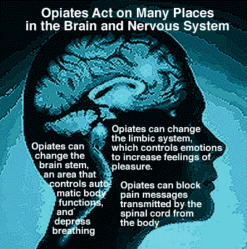

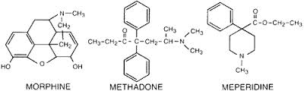

OPIATE MAINTENANCE THERAPY (OMT)
The Rockefeller Institute performed research on possible pharmacotherapies for long term opiate addiction in the 1960s beginning the search for successful therapies for heroin addiction. Professor Vincent P. Dole and his team hypothesized that heroin addiction is a disease of the brain with behavioral manifestations, and not merely a personality disorder or criminal behavior. Research was begun to discover whether a long-acting opioid agonist could improve successful heroine abstinence, however due to political social stigma reasons, the FDA did not support the development of such pharmaco-therapies for nearly 40 years. It was not until the turn of the millennia, following the release of an NIH report supporting long acting opiates such as methadone maintenance, that the fruits of the Rockefeller research was finally implemented.
The heroin replacement therapies, commonly referred to as Opiate Maintenance Therapy (OMT) involve the supply of an opioid agonist, such as methadone, with the rationale of decreasing excruciating cravings for heroin, alleviating devastating withdrawal symptoms, and mitigating the need to beg, borrow, and steal the money necessary to maintain the heroin habit, yet delivered at a controlled dosage below the euphoria threshold. Opiate replacement therapies can improve social and familial functioning and support general survival. Because so many heroin addicts die from not only overdose, but a variety of causes including greatly accelerated aging, and from diseases associated with IV drug use including AIDS, hepatitis induced liver failure, and endocarditis and heart failure, OMT can help reduce such risks. While heroin may impair fine motor ability and certainly depresses awareness and eye movements, OMT has not been shown to impair normal perception, cognition, coordination, or behavior and it is believed safe to drive, operate machinery etc.
There are thousands of methadone maintenance treatment programs found throughout the US, and hundreds of thousands throughout the world. Community and government funded methadone clinics are reported to be beneficial to addicts, serving to “reduce harm”, and prevent relapse, as well as significantly (by 75%) reduce the likelihood to dying by overdose or suicide.
Thus methadone and similar drugs successfully prevent abstinence symptoms, drug hunger or craving, and generally block the euphoric effects of other opiates, theoretically preventing relapse to illicit use of opiates. However, many addicts become adept at using very large doses of heroin to achieve the desired euphoric effects, and then use their methadone prescription to “come down” without experiencing significant illness. Furthermore, many addicts process their prescription OMT into an injectable drug and treatment center evaluations believe the problem is widespread. This abuse of OMT is leading many clinics and practitioners to switch to prescribing a buprenorphine/naloxone combination rather than buprenorphine alone – a therapy which would block the euphoric effects of opiates altogether and not lend itself to be easily abused. Some methadone users may also use benzodiazepines and/or gabapentinoid medications, and alcohol to attempt to potentiate the mild high received from the prescription OMT. Another possible disadvantage to opioid maintenance treatment, is that most users feel that it is even more difficult to quit than heroin itself. And many alternative practitioner share concerns that long term use of OMT only worsens the corrupted limbic system wiring.
If chosen, Methadone and the other long-acting opiates should be just one aspect of a multi-tiered approach that includes counseling and psychological support, treatment of any underlying depression or anxiety, cultivation of emotional maturity and coping skills, and development of job skills, work aptitude, and interpersonal relationship skills.
Buprenorphine (Suboxone) and methadone are the most studied OMT drugs used to reduce opiate craving, as well as reduce acute withdrawal symptoms. Buprenorphine at a dose of 8 mg and higher has been shown to be the most effective. A Cochrane review looked at compared clinical trials using buprenorphine to methadone in terms of retention of patients in treatment and prevention of relapse and reported that both drugs appeared to have equal success rates.
Naltrexone (Vivitrol) is an extremely long-lasting opiate antagonist blocking the euphoric effects of alcohol, heroin and prescription opiates, approved in the US for alcoholism in 2006 and for opiate addiction in 2010. Vivitrol is given as a one a month injection aimed at preventing relapse in abstinent heroin addicts. Clinical trials have shown improved abstinence compared to placebo, however with more side effects including hepatic enzyme abnormalities, nasopharyngitis, insomnia, hypertension, influenza, and injection-site pain. Early clinical monitoring suggests that hepatotoxicity may be an issue. The claimed benefit is that when an addict uses heroin or other opiate while on Vivitrol or other opiate antagonist, they experience no euphoria or reward, and therefore there is no positive reinforcement. The claim for Vivitrol therefore is that it will help extinguish drug-seeking behavior, particularly when addicts attempt to use and get no pleasure out of the experience. Very long lasting naltrexone skin implants are also being explored. The risk of fatal overdose may be greater for use of heroin following withdrawal from Naltrexone due to the increased sensitivity (abolition of tolerance) that will occur when on an opiate antagonist for any period of time. Another concern is the fact that some addicts will attempt to use very large doses of heroin to override the Naltrexone blockade to obtain the euphoric effects. But as the euphoria is blocked no matter how high the dose, respiratory depression, and death may ensue.
Other substances have been less rigorously studied. For example, some researchers are investigating a vaccine capable of blocking heroin’s effects as one prong of long term maintenance therapy for addicts. Such vaccines presently target the morphine/heroin by an antibody-based antagonism of heroin’s entry into the brain.

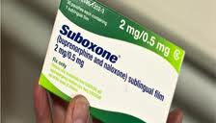

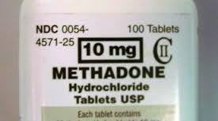

OPIATE AGONISTS VERSUS ANTAGONISTS IN OPIATE ADDICTION?
Two opposite types of psychopharmacological agents have been employed for opiate addiction: the use of mu-opioid agonists to treat withdrawal and prevent illicit use, and the use of mu-opioid antagonists, aimed at blocking the euphoric and physiological manifestations of opioid intoxication. Researchers report that a greater number of addicts are able to comply with agonist therapy long term compared to antagonists. However, due to the abuse of agonists, many clinicians are considering combinations of agonists-antagonists and other therapies as the research continues to emerge.

OMT SIDE EFFECTS
While some proponents of OMT report long-term methadone maintenance to be without toxic or serious sides affects, a large survey in Berlin, Germany, a city with a significant population receiving opioid maintenance therapies, reported very common side effects of sweating, sedation, irritability, and gastrointestinal distress, more so with levomethadone than methadone. Of even greater concern, other researchers report substantial side-affects that include fatigue, depression, diminished libido, impaired sexual function and other symptoms of hypogonadism. Some researchers suggest that supplementation with sex hormones may improve quality of life and help restore hormonal balance.

OPIATE INTERACTION WITH ENDOGENOUS STRESS, ADRENALIN AND CORTICOID PATHWAYS
Some studies suggest that noradrenaline pathways also play a role, not only in opiate abuse and addiction, but in virtually all addictive substances including alcohol, nicotine, marijuana, heroin, cocaine, and caffeine. Some researchers have reported that use of all of these substances boosts noradrenergic signaling acutely but may possibly suppress it over time with chronic use of such substances. When one uses heroin or any other common substance of abuse and then abstains, noradrenergic signaling tends to become elevated during the withdrawal phase. This may feel uncomfortable, exacerbate stress, interfere with sleep or concentration, contribute to restless legs, and cause many users, to imbibe again to relieve the discomfort or physical symptoms. This is why many physicians or addiction specialists will prescribe an adrenaline blocking drug, such as clonidine to addicts of all sorts attempting to reduce withdrawal symptoms. Other pharmaceutical agents that block norepinephrine/noradrenaline include guanfacine, lofexidine, propranolol, and prazosin.
Blockade of CRF receptors has been shown to mitigate the heightened pain sensitivity experienced upon withdrawal from opiates and reduce the escalation of heroin intake due to tolerance. Clonidine more so than other anti-adrenergics has been suggested to reduce the heightened pain sensitivity seen with chronic exposure to opiate drugs. (ibid).

OPIATE INTERACTIONS WITH NMDAR (NMDR) PATHWAYS
NMDAR, n-methyl-d-aspartate receptor agonists are noted to reduce heroine and opiate withdrawal symptoms. Some naturally occurring animal venoms contain peptide toxins known to antagonize NMDARs and are being explored as a possible therapy for opiate dependence.

BOTANICAL OPTIONS FOR
HEROIN ADDICTION, WITHDRAWAL, AND MAINTENANCE

Cannabis sativa - The endocannabinoid receptors are so named due to the fact that cannabinols such as THC (tetrahydrocannabinol) from marijuana bind them. Endocannabinoid receptors interact with opioid receptors and are usually found within close proximity to one another and the two systems may share G proteins in common, as well as both interact with dopamine. Cannabinoids evoke the release of endogenous opioids to promote a mild analgesic effect and researchers are presently reporting cannabinoid pathways to be integral to the analgesic effects of mu-opiate agonists., Some researchers report there to be an “antinociceptive synergy” between cannabinoids and opioids. Cannabinoids such as THC and anandamide promote the release of endogenous opioids.
Researchers also now believe the endocannabinoid system modulates various cognitive processes, including memory formation, retrieval and extinction, but the details remain unknown. Cannabinoid pathways are involved in nociceptive processing and can help in pain relief. The many uses of medical marijuana include chronic pain, nausea, and possibly opiate withdrawal. Researchers report differing mechanisms and pathway connections in the cannabinoid system depending on the level of stress and arousal in test subjects, both animal and human. The growing body of research suggests that cannabinoid pathways
may serve as an “emotional buffer”, moderating our experiences as they are put through cognitive processes. Elevated or up-regulated cannabinoids appear to play roles in mitigating fear, stress, pain, and other pathologies in a manner said to be “auto-protective”. , and therefore raising the possibility of developing cannabinoid-based medicines to target these pathways. Oleoylethanolamide (OEA) acts as satiety signal as it is released from enterocytes upon the ingestion of dietary fats to prolong the interval to the next meal, and other

cannabinoids may also help regulate craving and satiety.

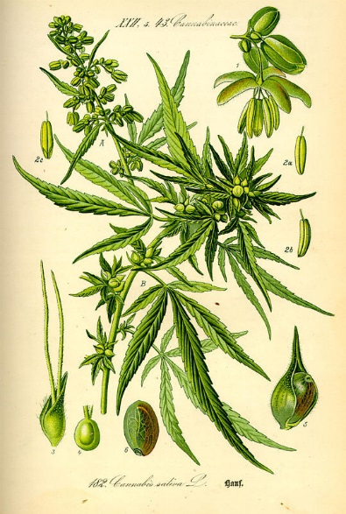

Cannabinoids include:
* N-acyl ethanolamines, such as N-arachidonoyl ethanolamide (anandamide), oleoylethanolamide and palmitoylethanolamide,
* monoacylglycerols, such as 2-arachidonoyl glycerol.

Drugs of abuse will alter lipid-based signaling molecules, the cannabinoid ethanolamines.
The cannabinoid system includes 2 types of G protein coupled receptors – CB1 that is found mostly in the brain, but also occur in the peripheral tissues, and CB2, found in peripheral lymphoid tissue and immune cells., and to a lesser extent in the CNS., THC binds CB1 receptors in the brain.

Anisodamine – is another naturally occurring atropine derivative that has been isolated and studied in China. Like atropine and scopolamine, anisodamine is a non-specific cholinergic antagonist but appears to be less potent and less toxic. Anisodamine has been shown to interact with and disrupt liposome structure while simultaneous anti-oxidant activity protects against cellular damage. Anisodamine is also a weak alpha adrenergic antagonist having vasodilating activity as well as anti-anxiety activity. Like scopalamine, it is being explored for opiate addiction in China.

Corydalis species: C. yanhusuo, C. bungeana, Corydalis humosa
Corydalis is a genus in the Poppy family (Papaveracea) long used as sedatives and analgesics and contains constituents including many isoquinoline alkaloids such as tetrahydropalmatine, corydaline, protopine, berberine, palmatine, jatrorrhizine, coptisine, and dehydrocorydaline, that may affect limbic and reward pathways. These alkaloids are also referred to as protoberberine alkaloids and some including palmatine, jatrorrhizine, coptisine, and dehydrocorydaline may also act as cholinersterase inhibitors, serving to promote acetylcholine and parasympathetic tone. Corydalis cava may promote adrenaline breakdown and metabolism, as well as the synthesis of melanine from dihydroxy-phenylalanine (DOPA). The half-life of phenolase enzymes is greatly lengthened by Corydalis.
The alkaloid tetrahydropalmatine occurs in both Corydalis and Stephania species and both plants are mentioned as being helpful for opiate addictions. Tetrahydropalamatine has been produced into a prescription drug in China marketed under the name Rotundine. Tetrahydropalmatine has been shown to bind to dopamine receptors and act as an antagonist at D1 and D2 and agonist at D3, α adrenergic and serotonin receptors. L-tetrahydropalmatine has been shown to decrease self-administration of heroin in animal models of addiction, and prevent heroin-driven changes in the nucleus accumbens and ventral tegemental area. Levo-tetrahydropalmatine has been found to diminish activation of the reward pathway in animal models of methamphetamine addiction, suggesting balancing effects on the limbic system. Levo-tetrahydropalmatine may also protect the limbic system from stress-induced changes in gene expression. Levo-tetrahydropalmatine may also bind GABA receptors.
L-isocorypalmine is a methylated analog of L-tetrahydropalmatine also found to bind dopamine receptors and act as a partial agonist at D1 and antagonist at D2 receptors, serving to mitigate cocaine withdrawal symptoms. Acetylchorynoline is another an alkaloid in C. bungeana shown to prevent dopaminergic degeneration in Parkinson’s disease models. Another Corydalis root constituent, the isoquinoline alkaloid tetrahydroberberine may help correct the digestive suppression induce by opiate drugs by upregulating GI motility via dopaminergic effects at D2 receptors and serotonergic receptor agonism.

Eschscholtzia californica, the California Poppy is in the Poppy Family and native to the west coast of North America where it was used as a sleep aid and pain remedy by indigenous people of the region. Eschscholtzia remains in common use as a gentle nervine and may be considered in herbal formulas for easing opiate withdrawal symptoms, and possibly long-term maintenance therapies to reduce the cravings. Eschscholtzia may inhibit the enzymatic degradation of catecholamine as well as inhibit the synthesis of adrenaline. Inhibition of diamine oxidases and monoamine oxidase are among the mechanisms of action.

Harpagophytum procumbens – Devil’s Claw has shown efficacy in reducing arthritic pain and reducing the need for other pain medications. The plant may be anti-inflammatory when applied topically. Some research has suggested that in addition to anti-inflammatory effects, Harpagophytum may be pain relieving via opiate pathways. This plant might especially be considered in formulas for those seeking to wean from opiate prescriptions for pain management.

Hypericum perforatum – St. Johnswort is a well-known herb used for depression and anxiety. Extensive research on the plant shows it to have a broad effect on numerous neurotransmitters including serotonin, GABA, and dopamine. Animal studies suggest it may also help ease the symptoms of acute morphine withdrawal. Hypericum was shown to be as effective as clonidine for the symptoms of opiate withdrawal in animal models of addiction. Other researchers report Hypericum perforatum to reduce abdominal spasm and diarrhea in animal models of acute opiate withdrawal.,

JITAI TABLETS and JINNUI CAPSULES - Jitai tablet are TCM an herbal marine product combo with a dozen ingredients traditionally used for detoxification and acute opiate withdrawal symptoms. In TCM such symptoms are described as being poison-blood stasis, cold and heat complex, and spleen and kidney weakness. Jitai tablets contain amygdalin, danshensu, ferulic acid, hydroxysafflor yellow A, and salvianolic acids A and B. The effects of Jitai tablets are similar to those of clonidine in controlling the withdrawal symptoms of morphine-dependent animals. Clinical studies have further confirmed that Jitai tablet has good efficacy in controlling both acute and protracted opiate withdrawal symptoms. One clinical trial reported equal efficacy to lofexidine for acute heroin withdrawal., Adverse herb reactions are mild and can be reduced during the treatment or after drug reduction. No significant adverse effects have been found on the liver and kidney function in patients.

Magnolia - Methyhonokiol may also bind cannabinoid receptors and contribute to its anti-inflammatory effects on neural tissue.

Mitragyna speciosa – Kratom/Khratom, Ketum is an Asian plant, often sought after by those looking for a drug-like effect as word has spread of this use by villagers in Thailand and Malaysia. Mitragyna leaves contain mitragynine and related alkaloids having both opiate and cocaine-like effects and legislation was passed in Malaysia in 2004 to outlaw its sale and consumption, more due to concerns of it being a “gateway” drug than any real toxicity or abuse issues. One ethnobotanical survey reported many rural villages ingest Mitragyna extracts as tea on a daily basis with reported effects including simple social and recreational effects, increased stamina and physical endurance, pain relief and improved sexual performance. Many users reported difficulty in abstaining from consuming the tea so frequently. At the same time, many heroin addicts in Thailand and Maylasia report Mitragyna to have helped them wean off heroin.
Animal studies suggest that Mitragyna induces cytochrome enzymes in the liver and speeds up metabolism of many drugs also metabolized via this pathway.

Nigella sativa - known in the US as Love in a Mist, Nigella sativa has been shown to ease opiate withdrawal symptoms without being an opiate itself, and ayruvedic clinicians report empirically that Nigella reduces the infections and weaknesses to which most addicts suffer.

Salvia divinorum
The plant is sometimes referred to as “Magic Mint” even though it is a perennial sage, however it is a member of the Mint or Labaitae family, not a family known for its psychadelics as are the Poppy and Cactus families. Salvia divinorum is native to the Oaxaca area of Mexico where it has been a long standing sacred plant used in rituals. Salvia divinorum has been used as a treatment for the "semimagical" disease panzón de borrego. The Mazatec people of Mexico also used Salvia divinorum for rituals and to treat gastrointestinal disorders.
The effects of Salvia divinorum come on quickly, within one minute following ingestion and last for a relatively short period of time. Researchers report that the effects may be so rapid due to the ability of salvinorin A to modulate the P-glycoprotein transporter and gain rapid transport through the blood brain barrier. Human investigations report no cognitive deficits, changes to vital signs with use, but spikes in prolactin and cortisol occur transiently. Other than talking, laughing, and moving more often, no untoward physical symptoms were observed in clinical placebo controlled trials of Salvia divinorum ingestion. Salvinorin A did not significantly increase heart rate or blood pressure. Participant narratives indicated intense experiences characterized by disruptions in vestibular and interoceptive signals (e.g., change in spatial orientation, pressure on the body) and unusual and sometimes recurring themes across sessions such as revisiting childhood memories, cartoon-like imagery, and contact with entities.
Salvia divinorum’s most studied constituents are its diterpenes. Salvinorin diterpenes are classified as neoclerodane, and said to be the first identified non-nitrogenous ligand of the opiate receptor, and the diterpene salvinorin A shown to be a kappa-opioid agonist and the first reported psychoactive diterpene known to exist in nature. Other naturally occurring neoclerodanes from a variety of Salvia species may have an affinity for opioid receptors, albeit not with a very strong binding affinity as seen with salvinorin. Salvinorin may act via both opiate and cannabinoid receptors to mitigate both stress and pain pathways. Animal research suggests that Salvinorin may reverse depression associated with chronic stress. Researchers also report that the ability to limit negative emotional consequences may also cause chronic use of Salvia divinorum to impair memory formation in general and affect learning. Isolated Salvinorin A has therapeutic potential as a treatment for pain, mood and personality disorders, substance abuse, and gastrointestinal disturbances, and suggests that nonalkaloids are potential scaffolds for drug development for aminergic G-protein coupled receptors.
Like many opiate agonists, S. divinorum affects colonic function. Salvinorin A inhibits gastrointestinal peristalsis and reduces neurogenic ion channel transport when overstimulated due to the presence of endotoxins, explaining its historical use for intestinal disorders. Salvinorin A inhibits intestinal motility through activation of kappa-opioid receptors. Additionally, intestinal inflammation upregulates cannabinoid receptors and endogenous cannabinoids, and salvinorin A may improve gastrointestinal symptoms through cannabinoid pathways as well.
Because there are cannabinoid receptors on immune cells and lymphatic tissue, some of the anti-inflammatory effects of marijuana and Salvia divinorum may be via binding these receptors. Salvia divinorum has been found to have modulating effects on activated macrophages, for example.

Scopalamine - Scopalamine is a tropane alkaloid found in many nightshades family members such as Atropa belladonna, Hyoscyamus, and Datura. Isolated scopolamine has been used for decades as a topical patch to prevent acute motion sickness is susceptible individuals. Recent research looked at Scopolamine using a therapy termed scopolamine detoxification technique (SDT) compared to methadone for acute heroin withdrawal symptoms. While all patients received methadone from 1 to 3 days, half were switched to SDT for the subsequent 3 days. SDT involves the IV administration of both scopolamine and chlorpromazine for 4 to 6 hours each day. Study participants reported their withdrawal symptoms on a daily basis. Urine samples were collected twice a week following discharge and a questionnaire to report reasons for relapse was collected following opiate positive urinalyses. Although groups did not differ on retention or the percentage of opioid-positive urine samples, the SDT group reported less heroin craving, depression, and anxiety compared with the methadone group. Datura leaves are an ingredient in the traditional Chineses Jitai formula discussed above.

Stephania intermedia is a traditional Chinese herb …… The alkaloid l-Stephanolidine is an interesting mixed dopamine D1 receptor agonist/D2 antagonist. Animal studies suggest that the herb may be helpful for opiate addiction reducing heroine seeking behavior in primed animals., This also suggests the herb may help prevent relapse in heroin addicts attempting to recover.

Withania somnifera - Ashwaghanda or Indian Ginseng has been reported to mitigate the effects of morphine on the CNS and is thereby considered a possible tool in the treatment of opiate addiction. Withania has effects on GABA receptors (γ-aminobutyric acid) and may also have weak binding at µ-opioid receptors.
Withania has also had numerous studies showing the ability to support protection and regeneration of neurons in various disease and inflammatory models over recent decades. Withania has been shown to reduce heroin withdrawal symptoms if given chronically prior to withdrawal, but not to ease the symptoms when given upon initial abstinence in animal models of heroin addiction and withdrawal. Further, long term ingestion of Withania has been shown to fully prevent the loss of dopaminergic density in the nucleus procumbens that typically happens upon opiate withdrawal. This suggest that pretreatment with Withania, prior to withdrawal has possible therapeutic benefits to heroin addicts.

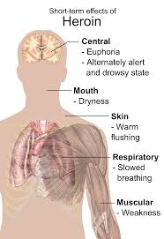

OTHER NATUROPATHIC APPROACHES TO OPIATE WITHDRAWAL
Most of the current therapies for opiate withdrawal involve replacing the short acting opiates such as heroin with a long acting opiate that reduces craving without producing the euphoric effect. While these opiate maintenance therapies may have many benefits for addicts, a big drawback is that they maintain the up-regulated opioid circuitry in the brain. Non-Opiate therapies may include GABA and herbs that bind GABA, agents that affect noradrenaline, dopamine, serotonin and other pathways outside of the opiates, and agents that regulate stress pathways of the HPA axis. Following are herbal suggestions for opiate replacement options, as well as non-opiate options to include in but acute withdrawal and long term maintenance therapies for heroin addicts.

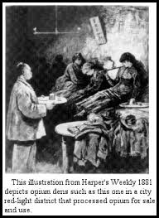

A BRIEF HISTORY OF OPIATES
Byzantine alchemists are believed to have produced opium-based medicinal syrups and elixirs and poppy seeds have been unearthed in ancient burial sites. Opium was one of the main remedies for pain for thousands of years and countless analgesic preparations based on opium existed including the historical Mithridate and Theriac Andromache, also known as Venice Treacle. Opium is mentioned in all of the most important medical texts of the ancient world, including the Ebers Papyrus and the writings of Dioscorides, Galen, and Avicenna.
Opium at one time, was thought of as something of a panacea, used for emotional disorders, sleep problems, snake bites, and pain. Opium has been referred to as lachryma papaveris or poppy tears as it is produced from the dried latex exudates obtained from the opium poppy, Papaver somniferum. Opium is a labor-intensive substance as each individual flower is incised many times per day and the exudates gathered by hand. Opium contains two main groups of alkaloids: Phenanthrenes including morphine, codeine, and thebaine which are narcotics and Isoquinolines including papaverine and noscapine which are non-narcotics. Opium addicts can consume 8 or more grams per day.
In India opium was traditionally harvested by licensed farmers who would score the ripe seed heads and allow the resin to dry on the outside of the capsule. The resin was collected and processed into opium, and opium may be further processed to extract morphine to supply the world pharmaceutical industry. In other countries, production techniques and facilities have used water and solvent extraction of dried plant material. In the 1700s, the East India Company was greatly involved in the opium trade through India, and later, in laudanum distribution.
The process of producing opium by incising the flower heads has not changed greatly since ancient times, although the opiate content of poppies has been greatly increased via selective breeding. Both Papaver orientale and Papaver bracteatum have been bred to yield greater quantities of the raw material, thebaine in great demand by the pharmaceutical industry and drug industry alike. Opium production by both legal and illicit growing operations are on the rise to try to meet the worlds demand for both legal and illegal opiates. Raw opium is usually refined into morphine or heroin close to the grow fields as it is less bulky and easier to smuggle. Black tar heroin is produced especially in Mexico and is common in the western states of the US.
The recreational use of opium in Asia began in the 1400s but the practice was not wide-spread due to its expense and lack of availability. Opium smoking began as a privilege of the elite and remained a great luxury into the early 19th century, but by 1861, Wang Tao wrote that opium was used even by poor peasants. Even a small village without a rice store would have a shop where opium was sold. As the opium trade became established over the next several hundred years, opium use became more common and opium “dens” emerged throughout China. Users would often smoke opium laying on their sides, to prevent choking on their own saliva due to respiratory suppression when laying on the back.
By the 1700s the use of opium was so widespread and problematic that China outlawed the practice, but with little effect as use continued to increase into the 1900s, when morphine and the first opiate drugs emerged. A Chinese emperor attempted to confiscate opium stores and interfere with the opium trade, and the effort led to what became known as the Opium Wars in 1839 and 1858. Chinese immigrants brought the opium smoking practice to the San Francisco region and rapidly brought down US governmental efforts to control consumption, such as ordinances passed by the International Opium Commission in 1909. US president William Henry Harrison was treated with opium in 1841, and in the American Civil War, the Union Army used 2.8 million ounces of opium tincture and powder and about 500,000 opium pills.

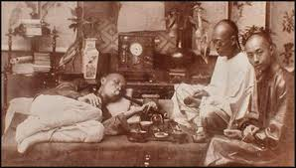

PLANTS THAT CONTAIN OPIATES OR OTHER MOLECULES THAT BIND OPIATE RECEPTORS
Actaea racemosa – Black Cohosh (formerly Cimicifuga racemosa) is a poppy family plant is commonly used as a nervine, hormone regulator in menopausal complaints, and for nervous and musculoskeletal hypersentivity in anxiety states and for fibromyalgia. Actaea extracts have been shown to bind mu opiate receptors and thereby affect hormones and nerve sensitivity.
Corydalyis species – A poppy family genus
Eschscholtzia californica – The California Poppy
Maytenus rigida – the stem bark may bind opiate receptors and provide analgesia, based on the evidence that its effects are block by the opiate antagonist naloxone.
Mitrigyna speciosa – Kratom contains the opiate agonist mitragynine.
Papaver somniferum and other Papaver species
Parastrephia lepidophylla – An aster family plant from Chile is folkloric analgesic believed to have activity at opiate receptors.
Trifolium pratense - not commonly thought of by herbalists or naturopathic physicians as a nervine, sedative or source of opiate, but Trifolium indeed binds mu and delta opiate receptors, the mu receptors with a very high affinity. This may be another mechanism, besides the isoflavones whereby Trifolium helps control menopausal symptoms due the regulating effects opiate pathways have on temperature, mood, and hormones.

AMINO ACIDS
TAURINE
The amino acid taurine has been shown to have a neuroprotective effect against morphine-induce neurotoxicity.

THE REWARD PATHWAY
The reward pathway is part of an ancient neurotransmitter system that encourages animals to seek food and enjoy sexual activity in manners that support the survival of an individual and the perpetuation of a species. Simply put, the reward system helps us to enjoy and seek out activities and experiences that are good for us. However, drugs of abuse offer a false reward – a fleeting euphoria that not only does nothing to enhance survival, challenges it. In fact, drugs’ effects on the reward system are so powerful that they are able to override other generally gratifying reinforcers: money, safety, loved ones, and morality. Even one’s survival becomes less important to the abuser than obtaining and using. Thus drugs offer a greater reward than the evolution of the reward system was intended to reinforce.
Dopamine is considered to be the primary neurotransmitter or the “reward pathway”, but because many other neurotransmitters and many drug of abuse affect dopamine via complex mechanisms, many other neurotransmitters and pathways are involved the brain’s reward system. Dopamine is inextricably intertwined with serotonin, GABA, and the opiates. Each of these neurotransmitters has its own personality and the combination, dominance, up and down regulation of each contributes to the personality, mood, and affect of an individual. Agents that bind dopamine and promote “normal” levels of dopamine have been shown to decrease the consumption of alcohol and possibly other drugs of abuse, by limiting the euphoria produced by the excessive release of dopamine obtained from such drugs. Stimulants such as cocaine, amphetamines, caffeine and nicotine all stimulate the brain reward pathway via various mechanisms and promote dopamine to varying degrees.
Serotonin plays a role in person’s motivation to work and the amount of energy one is willing to spend to obtain a reward, or in the case of addictions, a drug. Serotonergic pathways innervate the nucleus accumbens where it helps regulate dopamine release.
GABA also helps regulate dopamine and plays a role in drug addiction cycles. GABA is a primary inhibitory neurotransmitter distributed throughout the brain. Drugs of abuse cripple GABAnergic pathways by hyperpolarizing them and reduce or inhibit altogether their ability to fire. Dopamine is not inhibited when GABAnergic neuron are disabled in this way, and excessive levels of dopamine ramp up the reward system and the associated feelings of euphoria and sedation.
Opiates inhibit GABA thereby having a stimulatory effect, or said in another way, block the inhibitory effect of GABA. Dopamine fires more rapidly under the influence of opiates. Opiates are therefore said to be a second important neurotransmitter of the reward system.
Epinephrine and amphetamines also promote dopamine by increasing neuronal release and inhibiting synaptic uptake. Via its own mechanism on adenosine, the amphetamine-like stimulant caffeine also promotes dopamine.
Acetylcholine promotes dopaminergic activity downstream at post-synaptic neuronal sites. Nicotine and nicotinic agents act in this way and therefore activates reward pathways.

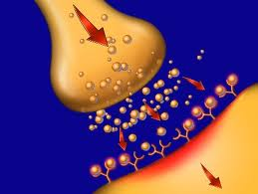

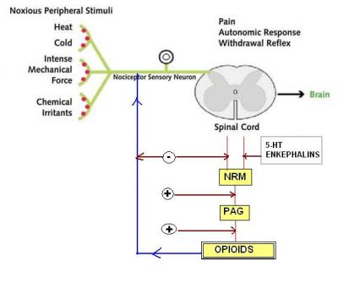

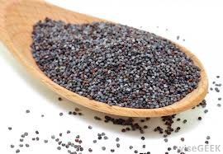
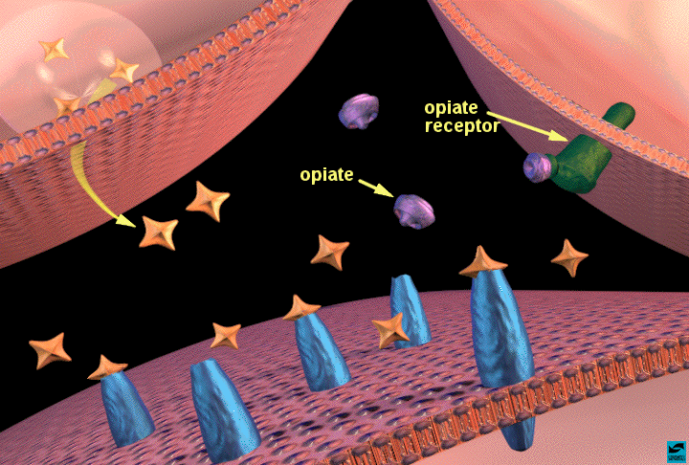

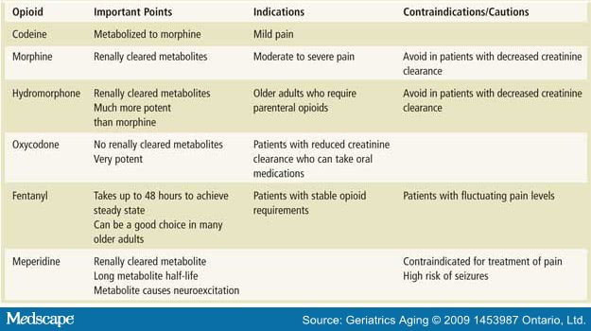

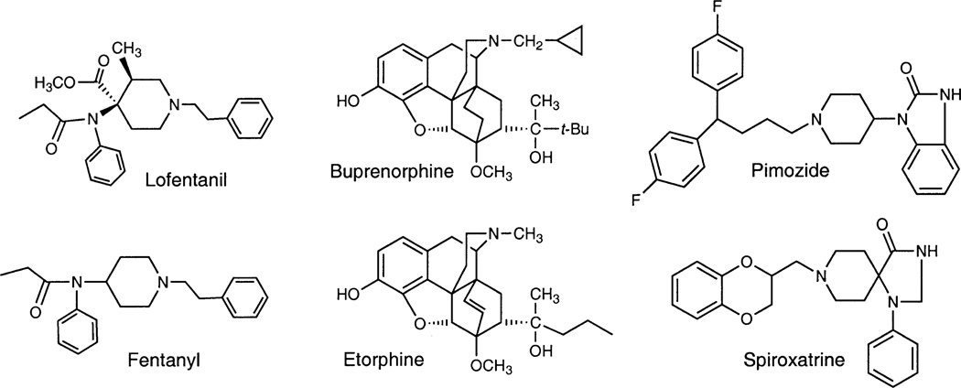
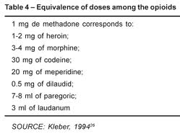

Noise Health. 2011 Sep-Oct;13(54):356-63. Auditory sensitivity in opiate addicts with and without a history of noise exposure. Rawool V, Dluhy C.
Biomol Eng. 2001 Sep;18(2):41-7. Engineering novel biocatalytic routes for production of semisynthetic opiate drugs. Boonstra B, Rathbone DA, Bruce NC.
Global Research, Center for Research on Globilization The Spoils of War: Afghanistan’s Multibillion Dollar Heroin Trade Washington's Hidden Agenda: Restore the Drug Trade Prof Michel Chossudovsky
Minn Med. 2013 Mar;96(3):38-41. The rampant abuse of prescription pain medications. Falkowski C.
Pain Physician. 2012 Jul;15(3 Suppl):ES9-38. Opioid epidemic in the United States. Manchikanti L, Helm S 2nd, Fellows B, et al
MMWR Morb Mortal Wkly Rep. 2011 Nov 4;60(43):1487-92. Vital signs: overdoses of prescription opioid pain relievers---United States, 1999--2008.Centers for Disease Control and Prevention (CDC).
BMC Public Health. 2012 Jun 18;12:443. Estimating the prevalence of illicit opioid use in New York City using multiple data sources. McNeely J, Gourevitch MN, Paone D, Shah S, Wright S, Heller D.
J Addict Med. 2013 May-Jun;7(3):177-82. Opiate-dependent patients on a waiting list for methadone maintenance treatment are at high risk for mortality until treatment entry. Peles E, Schreiber S, Adelson M.
Addict Biol. 2013 Dec 13. Chronic CRF1 receptor blockade reduces heroin intake escalation and dependence-induced hyperalgesia. Park PE, Schlosburg JE, Vendruscolo LF, et al.
Prog Neurobiol. 2000 Apr;60(6):513-30. Basal nitric oxide limits immune, nervous and cardiovascular excitation: human endothelia express a mu opiate receptor. Stefano GB, Goumon Y, Bilfinger TV, Welters ID, Cadet P.
Mol Pharmacol. 2007 Feb;71(2):549-57. An opioid agonist that does not induce mu-opioid receptor--arrestin interactions or receptor internalization. Groer CE, Tidgewell K, Moyer RA, et al
Pharmacol Ther. 2013 Nov 1. pii: S0163-7258(13)00216-7. The biology of Nociceptin/Orphanin FQ (N/OFQ) related to obesity, stress, anxiety, mood, and drug dependence. Witkin JM, Statnick MA, Rorick-Kehn LM, et al
Neuroscience. 2014 Jan 17;257:139-48. NOP receptor mediates anti-analgesia induced by agonist-antagonist opioids. Gear RW1, Bogen O1, Ferrari LF1, Green PG1, Levine JD2.
Br J Anaesth. 2013 Jul;111(1):80-8.. Opioids and immune modulation: more questions than answers. Al-Hashimi M, Scott SW, Thompson JP, Lambert DG.
Neuropharmacology. 2014 Jan;76 Pt B:228-34. More surprises lying ahead. The endocannabinoids keep us guessing. Piomelli D.
Trends Pharmacol Sci. 2013 Nov;34(11):637-44. Amygdala FAAH and anandamide: mediating protection and recovery from stress. Gunduz-Cinar O, Hill MN, McEwen BS, Holmes A.
Behav Brain Res. 2013 Nov 1;256:101-7. Effects of endocannabinoid and endovanilloid systems on aversive memory extinction. Laricchiuta D, Centonze D, Petrosini L.
J Clin Invest. 2013 Dec 2;123(12):5334-41. Impaired periamygdaloid-cortex prodynorphin is characteristic of opiate addiction and depression. Anderson SA, Michaelides M, Zarnegar P, et al.
Life Sci. 2003 Jun 27;73(6):663-78. Peptide and nonpeptide ligands for the nociceptin/orphanin FQ receptor ORL1: research tools and potential therapeutic agents. Zaveri N.
Rev Hist Pharm (Paris). 2010 Apr;58(365):81-90. The opiate pharmacopeia in France from its origins to the 19th century. Warolin C.
Schmerz. 2007 Aug;21(4):339-44, 346. Milk of paradise? Opium and opiates in nineteenth and twentieth century literature. Schäfer D.
Behav Pharmacol. 2011 Sep;22(5-6):540-7. Opioid antinociception, tolerance and dependence: interactions with the N-methyl-D-aspartate system in mice. Dykstra LA, Fischer BD, Balter RE, et al.
Phytother Res. 2012 Nov;26(11):1731-7. Oleuropein, chief constituent of olive leaf extract, prevents the development of morphine antinociceptive tolerance through inhibition of morphine-induced L-type calcium channel overexpression. Zare L, Esmaeili-Mahani S, Abbasnejad M, Rasoulian B, Sheibani V, Sahraei H, Kaeidi A.
J Med Food. 2010 Dec;13(6):1397-401. Ginger (Zingiber officinale Roscoe) elicits antinociceptive properties and potentiates morphine-induced analgesia in the rat radiant heat tail-flick test. Sepahvand R, Esmaeili-Mahani S, Arzi A, Rasoulian B, Abbasnejad M.
Addiction Volume 91, Issue 12, pages 1765–1772, December 1996, Fatal heroin ‘overdose’: a review Darke S, Zador, D
NCHS Data Brief. 2011 Dec;(81):1-8. Drug poisoning deaths in the United States, 1980-2008. Warner M, Chen LH, Makuc DM, Anderson RN, Miniño AM.
Ir J Med Sci. 2012 Dec;181(4):541-8.. The natural history of injecting drug use: a 25-year longitudinal study of a cohort of injecting drug users in inner city Dublin. O'Kelly FD, O'Kelly CM.
Am J Epidemiol. 2012 Feb 15;175(4):302-8. Mortality among young injection drug users in San Francisco: a 10-year follow-up of the UFO study. Evans JL, Tsui JI, Hahn JA, Davidson PJ, Lum PJ, Page K.
MMWR Morb Mortal Wkly Rep. 2012 Feb 17;61(6):101-5. Community-based opioid overdose prevention programs providing naloxone - United States, 2010. Centers for Disease Control and Prevention (CDC).
J Epidemiol Community Health. 2011 May;65(5):396-8. 30. For peace and pain: the medical legitimisation of Afghanistan's poppy crop. Attaran A, Boozary A.
Ann Ist Super Sanita. 2013;49(4):365-9. The relationship between personality traits and anxiety/depression levels in different drug abusers' groups. Tatalović Vorkapić S, Dadić-Hero E, Ružić K.
J Clin Invest. 2013 Dec 2;123(12):5334-41. Impaired periamygdaloid-cortex prodynorphin is characteristic of opiate addiction and depression. Anderson SA, Michaelides M, Zarnegar P, et al.
Proc Natl Acad Sci U S A. 2008 Jan 15;105(2):786-91. Opioid neuropeptide genotypes in relation to heroin abuse: dopamine tone contributes to reversed mesolimbic proenkephalin expression. Nikoshkov A, Drakenberg K, Wang X, et al
Proc Natl Acad Sci U S A. 2009 Jun 30;106(26):10811-6. Functional characterization of human variants of the mu-opioid receptor gene. Ravindranathan A, Joslyn G, Robertson M, et al
Addict Behav. 2013 Dec 1. Heroin and amphetamine users display opposite relationships between trait and neurobehavioral dimensions of impulsivity. Vassileva J1, Paxton J2, Moeller FG3, Wilson MJ4, Bozgunov K5, Martin EM6, Gonzalez R7, Vasilev G5.
Mt Sinai J Med. 2000 Oct-Nov; 67(5-6):375-80. Neurobiology of addictive behaviors and its relationship to methadone maintenance. Stimmel B, Kreek MJ.
Brain Res. 2010 Feb 16;1314:3-14. The role of CRF and CRF-related peptides in the dark side of addiction. Koob GF.
Front Neurosci. 2013 Oct 29;7:195. Inhibition of corticotropin releasing factor expression in the central nucleus of the amygdala attenuates stress-induced behavioral and endocrine responses. Callahan LB, Tschetter KE, Ronan PJ.
Biol Psychiatry. 2013 Nov 4. Acute Effects of Heroin on Negative Emotional Processing: Relation of Amygdala Activity and Stress-Related Responses. Schmidt A, Borgwardt S, Gerber H, et al
Sci Transl Med. 2013 Jun 5;5(188):188ra73. Amygdala-dependent fear is regulated by Oprl1 in mice and humans with PTSD. Andero R, Brothers SP, Jovanovic T, et al.
Neuropsychopharmacology. 2012 Oct;37(11):2405-15. Increased dopamine receptor activity in the nucleus accumbens shell ameliorates anxiety during drug withdrawal. Radke AK, Gewirtz JC.
Neurotox Res. 2009 Nov;16(4):343-55. Withania somnifera prevents morphine withdrawal-induced decrease in spine density in nucleus accumbens shell of rats: a confocal laser scanning microscopy study. Kasture S, Vinci S, Ibba F, Puddu A, Marongiu M, Murali B, Pisanu A, Lecca D, Zernig G, Acquas E.
Neurobiol Dis. 2013 Nov;59:220-9. Opiate dependence induces network state shifts in the limbic system. Dejean C, Boraud T, Le Moine C.
Neuro Endocrinol Lett. 2005 Jun;26(3):175-92. The Neurobiology of Love. Esch T, Stefano GB.
Neuro Endocrinol Lett. 2005 Jun;26(3):264-7. Love promotes health. Esch T, Stefano GB.
Neurosurg Clin N Am. 2014 Jan;25(1):137-45. Limbic neuromodulation: implications for addiction, posttraumatic stress disorder, and memory. Bari A, Niu T, Langevin JP, Fried I.
Am J Psychiatry. 2008 Mar;165(3):390-4. Acute effect of methadone maintenance dose on brain FMRI response to heroin-related cues. Langleben DD, Ruparel K, Elman I, et al
Psychiatry Res. 2013 Nov 30;214(2):122-31. Cannabis cue-induced brain activation correlates with drug craving in limbic and visual salience regions: preliminary results. Charboneau EJ, Dietrich MS, Park S, et al
Ann N Y Acad Sci. 2000;909:186-216. Methadone-related opioid agonist pharmacotherapy for heroin addiction. History, recent molecular and neurochemical research and future in mainstream medicine. Kreek MJ.
Neuroimage. 2013 Oct 17. Abnormal cortical thickness in heroin-dependent individuals. Li M, Tian J, Zhang R, Qiu Y, Wen X, Ma X, Wang J, Xu Y, Jiang G, Huang R.
J Clin Pharm Ther. 2013 Dec 16. Duration of opiate exposure as a determinant of arterial stiffness and vascular age in male opiate dependence: a longitudinal study. Reece AS, Hulse GK.
Urol Oncol. 2010 Nov-Dec;28(6):610-6. Opium consumption and risk of bladder cancer: A case-control analysis. Hosseini SY, Safarinejad MR, Amini E, Hooshyar H.
Noise Health. 2011 Sep-Oct;13(54):356-63. Auditory sensitivity in opiate addicts with and without a history of noise exposure. Rawool V, Dluhy C.
Prog Neuropsychopharmacol Biol Psychiatry. 2013 Dec 11. Morphine-induced trafficking of a mu-opioid receptor interacting protein in rat locus coeruleus neurons. Jaremko KM1, Thompson NL Jr1, Reyes BA2, et al
J Neurosci. 2013 Dec 4;33(49):19384-92.. Long-Term Antagonism of κ Opioid Receptors Prevents Escalation of and Increased Motivation for Heroin Intake. Schlosburg JE, Whitfield TW Jr, Park PE, Crawford EF, et al
Acta Derm Venereol. 2012 Sep;92(5):515-20. Opioid modulation of facial itch- and pain-related responses and grooming behavior in rats. Spradley JM, Davoodi A, Carstens MI, Carstens E.
Neurochem Res. 1996 Nov;21(11):1469-88. Opioid receptors: some perspectives from early studies of their role in normal physiology, stress responsivity, and in specific addictive diseases. Kreek MJ.
Int J Drug Policy. 2010 Jan;21(1):82-5. Dissolution of a harm reduction track for opiate agonist treatment: longitudinal impact on treatment retention, substance use and service utilization. Hartzler B, Cotton AJ, Calsyn DA, Guerra R, Gignoux E.
Substance Use and Misuse 1996, Vol. 31, No. 2 , Pages 177-196 Methadone Maintenance and Addicts' Risk of Fatal Heroin Overdose. John R. M. Caplehorn1, M. Y. N. Stella Dalton2, et al
Res Publ Assoc Res Nerv Ment Dis. 1992;70:205-30. Rationale for maintenance pharmacotherapy of opiate dependence. Kreek MJ.
Clin Drug Investig. 2010;30 Suppl 1:3-11. Intravenous misuse of buprenorphine: characteristics and extent among patients undergoing drug maintenance therapy. Moratti E, Kashanpour H, Lombardelli T, Maisto M.
Eur Addict Res. 2013 Oct 31;20(3):115-118. Gabapentinoid Abuse in Order to Potentiate the Effect of Methadone: A Survey among Substance Misusers. Baird CR, Fox P, Colvin LA.
Subst Use Misuse. 2013 Dec 11. Why do Patients Stay in Opioid Maintenance Treatment? Gutwinski S, Bald LK, Gallinat J, Heinz A, Bermpohl F.
Am J Drug Alcohol Abuse. 2010 Nov;36(6):332-41. Heroin anticraving medications: a systematic review. Fareed A, Vayalapalli S, Casarella J, et al
Cochrane Database Syst Rev. 2004;(3):CD002207. Buprenorphine maintenance versus placebo or methadone maintenance for opioid dependence. Mattick RP, Kimber J, Breen C, Davoli M.
CNS Drugs. 2013 Oct;27(10):851-61. Extended-release intramuscular naltrexone (VIVITROL®): a review of its use in the prevention of relapse to opioid dependence in detoxified patients. Syed YY, Keating GM.
Subst Abuse. 2011; 5: 1–9. Long-Acting Injectable Naltrexone for the Management of Patients with Opioid Dependence Kimberly L. Kjome and F. Gerard Moeller
Drug Alcohol Depend. 2013 Nov 1;133(1):80-5.. Naltrexone treatment for opioid dependence: does its effectiveness depend on testing the blockade? Sullivan MA, Bisaga A, Mariani JJ, et al
CNS Neurol Disord Drug Targets. 2011 Dec;10(8):865-75. Developing a vaccine against multiple psychoactive targets: a case study of heroin. Stowe GN, Schlosburg JE, Vendruscolo LF, Edwards S, Misra KK, Schulteis G, Zakhari JS, Koob GF, Janda KD.
Hum Vaccin. 2009 Apr;5(4):214-29. Vaccines against morphine/heroin and its use as effective medication for preventing relapse to opiate addictive behaviors. Anton B, Salazar A, Flores A, et al
Subst Abuse. 2011; 5: 1–9. Long-Acting Injectable Naltrexone for the Management of Patients with Opioid Dependence Kimberly L. Kjome and F. Gerard Moeller
Res Publ Assoc Res Nerv Ment Dis. 1992;70:205-30. Rationale for maintenance pharmacotherapy of opiate dependence. Kreek MJ.
Psychiatr Prax. 2013 Nov 19. Methadone and Levomethadone - Dosage and Side Effects. Schoofs N, Riemer T, Bald LK, Heinz A, et al
J Sex Med. 2013 Oct 28. The Prevalence of Sexual Dysfunction among Male Patients on Methadone and Buprenorphine Treatments: A Meta-Analysis Study. Yee A, Loh HS, Hisham Hashim HM, Ng CG.
J Addict Dis. 2002;21(4):47-53. Narcotic-induced hypogonadism during therapy for heroin addiction. Daniell HW.
Subst Abuse. 2013 Oct 13;7:171-183. Elevated Norepinephrine may be a Unifying Etiological Factor in the Abuse of a Broad Range of Substances: Alcohol, Nicotine, Marijuana, Heroin, Cocaine, and Caffeine. Fitzgerald PJ.
Addict Biol. 2013 Dec 13. Chronic CRF1 receptor blockade reduces heroin intake escalation and dependence-induced hyperalgesia. Park PE, Schlosburg JE, Vendruscolo LF, et al.
Neurosci Lett. 2006 Sep 11;405(1-2):137-41. Conantokins and variants derived from cone snail venom inhibit naloxone-induced withdrawal jumping in morphine-dependent mice. Wei J, Dong M, Xiao C, Jiang F, Castellino FJ, Prorok M, Dai Q.
CNS Neurol Disord Drug Targets. 2009 Dec;8(6):422-31. Signal transduction via cannabinoid receptors. Dalton GD, Bass CE, Van Horn CG, Howlett AC.
Br J Pharmacol. 2009 Sep;158(1):225-31..Central antinociception induced by mu-opioid receptor agonist morphine, but not delta- or kappa-, is mediated by cannabinoid CB1 receptor. Pacheco Dda F, Klein A, Perez AC, et al
Life Sci. 2009 Aug 26;85(9-10):351-6. Opioid receptor and NO/cGMP pathway as a mechanism of peripheral antinociceptive action of the cannabinoid receptor agonist anandamide. Reis GM, Pacheco D, Perez AC, Klein A, Ramos MA, Duarte ID.
Int Rev Psychiatry. 2009 Apr;21(2):143-51. Interaction of the cannabinoid and opioid systems in the modulation of nociception. Welch SP.
Neurobiol Learn Mem. 2013 Dec 29. pii: S1074-7427(13)00266-9. The endocannabinoid system: An emotional buffer in the modulation of memory function. Morena M1, Campolongo P2.
Proc Nutr Soc. 2013 Oct 18:1-10. Elevating endocannabinoid levels: pharmacological strategies and potential therapeutic applications. Pertwee RG.
Peptides. 2013 Nov;49:21-6. The satiety signal oleoylethanolamide stimulates oxytocin neurosecretion from rat hypothalamic neurons. Romano A, Cassano T, Tempesta B, et al.
Prog Neuropsychopharmacol Biol Psychiatry. 2013 Dec 12;50C:1-10. Changes in endocannabinoid and N-acylethanolamine levels in rat brain structures following cocaine self-administration and extinction training. Bystrowska B Smaga I, Frankowska M, et al
Neurology. 2013 Dec 10;81(24):2064-5. Spice, pot, and stroke. Brust JC.
Proc Nutr Soc. 2013 Oct 22:1-12. Endocannabinoid system and pain: an introduction. Burston JJ, Woodhams SG.
Neurology. 2013 Dec 10;81(24):2064-5. Spice, pot, and stroke. Brust JC.
J Appl Toxicol. 2007 Mar-Apr;27(2):116-21. The pharmacological properties of anisodamine. Poupko JM, Baskin SI, Moore E.
J Asian Nat Prod Res. 2013 Nov;15(11):1158-62. Two new alkaloids from Corydalis humosa. Zheng XK, Li DD, Yan H, Li M, He JL, Feng WS.
Nat Prod Res. 2011 Sep;25(15):1418-22. Acetylcholinesterase inhibitors from Corydalis yanhusuo. Xiao HT, Peng J, Liang Y, Yang J, Bai X, Hao XY, Yang FM, Sun QY.
Nat Prod Res. 2011 Sep;25(15):1418-22. Acetylcholinesterase inhibitors from Corydalis yanhusuo. Xiao HT, Peng J, Liang Y, Yang J, Bai X, Hao XY, Yang FM, Sun QY.
Arzneimittelforschung. 1995 Feb;45(2):127-31. Modulation of key reactions of the catecholamine metabolism by extracts from Eschscholtzia californica and Corydalis cava. Kleber E, Schneider W, Schäfer HL, et al.
Future Med Chem. 2012 Feb;4(2):177-86. l-tetrahydropalamatine: a potential new medication for the treatment of cocaine addiction. Wang JB, Mantsch JR.
Pharmacol Biochem Behav. 2012 Jul;102(1):1-5. The dopamine receptor antagonist levo-tetrahydropalmatine attenuates heroin self-administration and heroin-induced reinstatement in rats. Yue K, Ma B, Ru Q, Chen L, et al
Zhongguo Zhong Yao Za Zhi. 2012 Nov;37(22):3457-61. Study on acting mechanism of anti-morphine conditioned place preference between aqueous extract of Corydalis yanhusuo and L-THP and comparison of their effects. Luo SY, Guo P, Qian G, et al
Physiol Behav. 2013 Jun 13;118:195-200. Roles of levo-tetrahydropalmatine in modulating methamphetamine reward behavior. Su HL, Zhu J, Chen YJ, et al.
J Integr Neurosci. 2013 Dec;12(4):513-28. Effects of tetrahydropalmatine on post-traumatic stress disorder-induced changes in rat brain gene expression. Ceremuga TE, Shellabarger P, Persson T, et al.
AANA J. 2011 Aug;79(4 Suppl):S75-80. Evaluation of the anxiolytic properties of tetrahydropalmatine, a Corydalis yanhusuo compound, in the male Sprague-Dawley rat. Henkes H, Franz M, Kendall O, et al
Drug Alcohol Depend. 2013 Dec 1;133(2):693-703. L-isocorypalmine reduces behavioral sensitization and rewarding effects of cocaine in mice by acting on dopamine receptors. Xu W, Wang Y, Ma Z, et al
Neuropharmacology. 2013 Aug 21. pii: S0028-3908(13)00364-X. Acetylcorynoline attenuates dopaminergic neuron degeneration and α-synuclein aggregation in animal models of Parkinson's disease. Fu RH, Wang YC, Chen CS, et al
J Pharmacol Exp Ther. 2011 Sep;338(3):917-24. Tetrahydroberberine, an isoquinoline alkaloid isolated from corydalis tuber, enhances gastrointestinal motor function. Lee TH, Kim KH, Lee SO, et al.
Arzneimittelforschung. 1995 Feb;45(2):127-31. Modulation of key reactions of the catecholamine metabolism by extracts from Eschscholtzia californica and Corydalis cava. Kleber E, Schneider W, Schäfer HL, et al.
Phytother Res. 2007 Dec;21(12):1228-33. Effectiveness and safety of Devil's Claw tablets in patients with general rheumatic disorders. Warnock M, McBean D, Suter A, Tan J, Whittaker P.
Planta Med. 2008 Apr 10 Dermal and Transcutaneous Delivery of the Major Glycoside Constituents of Harpagophytum procumbens (Devil's Claw) in vitro.Abdelouahab N, Heard CM.
Biol Pharm Bull. 2008 Feb;31(2):240-5.Antinociceptive effects of St. John's wort, Harpagophytum procumbens extract and Grape seed proanthocyanidins extract in mice. Uchida S, Hirai K, Hatanaka J, Hanato J, Umegaki K, Yamada S.
Phytother Res. 2009 Nov;23(11):1549-52. The inhibitory effect of Hypericum perforatum extract on morphine withdrawal syndrome in rat and comparison with clonidine. Feily A, Abbasi N.
Phytother Res. 2009 Apr;23(4):564-71. Adulterant profile of illicit street heroin and reduction of its precipitated physical dependence withdrawal syndrome by extracts of St John's wort (Hypericum perforatum). Subhan F, Khan N, Sewell RD.
Pharm Biol. 2013 Nov 21. Nature cures nature: Hypericum perforatum attenuates physical withdrawal signs in opium dependent rats. Khan M, Subhan F, Khan AU, et al
Journal of Chromatography B Volume 912, 1 January 2013, Pages 75–84 Simultaneous determination of six hydrophilic components in rat plasma after oral administration of Jitai tablet by liquid chromatography–electrospray ionization–tandem mass spectrometry: Application to a pharmacokinetic study Shu-Ping Wanga et al.
Am J Drug Alcohol Abuse. 2008;34(6):792-800. A comparative clinical study of the effects of the traditional Chinese medicine Jinniu capsules and lofexidine on acute heroin withdrawal symptoms. Shi J, Xu GZ, Liu TT, Wang X, Shen LY, Li J, Hao W, Chen HX, Li SX, Lu L.
Addict Behav. 2013 Oct;38(10):2596-600. The effectiveness comparison of Jitai tablets versus methadone in community-based drug treatment: a 1-year follow-up study. Hao SQ, Zhao M, Zhang RW, Zhang JC, Zhang J, Feng XS.
J Neuroinflammation. 2012 Jun 20;9:135. Methylhonokiol attenuates neuroinflammation: a role for cannabinoid receptors? Gertsch J, Anavi-Goffer S.
Drug Metabol Drug Interact. 2013;28(2):95-105. Mitragyna speciosa Korth leaves extracts induced the CYP450 catalyzed aminopyrine-N-demethylase (APND) and UDP-glucuronosyl transferase (UGT) activities in male Sprague-Dawley rat livers. Azizi J, Ismail S, Mansor SM.
J Ethnopharmacol. 2012 May 7;141(1):446-50. Mitragyna speciosa use in the northern states of Malaysia: a cross-sectional study. Ahmad K, Aziz Z.
Int J Drug Policy. 2010 Jul;21(4):283-8. The informal use of ketum (Mitragyna speciosa) for opioid withdrawal in the northern states of peninsular Malaysia and implications for drug substitution therapy. Vicknasingam B, Narayanan S, Beng GT, Mansor SM.
Drug Metabol Drug Interact. 2013;28(2):95-105. Mitragyna speciosa Korth leaves extracts induced the CYP450 catalyzed aminopyrine-N-demethylase (APND) and UDP-glucuronosyl transferase (UGT) activities in male Sprague-Dawley rat livers. Azizi J, Ismail S, Mansor SM.
J Ayub Med Coll Abbottabad. 2008 Apr-Jun;20(2):118-24. A new and novel treatment of opioid dependence: Nigella sativa 500 mg. Sangi S, Ahmed SP, Channa MA, Ashfaq M, Mastoi SM.
Postepy Biochem. 2012;58(4):485-91. Salvinorin A and related diterpenes--biological activity and potential therapeutic uses. Piekielna J, Fichna J, Janecka A.
J Pharmacol Exp Ther. 2012 Jun;341(3):802-8. Behavioral effects and central nervous system levels of the broadly available κ-agonist hallucinogen salvinorin A are affected by P-glycoprotein modulation in vivo. Butelman ER, Caspers M, Lovell KM, et al
Biol Psychiatry. 2012 Nov 15;72(10):871-9. Dose-related behavioral, subjective, endocrine, and psychophysiological effects of the κ opioid agonist Salvinorin A in humans. Ranganathan M, Schnakenberg A, Skosnik PD, et al
Psychopharmacology (Berl). 2012 Mar;220(1):195-204. Acute and post-acute behavioral and psychological effects of salvinorin A in humans. Addy PH.
Drug Alcohol Depend. 2011 May 1;115(1-2):150-5. Human psychopharmacology and dose-effects of salvinorin A, a kappa opioid agonist hallucinogen present in the plant Salvia divinorum. Johnson MW, MacLean KA, Reissig CJ, et al
J Med Chem. 2013 May 9;56(9):3435-43. Neoclerodanes as atypical opioid receptor ligands. Prisinzano TE.
J Ethnopharmacol. 2013 Dec 4. pii: S0378-8741(13)00836-2. From local to global-Fifty years of research on Salvia divinorum. Casselman I, Nock CJ, Wohlmuth,
Tetrahedron. 2008 Dec 20;64(43):10041-10048. Synthetic studies of neoclerodane diterpenoids from Salvia splendens and evaluation of Opioid Receptor affinity. Fontana G, Savona G, Rodríguez B, et al
Mol Pain. 2012 Aug 23;8:60. Salvinorin A reduces mechanical allodynia and spinal neuronal hyperexcitability induced by peripheral formalin injection. Guida F, Luongo L, Aviello G, et al
Behav Pharmacol. 2012 Oct;23(7):710-5. Antidepressive effects of the κ-opioid receptor agonist salvinorin A in a rat model of anhedonia. Harden MT, Smith SE, Niehoff JA, et al
Int J Toxicol. 2011 Dec;30(6):650-61. Learning and memory impairment induced by salvinorin A, the principal ingredient of Salvia divinorum, in wistar rats. Braida D, Donzelli A, Martucci R, et al
Drug News Perspect. 2009 Sep;22(7):383-92. Selective natural kappa opioid and cannabinoid receptor agonists with a potential role in the treatment of gastrointestinal dysfunction. Fichna J, Schicho R, Janecka A, et al
Pharmacol Rev. 2011 Jun;63(2):316-47. Neuropharmacology of the naturally occurring kappa-opioid hallucinogen salvinorin A. Cunningham CW, Rothman RB, Prisinzano TE.
Neurogastroenterol Motil. 2011 Jun;23(6):583-e212 Differential effects of salvinorin A on endotoxin-induced hypermotility and neurogenic ion transport in mouse ileum. Fichna J, Dicay M, Hirota SA, et al
Br J Pharmacol. 2008 Nov;155(5):681-9. Inhibitory effect of salvinorin A, from Salvia divinorum, on ileitis-induced hypermotility: cross-talk between kappa-opioid and cannabinoid CB(1) receptors. Capasso R, Borrelli F, Cascio MG, et al
J Mol Med (Berl). 2011 Sep;89(9):891-902. Ultrapotent effects of salvinorin A, a hallucinogenic compound from Salvia divinorum, on LPS-stimulated murine macrophages and its anti-inflammatory action in vivo. Aviello G, Borrelli F, Guida F, et al
CNS Drugs. 2013 Dec;27(12):1093-102. Scopolamine detoxification technique for heroin dependence: a randomized trial. Liu S, Li L, Shen W, Shen X, Yang G, Zhou W.
Neurosci Lett. 2013 Nov 20. l-Stepholidine, a natural dopamine receptor D1 agonist and D2 antagonist, inhibits heroin-induced reinstatement. Ma B, Yue K, Chen L, et al
Neuroreport. 2014 Jan 8;25(1):7-11. L-Stepholidine, a naturally occurring dopamine D1 receptor agonist and D2 receptor antagonist, attenuates heroin self-administration and cue-induced reinstatement in rats. Yue K, Ma B, Chen L, Tian X, Ru Q, Gan Y, Wang D, Jin G, Li C.
Behav Pharmacol. 2013 Apr;24(2):133-43. Withania somnifera prevents acquisition and expression of morphine-elicited conditioned place preference. Ruiu S, Longoni R, Spina L, et al.
Neurotox Res. 2009 Nov;16(4):343-55. Withania somnifera prevents morphine withdrawal-induced decrease in spine density in nucleus accumbens shell of rats: a confocal laser scanning microscopy study. Kasture S, Vinci S, Ibba F, Puddu A, Marongiu M, Murali B, Pisanu A, Lecca D, Zernig G, Acquas E.
J Agric Food Chem. 2006 Dec 27;54(26):9852-7. Black cohosh (Actaea racemosa, Cimicifuga racemosa) behaves as a mixed competitive ligand and partial agonist at the human mu opiate receptor. Rhyu MR, Lu J, Webster DE, Fabricant DS, Farnsworth NR, Wang ZJ.
Fitoterapia. 2007 Dec;78(7-8):460-4. Antinociceptive activity of Maytenus rigida stem bark. Dias KS, Marques MS, Menezes IA, et al
Nat Prod Commun. 2012 May;7(5):611-4. Evaluation of analgesic activities of tremetone derivatives isolated from the Chilean altiplano medicine Parastrephia lepidophylla. Benites J, Gutierrez E, López J, Rojas M, Rojo L, Costa Mdo C, Vinardell MP, Calderon PB.
J Ethnopharmacol. 2007 May 30;112(1):207-10. A red clover (Trifolium pratense) phase II clinical extract possesses opiate activity. Nissan HP, Lu J, Booth NL, Yamamura HI, Farnsworth NR, Wang ZJ.
Neurotox Res. 2011 Nov;20(4):334-42. Protective role of taurine against morphine-induced neurotoxicity in C6 cells via inhibition of oxidative stress. Zhou J, Li Y, Yan G, Bu Q, et al.

