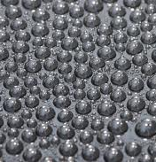

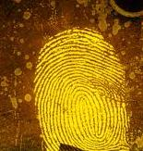

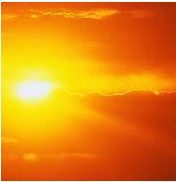

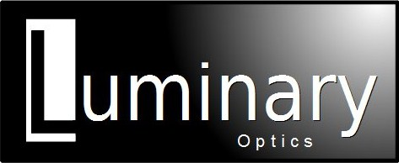

DuraCoat AR- Hardened Cover Glass

Anti-Smudge, Print-Free, Anti-Reflective Hard Coating

Features:

* Repels fingerprints
* Easy to clean with soft cloth
* 8H Hardness- 450,000 rub resistant
* Chemically inert- resists stains
* Withstands greater than 90 day salt-fog test (Mil-rated)
* Less than .4% surface reflectance
* High light transmission

**DuraCoat AR-** DuraCoat is a unique AR coating which is ideally suited for anti-reflective applications that require both durability and high optical performance. DuraCoat resists fingerprints and smudges and can hold up to harsh treatment making it an excellent cover glass for any optically bonded display. Additionally, DuraCoat is a great cover glass for Luminary Optics custom PCAP designs.

DuraCoat AR was specifically developed for the most rugged outdoor applications and is the most durable anti-reflecting (AR) coating available. The AR coating itself is less than .4% of specular reflectance, but more important, DuraCoat AR resists all smudges and fingerprints. Due to its low surface tension, smudges literally wipe away without special cleaners with just a soft cloth. The coating is also durable. The AR coating has an 8H pencil hardness which can tolerate abrasions, with up to 450,000 rubs without lifting or damage to the coating. DuraCoat AR can also survive a 90 day salt-fog test as well as a variety of other accelerated acid spray tests.

Why DuraCoat? AR coatings, with their index match properties to air, eliminate surface reflections to as low as .35%. Fingerprints tend to “stick” to AR coatings and since the print is NOT indexed matched, it reflects where the rest of the glass is anti-reflective. This means that the fingerprint will all but glow against its surrounding background. This means the display will increasingly show the fingerprints and develop a smeared and unappealing look. As fingerprints show up on AR glass, the tendency is clean the glass. Unless care is given, most AR coatings can literally be polished off the glass with repeated cleaning. Additionally, AR coatings are a metal. In a salt-fog application, such as marine navigation, the salt atmosphere becomes corrosive to the AR coating and it can be damaged.

Specifications: DuraCoat AR

|  |  |
| --- | --- |
| Test Description | DuraCoat AR / AR90 |
| Dry Cheesecloth rub test with 1.5 lbs. weight | 450,000 rubs |
| Steel wool #0000 with 1.5 lbs. weight | 10,000 rubs |
| UV exposure, noon Florida sun, 24/7 (equiv.) | 500 hours |
| Salt fog, 5% NaCl at 35 degree C | 90 days |
| Copper accelerated acid spray test | 30 days |
| Photopic reflection | < 0.4% |

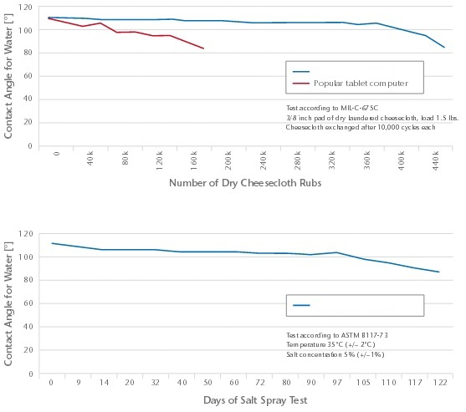

DuraCoat AR