consulting

sales

staffing

support

applications and MArkets

* **Military**
  + **Rugged PC**
  + **Ground vehicles**
  + **Avionics**
  + **3ATI/4ati/5ati/6ati in-cockpit displays**
* **CIVILIAN Transportation**
  + **In-vehicle DISPLAYS**
  + **ELECTRIC/HYBRID VEHICLES**
  + **Avionics**
  + **3ATI/4ati/5ati/6ati in-cockpit displays**
  + **Marine Navigation**
* **Medical**
  + **Ambulatory**
  + **Patient Monitors**
  + **Medical Imaging**
* **Industrial**
  + **Man/machine interfaces**
* **OUTDOOR DISPLAYS**
* **TESTED TURN-KEY PRODUCTS**

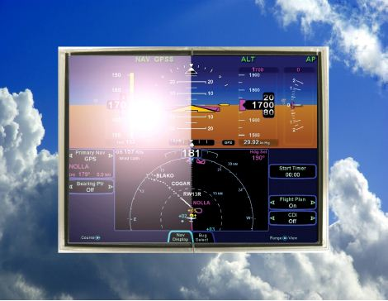

sdf

Luminary Optics

1800 NW 169th Place, Suite B-250

Beaverton, OR 97006

503 533-8939

503 924-9900

[www.luminary](http://www.luminary)optics.com

* NEED EXPERTS TO HELP YOUR DISPLAY PRODUCT PERFORM THE WAY YOU WANT?
* SINCE 2010, LUMINARY OPTICS HAS ESTABLISHED ITSELF AS THE WORLD LEADER IN HIGHEST QUALITY DISPLAY EHANCEMENTS
* SHORTEST LEADTIMES
* KNOWN FOR THE HIGHEST QUALITY
* BROADEST RANGE OF ENHANCEMENTS
* DECADES OF EXPERIENCE
* NO MINIMUM QUANTITIES
* COMPETIVE PRICING
* IN MOST CASES, NO NRE OR ENGINEERING COST

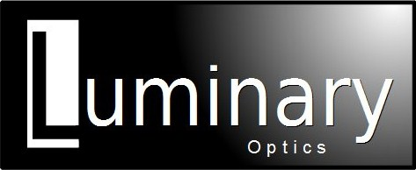



Display Enhancements

Display Enhancements

Display Enhancement Options

PCAP Touchscreens with custom features and configurations

Luminary optics supplies high performance multi-touch Projected Capacitive (PCAP) or Resistive Touch touchscreens with the ability to add custom features. Using our knowledge of optics and our lamination expertise, we can supply PCAP touchscreens with a variety of enhancements. Starting with a unique “film-film” PCAP construction, the base touch sensor is ultra-thin. After adding a 1.1mm cover glass and 1.1mm ITO filter and bus bar, the entire touch element is still less than 3mm thick.

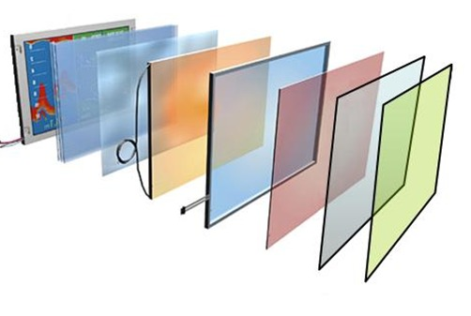

# Optical Bonding

The premium method for reducing reflective loss

DuraCoat AR Is a uniquely formulated window coating specifically developed for rugged outdoor applications. DuraCoat AR front coating is the most durable anti-reflecting (AR) coating with less than .4% of specular reflectance. Moreover, DuraCoat AR is oleophobic and hydrophobic and has an 8H pencil hardness which can tolerate abrasions, with up to 450,000 rubs without lifting or damage to the coating. DuraCoat AR will also survive a Mil-rated 90 day salt-fog test as well as a variety of other accelerated acid spray tests.

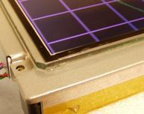

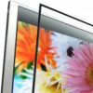

* Display can maintain a high contrast ratio even in bright ambient conditions
* Reduces Specular Reflection to less than .5%
* Can easily be de-bonded
* Ruggedizes the display
* Eliminates moisture condensation and contamination under the cover glass or touch screen
* High adhesion passes Mil rated Rapid Decompression test
* Never Yellow - UV stable

* Viewing Angle Correcting Film
* DuraCoat AR Glass
* Custom PCAP Touch Screens
* ITO EMI Filters
* Mesh EMI Filters
* ITO Heaters
* Circular Polarizing Filters
* Screen Printing

Featured Optical Technologies

DuraCoat



Luminary Optics

“MENU” approach to display enhancements

Luminary Optics is the premier display enhancement company. As a supplier of optical bonding and display enhancements, Luminary offers a wide range of products and services that increase the performance of displays, making them perform in the most demanding applications. Factory displays rarely meet the requirements of high-end user applications. Our unique approach to the industry is what sets us apart from the others. Luminary Optics provides you with a “menu” of various display enhancements, and we allow you to select what you want or need for your specific application. We rarely require NRE charges and we have the shortest lead times in the industry.

HI-Rel / Mil / COTS

Luminary Optics has been supplying display solutions specially designed to meet the demanding specifications for Military and COTS Military applications. Designs include NVIS, EMI Mesh, EMI ITO, ITO Heaters and full backlight improvements.

Team Partners

Luminary Optics partners offers advanced custom products and enhancements through a team of support partners with years of experience. They provide custom displays including dual mode sunlight/NVIS displays in ultra-thin packages. Custom filters include Circular Polarizers and custom coatings are available.

Optical Engineering

Luminary Optics understands the customer’s display goals and will engineer solutions using advanced display optics. Our design engineers have many years of display and optics experience to create solutions for demanding applications