**Josiah York**

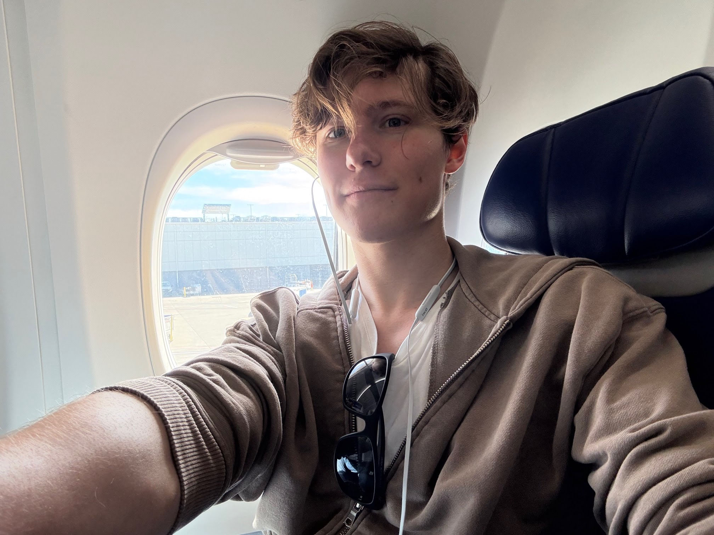

Hey there! I'm working state side for the time being, at the JAARS headquarters in Waxhaw, NC. Currently I am helping train, and being trained in our Land & Sea department to assist international missions teams across the world and equip them with the skills to more effectively and safely traverse difficult off-road and water travel conditions. I attended Moody Aviation, up in Spokane WA. My hobbies include TTRPGs, longboarding, BJJ, and volleyball.