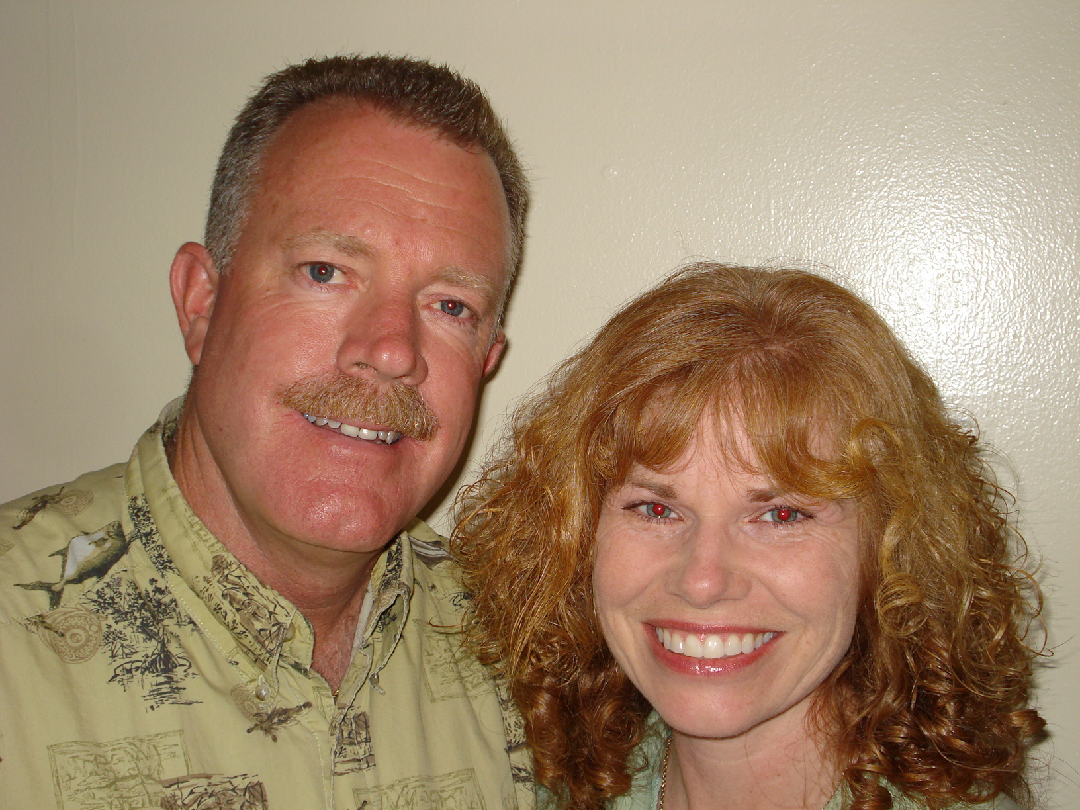

Allen Johnston
Harvest Aviation
Allen Johnston is the president of Harvest Aviation, Inc., a mission ministry based out of Wauchula, Florida. As a former Manatee County Sheriff’s deputy, detective, and pilot, Allen has a unique perspective on the needs and challenges of others. Three years ago he resigned from his position with the Sheriff’s office so he could devote more time to this quickly expanding ministry. As a pilot and certified flight instructor, Allen uses his administrative skills and flying talent to inspire, train, and support those who serve Christ at home and abroad.
Nanette Johnston is a teacher and speaker. She holds a B.A. in Social Work and B.S. in Education from Olivet Nazarene University as well as a PhD in Christian Clinical Counseling from International Theological Seminary. Nanette currently teaches high school Mathematics in Sarasota County, Florida as well as volunteers for Harvest Aviation. She has a special interest in the history of Israel and how the Old Testament prophecies see their fulfillment in the New Testament.
Allen and Nanette have four children and reside in Bradenton, Florida.

