Biographical Information: Stephen F. Saint
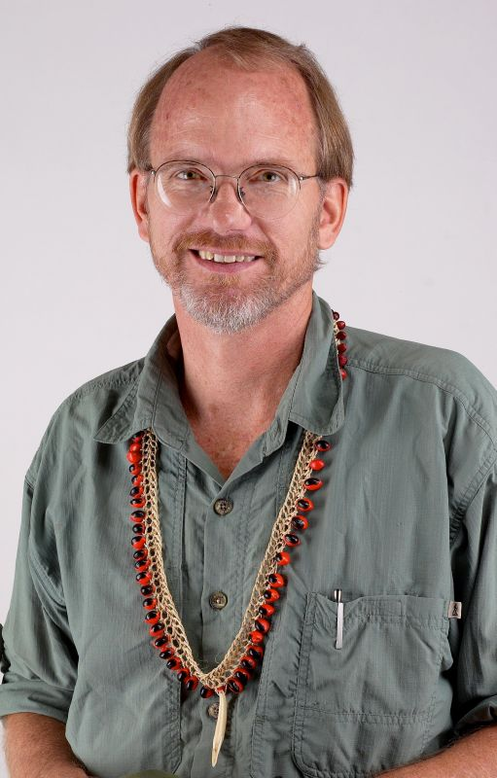
Steve was born and raised in Ecuador where his parents were missionaries. His father, Nate Saint, was the “Jungle Pilot” who was one of five young men killed in 1956 by the Waodani Indians (known as Aucas) whom they were trying to reach with the Gospel. Miraculously, two years after the killings, Steve’s Aunt Rachel (along with Elisabeth Elliot) was invited by the tribe to live with them where she was based until her death in 1994.

Steve’s mother, Marj, moved with her three children to Quito, where Steve attended school. Steve visited his aunt and the Waodani during the summers. He grew up knowing the men who had killed his father and came to love them and regard them as family - to be baptized by their hands, and embraced as a son

Steve went on to further schooling in the U.S. graduating from Wheaton College in Illinois. He returned to Ecuador, and while acting as a tour guide, met his wife Ginny, who was traveling with a Christian music group from Minnesota. They were married in Ecuador, and Steve started a construction business there. They moved to Minnesota soon after the birth of their first child, Shaun.

Steve continued a career in business, spending seven years in Minnesota, supporting Missions through business, and it was there that their other children were born—Jaime, Jesse and Stephenie. Business took the family to Dallas for a time; they left to spend a year in Mali, West Africa with MAF (the Missions his parents were with) to start an emergency operation in West Africa during a time of severe drought and famine. Florida became their home following that assignment.

Success in the business world has made it possible for Steve and Ginny and their family to respond to missionary opportunities—in South and Central America and Mali, West Africa. The sale of his business made it feasible for the family to go to live with the Waodani, at their request, after Rachel’s death.

Living among the Waodani, Steve came to understand their dependency on missionaries and help agencies resulting in a loss of pride and ingenuity among the indigenous Christians. Their church was without any designated leadership. The desire to reach their own people for Christ was there, but they felt inadequate to do so. It was this insight which gave Steve the vision for I-TEC (Indigenous People’s Technology and Education Center).

Part of his work with I-TEC is sharing the vision in increasingly busy speaking schedules. He has authored five books and a number of articles on missions and the Christian life. Steve continues his involvement with the Waodani, and visits the tribe several times each year.

Steve and Ginny live in Ocala, Florida. Their daughter, Stephenie, died suddenly in July of 2000, after a year of travel with Carpenter’s Tools International. Their three sons are married to Anne, Jessica and Jenni Joy, and have given them twelve beautiful grandchildren.

Specific data:
Born January 30, 1951 in Ecuador at a Mission hospital
Steve was five years old when his father was killed.
Met the Waodani at age 10. Baptized at age 13, by the Waodani, at “Palm Beach”.
High school in Ecuador,
B.A. in Economics at Wheaton College.
Certified Financial Planner—College of Financial Planning in Denver, Colorado.
Pilot with multi-engine instrument rating, he is also an experienced bush pilot.

