Jeremiah & Julie Diedrich
Wycliffe Bible Translators

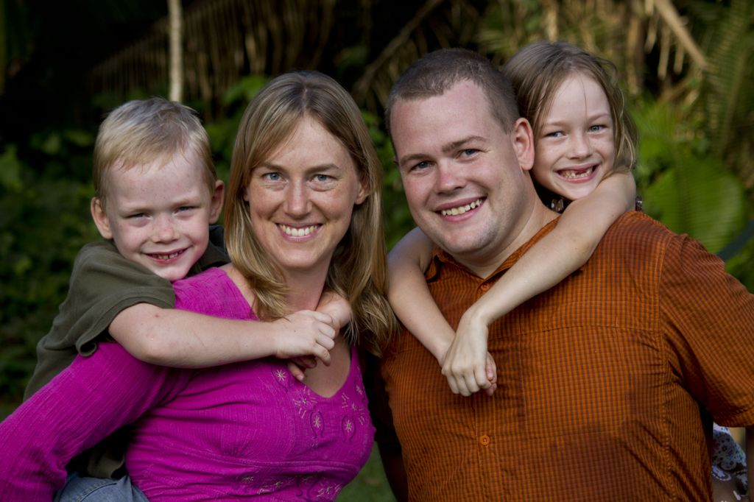

Jeremiah & Julie Diedrich, Miriam 7, Nehemiah 5
Jeremiah grew up in New York and Illinois as the son of a pastor and felt God calling him to be a missionary pilot early in life. Julie grew up in Canada and got her interest in aviation from her pilot father. Jeremiah & Julie met and married while attending Moody Aviation in Tennessee. They felt God calling them to join Wycliffe Bible Translators. They have been serving in Porto Velho, Brazil since 2006 with Jeremiah as pilot/mechanic and Julie as part time aviation mechanic and home school mom.

