Bob and Sally Dontje
Biographical Sketch
Bob’s roll is aviation recruiter for Wycliffe working from his home in East Moline, Illinois. He is able to draw on his many years of mission field experience in aviation to challenge individuals to be involved in aviation support roles to see a Bible Translation program in progress in every language still needing one by 2025.
Bob’s aviation career started with training at Moody Bible Institute and Moody Aviation in Tennessee. He joined Wycliffe in 2011 with 29 years of experience in aviation and other related activities serving with Mission Aviation Fellowship (MAF). Bob’s main role with MAF was as a pilot/mechanic, serving for many years in Papua, East Kalimantan (Borneo), and Sulawesi, Indonesia. Bob and his first wife felt a strong call to return to the USA in 1999. Shortly after returning, Neva became ill with cancer and subsequently died and Bob went legally blind with cataracts. After her death and his cataract surgery, Bob returned to the aviation world serving in Lesotho, Africa as pilot/mechanic and administrative advisor, in Sumatra, Indonesia as interim program manager, in East Democratic Republic of the Congo doing construction and refurbishing houses for staff, and several weeks in Haiti after the earthquake doing logistics.
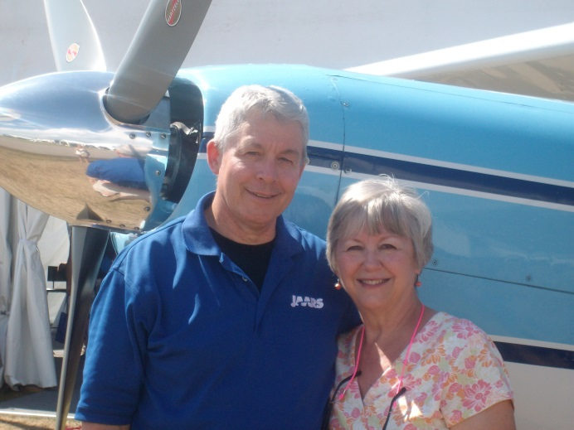
With changes in Bob’s life he began to seek ways to stay more strongly connected directly to his aviation passion. He began to look at serving with Wycliffe and heard about our new aviation recruitment efforts. He joined Wycliffe and after finishing his recruitment training has been actively seeking new recruits. Bob’s vision for Bible translation was planted as he grappled with understanding Bible teaching in a second language, the Indonesian language. The vision was greatly expanded when he had the privilege of participating in the dedication of the Uma New Testament in Sulawesi, Indonesia and the joy he saw as people began to read the Bible in their heart language.
Bob and Sally were married on July 10, 2010. Sally is extremely supportive of Wycliffe and continued her role as administrative assistant at their church until retiring in Aug of 2013. Together they have five children. Matt (45) and his wife Laura and their four children along with Nathan (41) and his wife Michelle and their sons, London and Ronin, live and work in the Moline, Illinois area. Josh (35) is enjoying using his degree in horticulture working with a tree company in the Des Moines area. Tim (33) married Susanna in February 2012, works for a farm co-op in northern Iowa and has a degree in auto mechanics. They blessed them in April 2013 with Israel the sixth grandchild and again in Sept 2014 bringing Verity Joy into their lives. Steph (28) completed a Christian Ed major and Missions minor from Faith Baptist Bible College in 2011 and after a short-term mission trip to Tanzania, Africa, worked in mid management at Olive Garden, as office assistant at an insurance agency and now is office assistant with Century 21.

