Loren and Michelle Rothmann
Wycliffe Bible Translators / SIL International
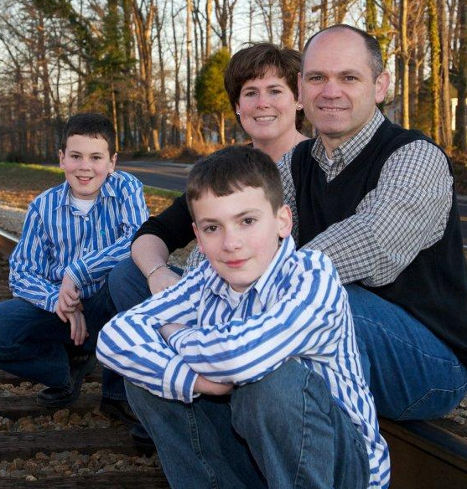

Loren provides technical support and information to global Wycliffe members and help desks. His primary role in the SIL Global Technology and Information Services department is knowledge architecture. His current projects include intranet resource (a.k.a. wiki) development, Google Apps integration, and global tech community development.
Loren and Michelle became Wycliffe members in 2010 and serve at the JAARS Center in Waxhaw, NC. Loren brings 14 years corporate experience in technical support, technical writing and knowledge management. Michelle has a degree and 8 years experience in nursing and serves at the JAARS Health Clinic.
Loren and his wife, Michelle, were married in 1997 and have two boys; Matthew (1998) and Zack (2000). Their family is very involved in homeschooling, Scouting, music, and church development.

