Don & Judy Vander Ploeg
Wycliffe Bible Translators

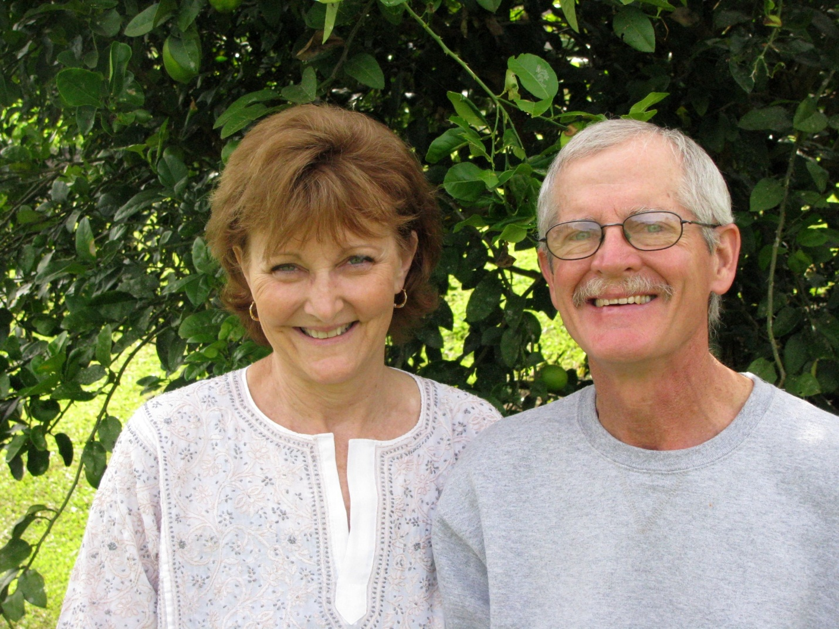

Don and Judy have been with Wycliffe Bible Translators for over 30 years. Both went to Papua New Guinea as single short-term assistants with Judy teaching in the primary school for missionary children and Don working in the auto-shop at the main translation center of Ukarumpa. They were married in Papua New Guinea in 1981.
In 1986 they became full members with Wycliffe. Since 1986 they have served the translation effort in the areas of regional center management, education (Judy) and maintenance/construction/industrial trades (Don). Having spent most of their time overseas in Papua New Guinea, they have also served in the Democratic Republic of Congo, Kenya and at the JAARS Center in Waxhaw NC. On furlough after 3.5 years in Papua New Guinea, they anticipate a return to the field later in 2012.

