James Curry
Liberty University

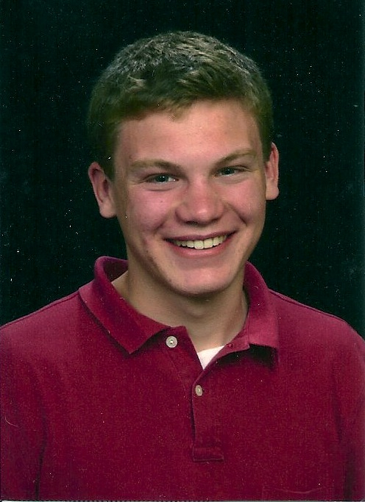

James is originally from Brodhead, Wisconsin. He took an interest in aviation at a young
age and earned his private pilots licenses in airplanes and gliders by age 17. James is an active member of the Blue Ridge Soaring Society in New Castle, VA, where he gives glider rides and flies the club’s tow planes while building valuable flight time. James came to Liberty University because of their diverse fields of study. He is currently earning a degree in Aeronautic Science while continuing to play his violin with a minor in Music. He hopes to pursue an A&P certificate after he graduates and looks forward to taking advantage of the opportunities that the Lord may present.

