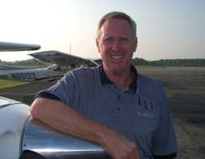
Dave Young
w/Liberty University School of Aeronautics

Dean, School of Aeronautics
Director of Aviation Development
Aviation Professor
dlyoung@liberty.edu

Source: http://www.liberty.edu/index.cfm?PID=17204

