Jason Patton
Life Builders International President
Moody Bible Institute
Winona State University Graduate
Pilot and A&P

Building Lives with
Great Commission Purpose
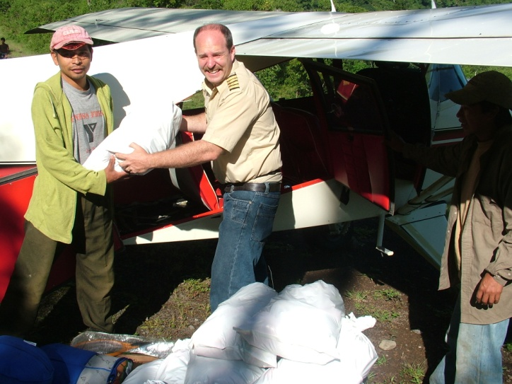

LBI is located in a community of Guatemala City called Santa Fe. This area has some of the greatest needs in the entire country of Guatemala. There are many spiritual strongholds in the area and this is the reason for our location. We run school sponsorship/tutoring, aid to families-in-crisis, drug/alcohol rehab (providing access and follow-up/discipleship), feeding program, children's programs, flight program, evangelism, and discipleship programs. God is using this ministry to impact where no other missionary is reaching, but we are in need of help on a permanent basis. In 2008, we will have space for an individual or a couple to commit a year to aid PMI in the Lord’s work, specifically involving youth outreach and teaching programs.

