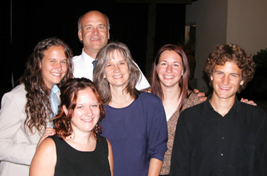
Ralph and Valerie Dawson

MAF

Ralph and Valerie Dawson and their children Kathryn, Elliot, Emilee, and Elisabeth, are missionaries with Mission Aviation Fellowship. They are currently serving at MAF's headquarters in Nampa, Idaho. Their previous terms have been spent in Irian Jaya (now Papua) Indonesia.
Ralph shares that the highlight of their ministry in Indonesia was working together with the local church to reach the remaining isolated areas of Irian Jaya, bringing the Gospel to those who have not yet heard. He flew more than 800 hours a year to help support the church development in areas where there is no other transportation. Valerie loved seeing God work in the lives of the national people. She shares, "As I saw each person change and grow in Christ, I was being changed and grew in ways I never imagined."
Ralph is currently part of the Recruiting Department in MAF Headquarters. He plays an integral part in recruiting pilot, mechanics and computer specialists for the worldwide ministry of MAF.
Valerie enjoys participating on MAF panels representing the MAF wives' role, addressing the new candidates coming into MAF. She opens her home providing meals for candidates and orientees while they are in Redlands. Valerie also shares her musical talent through singing and playing her violin for MAF Chapels and other functions.
Ralph was born and raised in California. The evidence of Christ in the lives of some of his high school friends was instrumental in his decision to accept Christ as his Savior. Attending an Urbana Missions Conference confirmed Ralph's desire to serve in missions. Ralph earned a B.S. in Electrical Engineering Technology, and his Airframe and Powerplant mechanic license from LeTourneau University in Texas. He received his flight training at Moody Aviation in Tennessee. He holds a Commercial Pilot License, Instrument Rating. In November 2002, he received his Commercial Flight Instructor-Instrument rating.
Valerie also grew up in California. At age 19, she heard and truly understood the Gospel message, accepting Christ as her Savior. She attended Modesto Junior College and California State University at Chico, where she received a B.A. in Elementary Education. Valerie also attended Urbana in 1976 and 1979 where the Lord challenged her to make a commitment to missions. Ralph and Valerie met in 1978 and were married in 1980.
Ralph's favorite verse is 1 Thessalonians 5:24, "Faithful is He who calls you, and He also will bring it to pass."
Lamentations 3:22-23, is a special passage for Valerie. "The Lord's lovingkindnesses indeed never cease, For His compassions never fail. They are new every morning; Great is Thy faithfulness." The Lord's grace is sufficient for whatever situations she finds herself in.

