Rick & Teresa Dickson
MAF

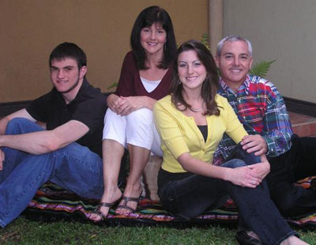
Rick and Teresa began their work with Mission Aviation Fellowship in Lesotho, Southern Africa, where Rick was a pilot & mechanic and then served additionally as the Program Manager. After 6 years in Lesotho, they were relocated to Nairobi, Kenya, in East Africa, where Rick served as Southern Africa Area Manager, overseeing MAF’s operations in the countries of Lesotho, Mozambique, and Zimbabwe.
Two years later, in January of 2006, Rick prayerfully accepted a new assignment to serve as MAF's Latin America Regional Director. With this new endeavor, the family has relocated to San Jose, Costa Rica. MAF has mission work in many Latin American countries, such as Ecuador, Brazil, Mexico, Guatemala, Haiti and Suriname.
In October, 2011, after getting their son John settled in college in Alabama, Rick and Teresa relocated to Idaho to serve at MAF’s HQ in the role of Senior Director of Regional Operations. Although not looking to relocate back to the US from overseas service, Rick realized that in this role he might have a greater impact on the mission of MAF around the world.
“Since serving the Lord from the beginning in Lesotho,” comments Rick, “I’ve come to realize that Satan has such a grip on this part of the world that the people fail to see the God of creation through His works. My desire is that the veil of deceit would be lifted from their eyes in order that they may worship the true and living God.”
Teresa considers her main goal in life as best said by Matthew 6:33, “…seek ye first the Kingdom of God and all His righteousness, and all these things shall be added to you.” She adds, “It is such an adventure to follow the Lord. You just start by loving him one day at a time and He takes care of all the rest!”
Rick grew up in Huntsville, Alabama. He realized his need for a personal relationship with Jesus Christ when he was a sophomore in high school. He earned a Bachelors of Aviation Management from Auburn University, Auburn, Alabama, and an airframe and power plant license from Tennessee Technology Center in Nashville. Rick holds a commercial single-engine pilot’s license with instrument rating and is a certified flight instructor.
Teresa was raised in a Christian home in Bowling Green, Kentucky. She gave her life to the Lord at age 11. Teresa earned a Bachelors of Chemical Engineering from Auburn University. Teresa and Rick met while studying together at the university and were married in 1981.
To fund the worldwide ministry of MAF, God is faithful in providing generous ministry support from His people. He has called the men and women of MAF to serve Him in a unique way.
He is also calling people like you to play a special role in the ministry of MAF around the world. You are invited to become a ministry partner with the Dickson’s.

