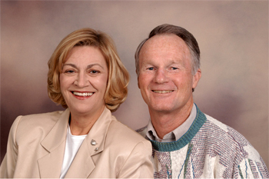
Denny and Carol Hoekstra
MAF (Mission Aviation Fellowship)

Denny and Carol Hoekstra have been missionaries with Mission Aviation Fellowship since 1965, serving in Zaire (now DRC), Kenya, and Ethiopia, as a pilot/mechanic family. Denny was also an instructor pilot, and program manager, with Carol working alongside him. They have three adult sons, Scott, Jeffrey, and Kelly.
Denny was born in Holland, Michigan, but grew up in Sudan, Africa, where his parents served as missionaries. When MAF began service in Sudan, Denny’s life was greatly impacted because his parents’ ministry was able to expand. However, at the same time, the two-week overland trip to boarding school was decreased to just two days. God also used the pilots’ lived-out testimonies to set the direction of Denny’s life. Following graduation from high school, he attended Hope College, Spartan School of Aeronautics, and Moody Bible Institute. He holds commercial, instrument/instructor, and airline transport pilot licenses with a multi-engine rating. Denny is also an aircraft & powerplant (A&P) mechanic.
Carol is a third-generation southern Californian. She accepted Christ as her Savior as a 12-year-old, and committed herself to serve God as a missionary at the same time. Pursuing that goal, Carol studied at Moody Bible Institute, and earned a B.A. in business management from the University of Redlands.
Since 1976, the Hoekstras have been assigned to headquarters, serving for one summer (1985) in Democratic Republic of Congo, Africa. Denny has served in the vital position of Director of Aviation for many years, with responsibilities in safety, training, and technical support for worldwide aviation operations. Denny is currently serving as Director of Fleet Optimization Funding.
Carol has served as Manager of Staff Development, which encompasses candidate, orientation, and management training programs. Carol has also served as Vice President of Human Resources.
The Hoekstras continue to invest their lives in facilitating the spread of the Gospel, ministering to those in service for God, and building their personal relationship with Him. Philippians 2:13 says, "For God is at work within you, helping you want to obey Him, and then helping you do what He wants." Carol and Denny are currently living in southern California.
To fund the worldwide ministry of MAF, God is faithful in providing loyal, generous ministry support from His most caring people. He has called the men and women of MAF to serve Him in unique ways. He is also calling people like you around the world to play a special role in the ministry of MAF.
You are invited to become a ministry partner with Denny and Carol in this strategic ministry. Please prayerfully consider involvement with them through prayer and/or financial support. http://www.maf.org/hoekstra

