John and Nancy Hook
Mission Aviation Fellowship (MAF)
John and Nancy Hook are Mission Aviation Fellowship Missionaries serving at the MAF HQ in Nampa, Idaho. John is the South West Recruiter in care of bringing new MAF Pilots and Mechanics into the organization. John also gives Flight Seminars and speaks on Missionary Aviation in many areas of the U.S. The Hooks joined MAF in 1975 and served 15 years on the islands of Indonesia. They then continued to serve in South America and Haiti. John also flew the MAF King Air 200 in Afghanistan and Africa on short term trips and is a pilot for the disaster relief team of MAF that serves worldwide in case of natural disasters. Nancy raised 4 children and was Flight radio operator, medical programs and educational programs for children in the villages of the countries where we lived. Since 1996 the Hooks have been assigned to the MAF Headquarters in Nampa as a flight instructor to train new pilots for 10 years and now a full time recruiter.
John accepted the Lord as a teenager. By the time he was 19; he left his hometown of Xenia, Ohio and was on his way to Viet Nam with the US Army flying Helicopters. After his military assignment was complete, John decided to attend Grace College in Indiana, where he found and married Nancy.
Nancy was raised on a farm outside Gosport, Indiana. Through the Godly witness of her mother and faithful Sunday school teachers, she came to know the Lord at a young age and committed her life to the Lords service by the time she was 12. Shortly after meeting John at college, they realized that God could use them as a team to serve Him and they were married in May 1972.
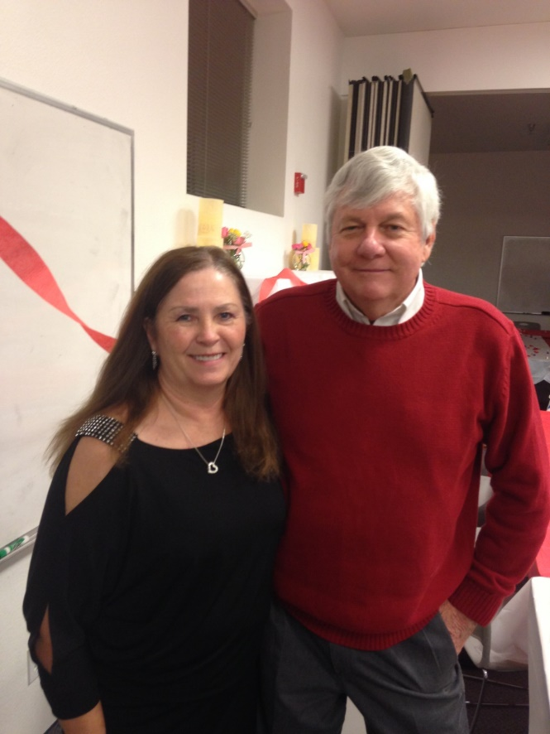
In preparation for the mission field, John studied aviation technology at Embry-Riddle Aeronautical University and Western Pacific U. and earned a B.S. Degree in Aviation Technology. He holds an Airline transport rating for both Airplane and helicopter, Commercial, Instrument, Sea-Plane, certified Flight Instructor and Airframe-Power Plant Mechanics Rating. Nancy graduated from Daytona Beach College with an A.A. degree in Education before going to Indonesia. In 1998 she graduated from Crafton Hills College with an A.A. in Liberal Studies.
During their overseas career, they served in some of the most isolated areas of the world to help pioneer missionaries reach many new tribal groups for Christ and Bible translations, Church Planting and Bible teaching for new Pastors. Their years of overseas experience have been an invaluable asset in the challenges of preparing new pilots for service overseas with MAF.
The Hooks oldest daughter, Elisa is married to Kurt Eckert and is mother to our first grandson Austin. Estee has a Doctorate in Physical Therapy and teaches in a Hospital and has completed a fellowship in Orthopedic Surgery. Stephen is married to our Indonesian daughter-in-law and parents of Destan our second grandson. Thomas our youngest is a property manager in downtown Chicago.
The Hooks look forward to many more years of serving with MAF. We are blessed with a very technical ministry of Aviation to serve missionaries around the world with transportation and communication.

