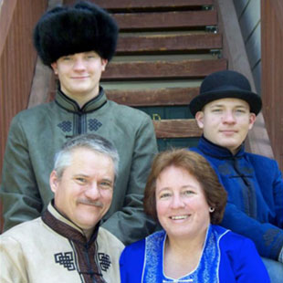
Tom & Diana Mason
MAF
Since 1995, Tom and Diana have served with Mission Aviation Fellowship, most recently in Central Asia. For 10 years in Puerto Ayacucho, as a maintenance specialist, Tom was responsible for regular maintenance and repair of the aircraft in the Venezuela program.
Both Tom and Diana feel that the most enjoyable and fulfilling part of serving is the interaction and friendships with the local people. In Asia their service varied from program development in Siberia, and arranging flight permits in a country further south, to filling in as Program Manager in Mongolia.
Diana’s ministry centered on providing a loving, Christian home for her family. She has enjoyed homeschooling their sons, Anthony and Joshua, now living and working in Colorado. She enjoys hospitality, hosting guests and travelers in there home. Most recently she has been mentoring newly arriving MAF families, helping them adapt to their new surroundings, culture, and language.
Diana’s favorite verses are found in Proverbs 31, which describe a godly woman. “They are the goals I would like to strive for in my own life,” Diana says.
Tom grew up in Iowa, in a God-fearing home, and was moved to accept Jesus as his personal Savior after attending a youth rally showing the film, “A Thief in the Night.” Following High School he studied Agriculture at McPherson College, and later obtained his Airframe and Powerplant mechanic’s certificates in Colorado.
Diana grew up in Fort Collins, Colorado, also in a Christian home. She asked the Lord into her heart at age 10, during junior church. Diana attended McPherson College in Kansas, studying Biology toward a Pre-vet major. She met Tom there; they were married in 1982.
You are invited to become a ministry partner with the Masons in this strategic ministry. Please prayerfully consider involvement with them through prayer or financial support.

