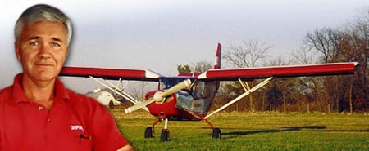
ART MITCHELL
Mission Aviation Fellowship, Canada

Art Mitchell has been involved in professional aviation for more than 20 years with over 4,000 hours flying and 14 years in maintenance and repair. He has taught at Trinity Western University in Langley, B.C. and helped develop a course in mountain flying.

Since 1980 he has been with Mission Aviation Fellowship, flying mostly in East and Central Africa. Art is the founder and president of Flypass Ltd., and is Zenith Aircraft's central Canada distributor. Flypass built the prototype STOL CH 801 under the design and construction supervision of designer Chris Heintz.

Art’s background:
1966-1970 | Youth Pastor in Vancouver, Canada.
1972-1976 | Bible School Teacher in Zaire with Africa Inland Mission
1976-1980 | Flight & Aircraft Maintenance training, Northrop Institute of Technology, Los Angeles, CA.  Missionary/pilot with The Shantymen's Christian Association in western Canada.  Teacher at Trinity Western University, Department of Aviation
1980-1987 | Pilot/mechanic with Mission Aviation Fellowship in Bukavu, Zaire.
1987-1990 | Operations Manager with MAF in Dodoma, Tanzania.
1990-1994 | Overseas Staff Facilitator (Pastor to overseas staff) with MAF Canada.
1994-2003  2003-present  2008 – present | Owner of Flypass Ltd at the Waterloo Regional Airport, in Kitchener, Ontario, Canada (flight training, aircraft assemblies and sales).  Director of Ministry Partnership and Recruiter (Canada East) for Mission Aviation Fellowship of Canada.  Half time as Mentoring Pastor of Maple Hill Baptist Church, Keswick, Ontario, Canada

